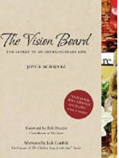

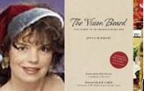
Perfect holiday gift: THE VISION BOARD trade paperback http://tinyurl.com/ordervivisionbook only $12.81 now!
Fall, 2009,www.ihaveavision.org
THE VISION BOARD book
Joyce Schwarz, 310-822-3119 thevisionboard@aol.com

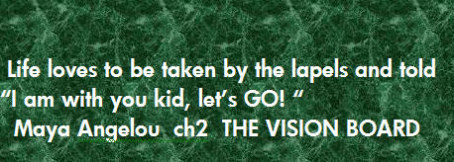

LETTER FROM THE AUTHOR: JOYCE SCHWARZ

IN THIS ISSUE:
*E Entertainment TV morning show pix
*Joyce speaking in Latin America
*Meet the new Certified Vision Board Counselors!
*The Vision Board goes to trade paperback http://tinyurl.com/ordervisionbook

The Vision Board book featured in more than 300 interviews in print & electronic media across the USA & Canada

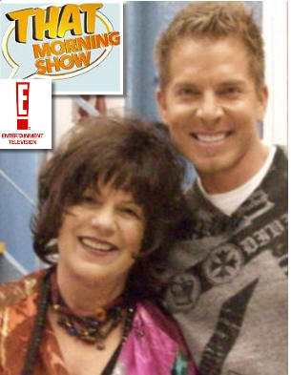
Fall vision board creation tip: you can make the host of your next party or even your local or national TV appearance smile as Joyce did when we created a custom tribute Vision board for the E Entertainment TV morning show! Joyce is shown with Mark Long one of the great hosts on THAT MORNING SHOW televised nationally in fall 09

Great news !THE VISION BOARD book hardback first edition is

TOTALLY SOLD OUT – all 20,000 copies! THANKS SO MUCH.

The Trade paperback of THE VISION BOARD (see pictures and details at

http://tinyurl.com/ordervisionbook ) launches December 22 at online

bookstores and at more than 3000 books in USA and Canada!

As you probably know, THE VISION BOARD topped

Amazon.com’ as the #1 Mystical best-seller for more
than 22 weeks in 2009 & hit #5 on Canada’s GLOBE & MAIL bestseller list.

Maya Angelou’s quote perched against a bright green background above
is a reminder that the life just gets better and better but please enjoy the

NOW!

Congratulations to more than 25 accredited Vision Board Counselors
Across the USA and Canada and now in training in Singapore and UK!

Share the vision,
Joyce Schwarz
email: thevisionboard@aol.com

THANKS TO ALL THE PRESS AROUND THE WORLD FOR GREAT REVIEWS!

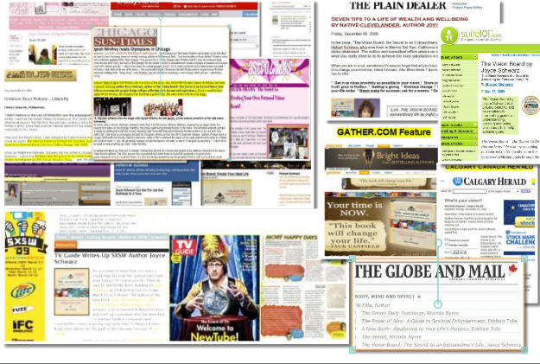
THE PRESS LOVE THE VISION BOARD book!
For a complete list of all press to date more than 300 interviews and radio shows email joyceschwarz@gmail.com
PS If you know a press or are a press person who wants a paperback to review email thevisionboard@aol.com

www.ihaveavision.org
www.visionboard.info
thevisionboard@aol.com
or call Joyce Schwarz @
310-822-3119

________________________________________________________________________________________
EVENTS you may have spotted The Vision Board at this year:

*BEYOND THE SECRET DVD Extra features!

*BOOK SIGNING MYSTICAL JOURNEY, VENICE, CA

*WEST HOLLYWOOD BOOK FAIR courtesy of WNBA
San Diego and Portland Body Mind Spirit Expos and SHOW BIZ EXPO LA!

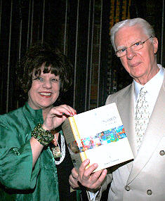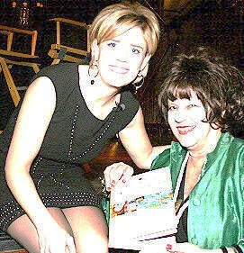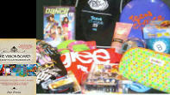
Did you see Joyce Schwarz in a special feature on the DVD of BEYOND THE
SECRET movie featuring Bob Proctor and Holli Walker and so many more
VIPs? Thanks to the generosity of Harper Collins Publishing, Collins Design and
My VIP pal Dhustle THE VISION BOARD book was at the TEEN CHOICE AWARDS
In Hollywood (see the VIP SWAG bag with THE VISION BOARD book above!

FEATURED ON THE E ENTERTAINMENT THAT MORNING SHOW The Vision Board book was featured on THAT MORNING SHOW nationally on E Entertainment TV’s national TV show. Thanks E and all for making it possible! BELOW left see Joyce’s vision board, Joyce and co-hosts of THAT MORNING Show and the Tribute Vision Board created to honor THAT MORNING SHOW!
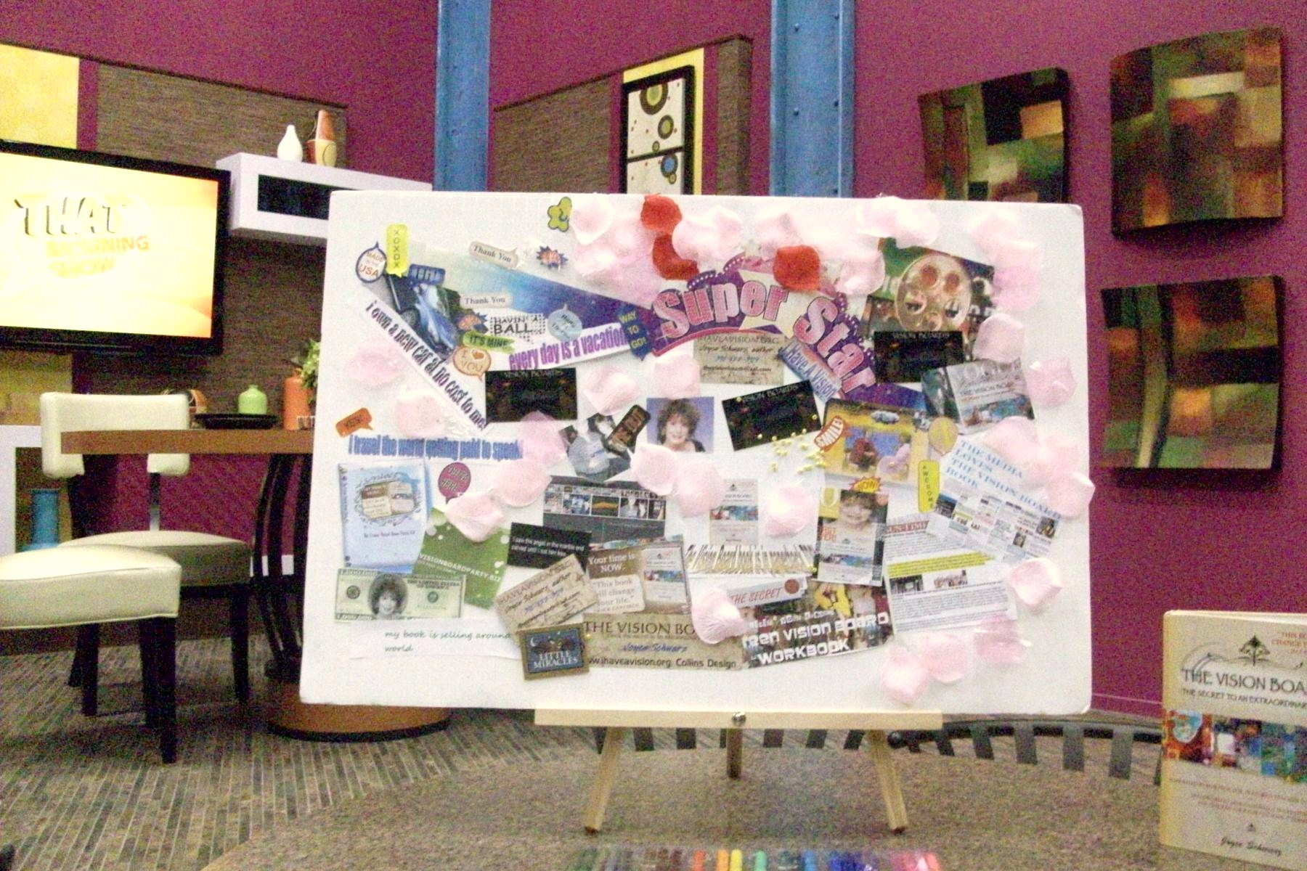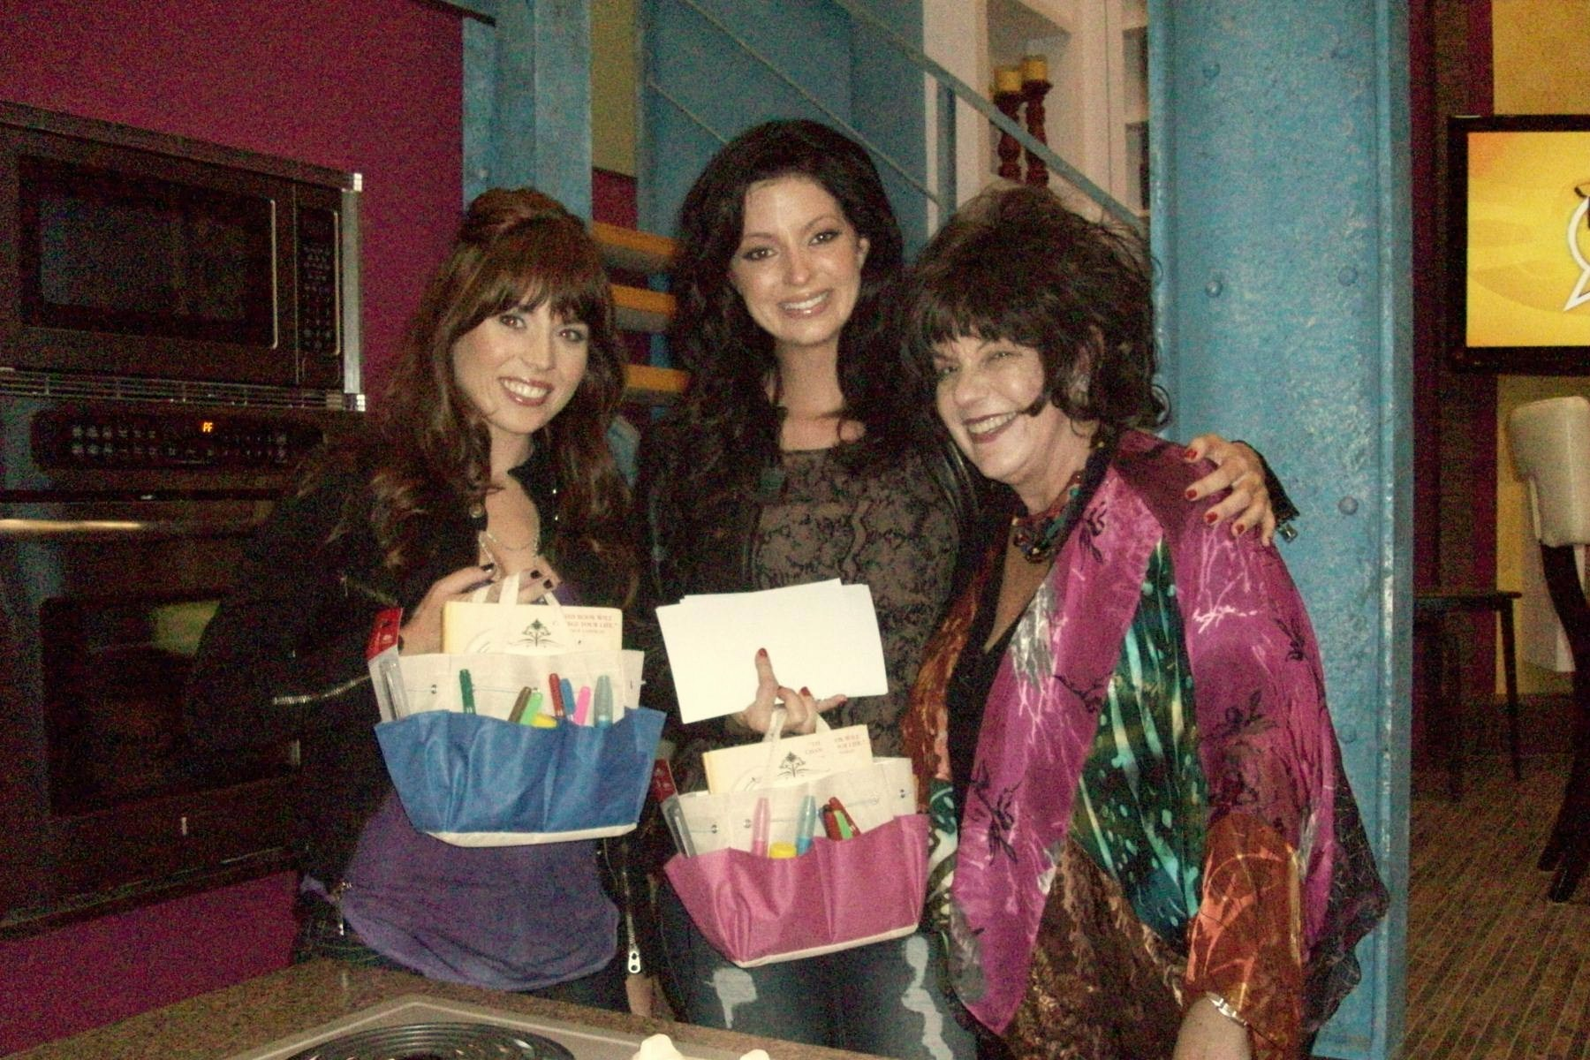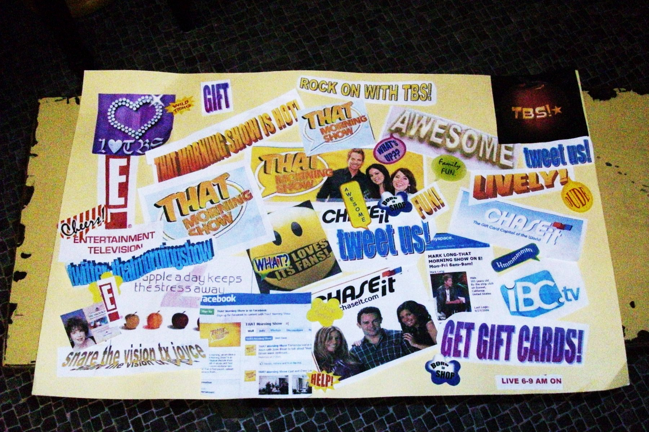
VISION BOARDING TIP FROM JOYCE SCHWARZ:
Are you thinking about 2010. Be sure to share the concept of VISIONING the new year versus just New Year’s resolutions. For tips you can see articles in THE VISION BOARD blog at www.visionboard.info!

Watch the blog and the official Facebook vision board group at http://tinyurl.comfacebookvisionboard for details on radio & TV interviews on New year’s visioning!

THE VISION BOARD AROUND THE WORLD!
.
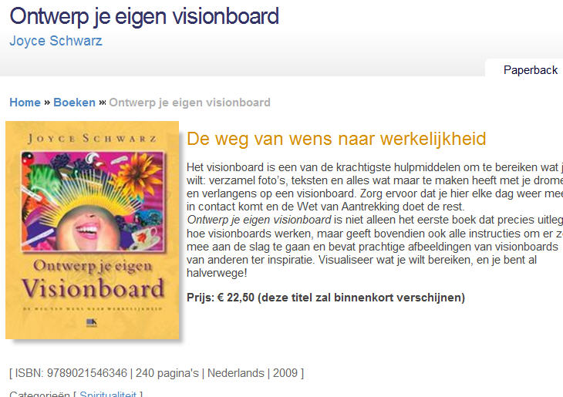
CONTEST – when you see anyone reading THE VISION BOARD book (yes, you too) in any language take a pix with your cell phone or digital camera and email to: joyceschwarz@gmail.com
PRIZE is an autographed copy of the new paperback edition!
YES, the Dutch rights of THE VISION BOARD book sold to a publisher in the Netherlands and the book is now on sale across Holland and beyond. Of course it is also in all English speaking countries too. To locate a bookseller in your area, email joyceschwarz@gmail.com and we’ll tell you the location closest to you or go to http://tinyurl.com/ordervisionbook

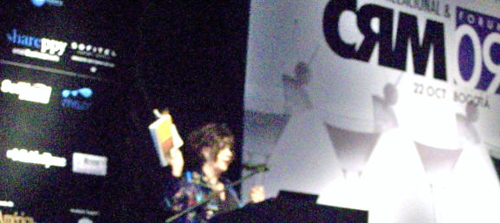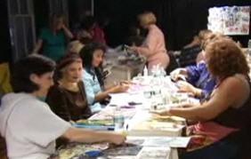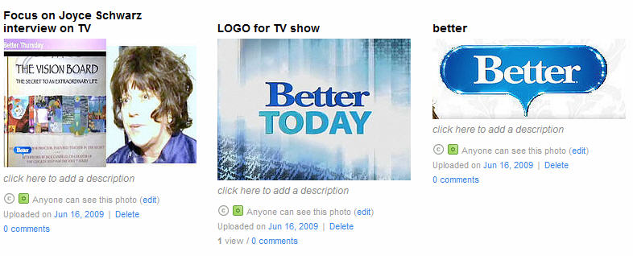
Around the world from Holland (see above) to Bogota, Colombia to New York THE VISION BOARD and best-selling author Joyce Schwarz and artists (see middle picture above) are being featured on BETTER TV, radio and sharing the vision that your dreams can come true! Thanks to all of you for your support! And to all of my pals around the world and the fans of THE VISION BOARD book who make all of this possible. And thanks to Irene Goodman and all of the wonderful people at Harper Collins Publishing, Collins Design!

EXTRA! EXTRA! WORLD’S FIRST VISION BOARD COUNSELORS ARE ACCREDITED www.visionboardinstitute.com
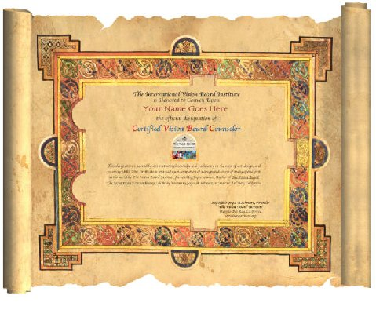
THIS IS THE BEAUTIFUL SCROLL THAT all Certified Vision Board Counselors earn at the time of their accreditation. For more info on becoming a CVBC email: thevisionboard@aol.com
________________________________________________________________________________

INTRODUCING THE World’s FIRST VISION BOARD COUNSELORS Accredited CVBC, THE VISION BOARD INSTITUTE www.visionboardinstitute.com
by Joyce Schwarz, founder THE INTERNATIONAL VISION BOARD INSTITUTE, 310-822-3119, email: joyceschwarz@gmail.com
SCROLL DOWN FOR LIST OF CERTIFIED VISION BOARD COUNSELORS ACROSS THE GLOBE:
Here is the list of the world's first Certified Vision Board Counselors and the cities that they are located in or near. Please feel free to contact them directly about courses, workshops or one-to-one counseling. If your city is not listed yet, email: thevisionboard@aol.com for a referral to an online or tele-class counselor who can answer your questions. Note this list is in random order, we will be providing an alpha list by region in 2010 look for your city or for a location near you and contact the CVBC counselor directly or call 310-822-3119 for recommendations and referrals and more information about courses, classes and workshops
WORLD’S FIRST CERTIFIED VISION BOARD COUNSELORS CVBC
DOREEN ROMAN FLIN FLON MANITOBA, CANADA Rdroman@mts.net, 159 Green Street Flin Flon, MB R8A 0G3 204-687-5791 OR 204-687-0836 Certified BodyTalk Practitioner Reiki Level II Educational Assistant
DuEwa Frazier NEW YORK duewacreates@yahoo.com P.O. Box 26183 Brooklyn, NY 11202
Office 800-796-4369 Writer, Author, Performer & Educator

Leanne Vellacott AUSTRALIA leannevellacott@optusnet.com.au 83A Tennyson Rd Gladesville NSW, 2111 Australia address for mail out- work: Ultraceuticals suite 2 level 4 436-484 Victoria Rd Gladesville NSW 2111 Australia home phone number 612 9879 4408 Occupation: Receptionist, study counseling and Soul Collage

Marj Bostock CRANBROOK, BC Canada mjbostock@shaw.ca Box 201 Cranbrook, BC, Can 250 426 9756Home based business (Healthy Homes, Healthy life and independent Nikken consultant and part-time driver examiner

Teri Schulte TEXAS teri@terischulte.com 1524 Rambler Rd. Arlington, Texas 76014 682-554-4425 Author, Speaker, Internet Marketer

Sharon Shenker MONTREAL QUEBEC, CANADA sharonshenker@gmail.com Address: 801-7400 Sherbrooke West Montreal, Quebec, Canada H4B 1R8 Cell Phone number: 514-804-3585 Home phone number: 514-369-8142 Occupation: Founder of Divorce Support Plus (www.divorcesupportplus.ca)Family Relationships Coach

Cheryl Planert NORTH DAKOTA Cherylplanert@pacbell.net or cplanert@mac.com
PO Box 982, Beach, ND 58621 701-872-2667 Owner, Dakota Lights Licensed Marriage and Family Therapist (LMFT) Registered Movement Psychotherapist (ADTR) Certified Kundalini Yoga Teacher
Health Mastery & Life Path Facilitator

Robin Chant MANITOBA, CANADA robin_bfd@hotmail.com 616 - 41st Street, Brandon, Manitoba R7B 4E1 204-729-8596 Fire Fighter / Paramedic Body Talk Practitioner

Graham Robertson, VANCOUVER, CANADA grahamrobertson@gmail.com, The Ritz
PO Box 17514 Vancouver, BC V6E 0B2 778-229-0157 Life Coach / Online Dating Consultant

Judith Fine-Sarchielli CALIFORNIA sarchjudith@gmail.com www.visionart@vpweb.com www.sarchiellieditingservices@vpweb.com 6526 Alma St. Simi Valley, CA 93063, Creative Catalyst ASR Communications Educator, Developmental Editor , Personal Brand Consultant

Dr. Sheri A. Wallace, LMHC , FLORIDA Sheri@DrSheriWallace.com 2603 NW 13th Street, #309, Gainesville, FL 32609 OneSource Coaching and Training Offices in Gainesville, Starke, St. Petersburg, FL
Phone: 352.870.8975 FAX: 866.372.0203 E-Mail: Sheri@DrSheriWallace.com Website: DrSheriWallace.com

Brenda Molyneaux PENTICTON, BC Canada aleapintolife@gmail.com 903 Dynes Ave Penticton BC Canada V2A 1E7 aleapintolife@gmail.com

Laura B. (dusty) Friesen ,Alberta Canada dustyis@shaw.ca 7041 Gray Drive
Red Deer, Alberta. T4P 403 343 3774 EchoAdventurer@gmail.com

Teri Sewell DENVER, COLORADO terisewell@gmail.com Direct: 720-318-4404
Facsimile: 303-327-8491 http://www.buyhomesfromteri.com http://www.luvyourhealth.isagenix.com
terisewell@gmail.com 10234 West Wesley Drive, Lakewood, CO 80227

Note: list revised and updated 3:15 pm PST, 12/5/09 jas
LOOK FOR THE CVBC LOGO and Designation it assures you that the CVBC Vision Board Counselors have been accredited with more than 50 hours of study in the areas of art, design, visioning, vision board creation and more. For info on becoming a CVBC email: thevisionboard@aol.com
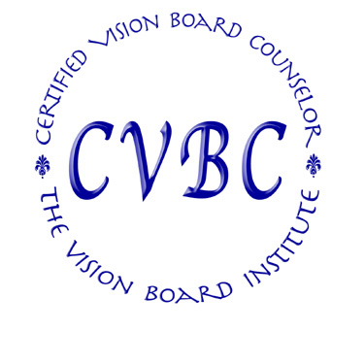

****** BeCOME the first certified vision board coUNSELORS in the world......

THE CVBC logo guarantees that your Vision Board Counselor is prepared by more than 50 hours of study and practice and is certified by THE VISION BOARD INSTITUTE.
______________________________________________________________________________
Do you qualify to be a certified Vision Board Counselor? READ NOW!

DISCOVER THE SECRETS TO:
• VISIONING YOUR LIFE
Find out how to earn $500 for just one workshop in ½ day or less
• Maximizing Profitability
Discover how to create your own products. Become a Certified Vision Board Counselor. Classes start THIS WEEK! YOU CAN AFFORD THIS payment plans available

Caption describing picture or graphic.

DO YOU QUALIFY to be a Certified Vision Board
Consultant? If you are passionate about personal development and have proven ability to speak publicly and conduct workshops; you may qualify to earn the accreditation CVBC (certified vision board counselor).
See the right column of this page for a preview of just a
few of the critical skills that you will gain during the 8 weeks.
NOTE THE FIRST CVBC WORKSHOP IS LIMITED TO ONLY 8
Counselors!

I eu feugiat nulla facilisis at vero eros et accumsan et iusto odio dignissim.

WHY BE CERTIFIED*** TURNKEY way to start or add to your own business.Classes are offered via teleclass weekly or home study. You can get more information by asking for an audio copy of an info call on becoming a Certified Vision Board Counselor or by talking directly with Joyce Schwarz by emailing her : thevisionboard @aol.com or call her directly at 310-822-3119 OFFERING THE ONLY CERTIFICATION worldwide for becoming a Vision Board Counselor

THE VISION BOARD INSTITUTE
Joyce Schwarz, Founder & Author
14004 Palawan Way,
Penthouse 6,
Marina Del Rey, CA 90293
310-822-3119, thevisionboard@aol.com
www.ihaveavision.org

