INTRODUCING MICHELLE HUDSON HALE WRITE-IN CANDIDATE PRESIDENT ELECTION 2020 DEMOCRATIC PARTY
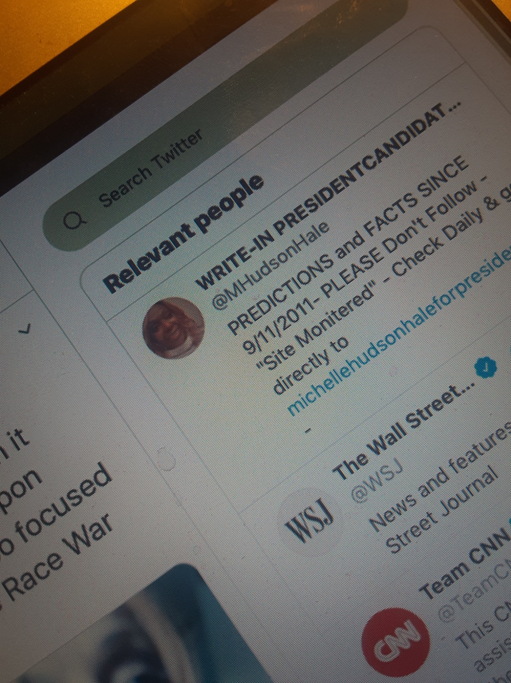

“The American People have had enough of Communism/Socialism types of Leadership” that means More of the:  Donald Trump: Rich/Poor Dictatorship Style  Or  Joe Biden/Barrack Obama: Complete Government Dictatorship  Now, It’s time to make “America, America Again” | INTRODUCING:  MICHELLE HUDSON HALE  2020 President Candidate  Write-In Candidate  Master's degree: Political Science A Political Analyst Associate  A WILMER HALE – AFFILIATE  Of Law Firm where Robert Muller Has Returned in Private Practice  Husband’s Grandfather // Co-Founder.  Website michellehudsonhaleforpresident.com  Email pr@michellehudsonhaleforpresident.com  Fax 954 844-77777  TIME IS RUNNING OUT!  WRITE-IN MY NAME ON BALLOTS FROM NOW TILL ELECTION  TO KEEP CONSTITUTIONAL AND DEMOCRATIC  RULE  Donation website  michellehudsonhaleforpresidesnt.com

Describe the areas in which you would like to improve during your administration, and how you can help in your planning for growth for the next four years.

Signature of Candidate*  *By signing this document you are assuring accuracy and truth. | Date
[Sign here in your handwriting]  MHH | [Date  6/27/2020

MORE INSTRUCTIONS:
Video Creation/Uploading: This is OPTIONAL – but highly recommended for many (unless you really don’t video well), especially if you are going out of the area. More and more out-of-area districts are requiring phone or in-person interviews; a video snippet of 5 minutes would be “just the thing” for them to say YES to you! Here are instructions for most of the likely formats you c/would use (Direct from CILT☺):

- Screencast-O-Matic (Easiest; Windows and Mac – recording and uploading)

Go to the website: https://screencast-o-matic.com
Click “Sign Up” to obtain a free account (videos can be up to 15 min)
Click the blue “Start Recording” button
It will prompt you to install the Screencast-O-Matic Screen Recorder
On the website, click “Launch Recorder”, then click “Allow” or “Open”, and it will open the Recorder app that you just installed (it usually will not launch if you just try to open the application – you must click the “Launch Recorder” button on the website)
In the Recorder, click the “Webcam” button – make sure that your webcam is positioned so it captures a good video of your head and shoulders
Click “Rec” to start your recording
Speak out your video and click the “Pause” button when it is complete (you can also pause and resume if you need to take a break)
Click “Done” and select “Upload to Screencast-O-Matic”
Once video uploads, copy the URL from your browser, and send that URL to the Office of Teacher Education, along with your Student Teaching Autobiography
Screencast-O-Matic has several good tutorials videos to describe this process, as well as other functions: http://help.screencast-o-matic.com

- YouTube (Common; Mac, Windows, and mobile devices - uploading)

Make a SEPARATE account that is NOT LINKED to your personal account or any
personal videos!!!
Create a YouTube Account:
•
How to setup a YouTube account: http://www.wikihow.com/Make-a-YouTube- Account
• Use this account for Student Teaching Autobiography and other professional uploads* ONLY!!
*you may choose to upload videos of you student teaching as long as students’ faces are not seen – see “Filming Policy” for this at that time
AFTER Recording Your Video:
- Make sure to publish it as “UNLISTED” in YouTube so it will only be viewed by those who have been given your specific link
- Copy & share the link in your Autobiography just to the left of your picture (where is says,
“To learn more about me…”
Recording OPTIONS:
Camera
(Windows 8 & 10 – recording)
Camera app is built in to PC computers that have Windows 8 or 10
Tutorial for using Camera app on Windows: https://youtu.be/7-aEKG_dEyg
Instructions for uploading a video to YouTube:
https://support.google.com/youtube/answer/57407?co=GENIE.Platform%3DDesktop&oco=1
Quicktime Player
(Mac OS – recording)
Quicktime Player is built in to Apple computers running Mac OS
Tutorial for using Quicktime player on Mac OS: https://youtu.be/lhkA1gYXJ9I
Instructions for uploading a video to YouTube:
https://support.google.com/youtube/answer/57407?co=GENIE.Platform%3DDesktop&oco=1
Photobooth
(Mac OS – recording)
Photobooth is built in to Apple computers running Mac OS
Tutorial for recording in Photobooth on Mac OS, and uploading video to YouTube:
https://youtu.be/ahD_9nWeyfU
*** The audio on his recording only comes out of the LEFT speaker when you are listening to the tutorial
Instructions for uploading a video to YouTube:
https://support.google.com/youtube/answer/57407?co=GENIE.Platform%3DDesktop&oco=1
Mobile Devices
(iOS, Android, or other mobile OS – recording)
Use the built-in camera on your iPhone, iPad, or other smartphone/mobile device to record your video – MAKE SURE TO STEADY your device so it is not shaky!
Tutorial for uploading to YouTube from iPhone: https://youtu.be/TJmvXujqHNE ***This tutorial is lengthy, but you can skip through it
Tutorial for uploading on YouTube’s Android app: https://youtu.be/NT5RYaP6HeI
Instructions for uploading a video to YouTube directly from the YouTube app on any device (computer, android, iOS):
https://support.google.com/youtube/answer/57407?co=GENIE.Platform%3DDesktop&oco=1

