Childress Ink LLC, Product Development, Children’s Publishing

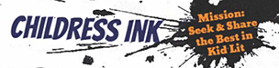

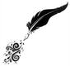
Kim Childress
Ink-A-Dink
Childress Ink
@KBChild
(Where it’s okay to be a child.)

February 2021

Kim Childress ̴ Childress Ink LLC ̴ 353 Green Ridge Dr. SE, Caledonia, MI 49316 ̴ 517.410.8747 ̴ kbchild@aol.com ̴ childressink.com

About Childress Ink LLC, Product Development, Children’s Publishing

As a product development company specializing in children’s literature—all ages, all genres—agenting fell into my lap, literally, partly due to my passion for helping other writers get published, but “Literary Agent” is only one role I fulfill as a Product Developer.

Founded in 2014 as a freelance editorial company, Childress Ink LLC has since helped publish 38 titles to outside recognition, awards and accolades, with two titles releasing in 2021.

Utilizing 30 years in publishing under many titles in the industry, I also serve as a PR company, branding and marketing specialist, speaker, reviewer, blogger, vlogger, with an employee-owned product development company and team of professionals vested in every project.

As a result, I have come to acquire a portfolio of projects, my own and those of clients whose work I find exceptional, with a queue of projects across all ages and genres, fiction and nonfiction.

A comprehensive current project and clientele list is available upon request.

Member:
- American Booksellers Association (ABA), Ink-A-Dink Children’s Bookstore
- Better Business Bureau (BBB): I believe in doing good business. I believe in helping local business, and especially businesses who also believe in doing good business, and I proudly support the BBB, a nonprofit, independently run association with a mission to promote companies small and large who practice good business.
- Small Business Association
- Women’s Small Business Association
- Caledonia and Jennison Chambers of Commerce

About Kim Childress: Thirty years in publishing, 28 specializing in children’s publishing, Girls’ Life Book Editor, previous Zondervan Middle Grade Acquisitions Editor (HarperCollins), Book Seller & lover of all things children’s books ~ with a personal focus group of four children.

And I aim to share books of excellence and get more books to as many children as possible!

ON EVERY PROJECT:
Authors are their own best PR Reps

- Partnering with authors and publishers to create quality children’s books and projects across all mediums
- Targeted marketing, individualized per product, with team guidance and direction from conceptualization through publication and lifetime sales
- Editing: All stages, all ages, all genres
- Branding: Creative social media campaigns from conceptualization
- Timely press releases, publisher approved, from contract and throughout
- Website creation with content creation and/or management, directing clients on every project, individualized for every project, with cross-promotion across all channels
  - Helping authors build personalized social media platforms while aiming for maximum SEO
- Ongoing development of social media platforms with booksellers, bloggers, school and library direct outreach
- Professional and creative marketing and PR campaigns and management, including endorsement campaigns, pre-book-buzz, early, multi-media, pre-release and launch campaigns, with ongoing direct outreach
- Heavy marketing and author promotion aimed at library, education and homeschool markets
- Full utilization of SCBWI tools including Book Page, Book Launch, Book Birthdays and listing in SCBWI bookstore
- Promotion on childressink.com while seeking partnerships and sponsors, such as Herizon Music, Dorktales, Broadway World, We Need Diverse Books, DORD Magazine, and more
- Extensive promotion on ChildressInk.com, including paid Facebook Boosts with simultaneous piggy-back-promotions across all social media platforms
- Targeted media outreach during strategic months before, during, & after book release including press releases, virtual “parties,” #BookBox Give-away’s & annual events
- Arrange and promote author events with schools, libraries, local and national festivals, and key annual events such as Krauss Memorial Library’s Reading Rocks in Rockford
- Attend key conferences, i.e. BookExpo, National Book Festival, ALA, MAME, SCBWI
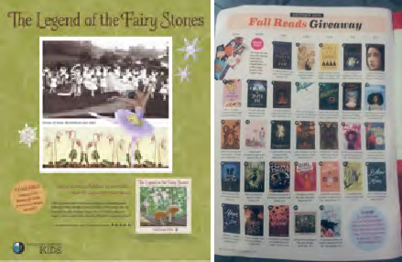
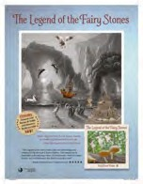
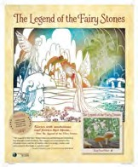
- FREE and reduced-priced promotions in Girls’ Life magazine and GirlsLife.com, Schoolhouse Magazine, and select others
PROVEN MARKETING RESULTS, CHILDRESS INK & TEAM
A sampling of reviews, endorsements and events around Find Your Future in Art and The Legend of the Fairy Stones, showing direct results of self-promotion and marketing efforts
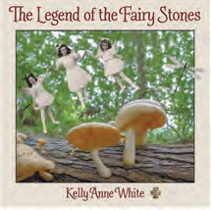
Girls’ Life “Books We’re Crushing On,” Feb/Mar 2021
Girls’ Life “Teen Read Week,” Oct/Nov. 2020
2020 VOWA Excellence in Craft Award Winner, Virginia Outdoor Writers Association
Barnes & Noble Bookseller Favorite Pick
Purple Dragonfly Book Award, Best Interior Design
Gale/Cengage Learning’s Book Review Index Children's Bookwatch
Midwest Book Reviews Readers’ Favorite Five-starred Review
Cool Book of the Week, JuliasBookbag.com
ALA Conference 2019 Combined Book Exhibit
BookExpo America 2019 New Title Showcase

The Legend of the Fairy Stones, written & illustrated by Kelly Anne White Traditionally published by Morgan James Kids, April 2019, ISBN-13: 9781642791969 (Hardcover), ISBN-13: 9781642791952 (Softcover) ASIN: B07P9C45VN (ebook), ISBN-13: 9781642791976 (Nook Book)

Midwest Book Review, May 2019 online book review, http://www.midwestbookreview.com; Vol. 19, Issue 5: A unique stand- alone picture book, "The Legend of the Fairy Stones" by Kelly Anne White shares the fictional legend of how real-life fairy stones were formed. Woodland lore has it that the cross-shaped stones came from the solidified tears of forest fairies the day they heard that Jesus died. "The Legend of the Fairy Stones" takes young readers ages 4-10 on an upbeat journey through a land filled with joyful fairies of all varieties before twisting and turning into a world of evils and ill wills combated by a sense of fearlessness found in the spirit of the fairy stones. It's been deemed that fairy stones repel witches, ghosts, goblins, ghouls, and all other types of ghastly fools. With its rhythmic text and classic fairy-tale style, "The Legend of the Fairy Stones" cleverly integrates fantastical folklore in a collage-style montage of amazing artwork from the public domain. These very real stone crosses, officially called Staurolite, form naturally through a geothermal process known as "cruciform penetration twinning". Alongside its elements of fantasy and whimsy, "The Legend of the Fairy Stones" remains grounded in educational content with back matter that focuses sharply on STEAM and Common Core Standards, making it an ideal and recommended addition to both community and elementary school library collections. It should be noted for parents that "The Legend of the Fairy Stones" is also available in a paperback edition (9781642791952, $11.95).
Additional endorsements and events around The Legend of the Fairy Stones can be found at kellyannewhite.com.

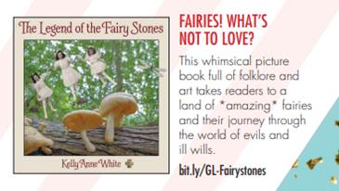
“Books We’re Crushing On” guide for your records, Feb/Mar 2021 Issue:
Brooke Winters, National Advertising Director, Girls’ Life magazine & Girlslife.com
Phone: 201-618-5013, Email: Brooke@Girlslife.com

Girls' Life Teen Read Week recap & winners, Oct/Nov 2020
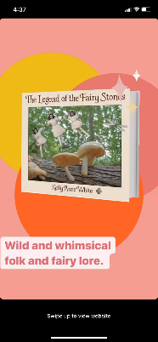
Hi Kim,
We’ve wrapped the Teen Read Week program and it was a huge success! The program received a total of 3.58M impressions and The Legend of the Fairy Stones received 1,208 entries into the giveaway! I’ve attached screenshots above… Thank you! -Brooke Winters, Girls’ Life

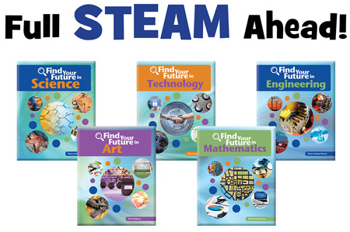

The Find Your Future Series

Helped conceptualize, edit and contribute to the first 19 titles in the Find Your Future series with Cherry Lake Publishing/Sleeping Bear Press

Featured Series for 2020 Take Our Daughters & Sons to Work Day, April 23, 2020 (#WorkplaceSuperstars)

LitPick.com feature and lesson plans, Find Your Future in Art, by Kim Childress, https://litpick.com/books/find-your-future-art, https://litpick.com/books/find-your-future-engineering

RECENTLY RELEASED
The B!ble Dare: TheBibleDare.org
TalkABook: Kim Childress, Presenter

RECENT PRESS RELEASES Childress Ink LLC
PR.com: Childress Ink

DORD Magazine Releases “xoxo” Issue; Grand Rapids Literary Magazine, Educating & De-Stigmatizing Mental Health Issues with Hope & Humor
DORD Magazine Releases February 2021 “xoxo” Issue, Mental-Health Based Literary Magazine, Educating & De-Stigmatizing with Hope & Humor, DORDMagazine.com
"The Stars in April" by Debut Author Peggy Wirgau; Featured Author for American Christian Fiction Writers (ACFW) February 2021 and ACFW April Book of the Month

"Where the Briars Sleep" Acquired by Tangled Tree Publishing, Debut Thriller & Chiller Releasing Worldwide July 2021
Tangled Tree Publishing Acquires Gothic, Victorian Ghost Story, "Where the Briars Sleep" - July 17, 2020
Local Author Shares Little-Known Tale of Michigan Teen Titanic Survivor Ruth Becker in "The Stars in April"
Fact-Based Historical Fiction on Teen Titanic Survivor Ruth Becker, "The Stars in April" Releases Worldwide in Spring 2021. - June 29, 2020
"The Stars in April" Acquired by Iron Stream Media
"The Stars in April" Releases Worldwide in Spring 2021. - April 12, 2020
Product Development Company in Children’s Publishing Childress Ink LLC Receives Media Attention, BBB Accreditation, & Adds Award-Winning Journalist to Team
Author, award-winning editor, longtime Girls’ Life reviewer, and children’s book product developer Kim Childress proudly announces Childress Ink LLC products’ recognition in the media, Better Business Bureau accreditation, and expansion of the Childress Ink product development team. Founder... - March 20, 2020
Michigan Author & Editor Produces New Picture Book Project, "The Legend of the Fairy Stones"
Local author, award-winning editor, reviewer, and product developer specializing in children’s publishing, Kim Childress celebrates the release of "The Legend of the Fairy Stones" from Morgan James Kids. “In two words, brilliantly rendered,” said Childress, long-time reviewer... - May 10, 2019

Reading Rocks in Rockford 2019
Author and award-winning editor Kim Childress joins Author Row for Reading Rocks in Rockford 2019, at the Krause Memorial Library in Rockford, MI, and she will be featuring The Legend of the Fairy Stones and other titles, with book-give-aways complements of Girls' Life Magazine and ChildressInk.com. - April 27, 2019
11th Annual Reading Rocks. Local Author, Award-Winning Editor & Reviewer Among Guests Slated for Annual Event.

KIM CHILDRESS Online
- ChildressInk.com: https://www.childressink.com, averaging 20K unique visitors annually from more than 40 countries, Currently getting a new professional built out, relaunch anticipated March 2021
- Eventbrite: https://www.eventbrite.com/o/childress-ink-llc-29943182259
- Ink−Α−Dink.com: soft launch, online children’s bookstore for “Kids of all ages and adults in their lives”, more information included below, member of The Book Sellers Association and Official Indie Bookstore, launch anticipate March 2021
- Twitter: 2187 followers, @kbchild, https://twitter.com/KBChild:
- LinkedIn: 3147 connections, https://www.linkedin.com/in/kim-childress
- Facebook Pages:
  - Personal: 2167 followers, https://www.facebook.com/kim.childress.395
  - ChildressInk Book Reviews: 821 followers, https://www.facebook.com/ChildressInk
  - Find Your Future in Art: 190 followers, https://www.facebook.com/KimChildress123
- Blog: One Writer’s Musings 2246 followers, https://www.onewritersmusing.com
- Instagram: 341 followers, https://www.youtube.com/user/KBChild
- Pinterest: https://www.pinterest.com/kbchild
- Goodreads: https://www.goodreads.com/user/show/4951900-kim-childress
- SCBWI: https://www.scbwi.org/members/kim-childress
- Reedsy: https://reedsy.com/kim-childress
- Snapchat: kbchild
- Tumblr: tumblr.com/settings/blog/childressink
- YouTube: https://www.youtube.com/user/KBChild
- Pr.com: business.pr.com/childressink

EDITORIAL AWARDS & HONORS
- 2019 Purple Dragonfly Book Award winner, The Legend of the Fairy Stones
- 2020 Winner VOWA Excellence in Writing, The Legend of the Fairy Stones
- 2014-2015, Agatha (Christie) finalists and recipient, Acquisitions and Developmental Editor, the Andi Unexpected series, Andi Unexpected and Andi Under Pressure, by Amanda Flower—a Barnes & Noble and USA Today Best-Selling author
- May 2019, Finalist, Agatha Best Ever Middle Grade Mystery Fiction ages 8-12, Acquisitions and Developmental Editor
- 2017 Christian Retailers Best Nonfiction Ages 8-12: Acquisitions Editor, 101 Ways to have Fun
- Editor of Code of Silence, by Tim Shoemaker, SLJ’s Top-Ten Mystery for Young Adults, 2012; starred Booklist review
- Acquired Kirk Cousin’s Game Changer in multi-CBA bid while at HarperCollins Christian Publishing (HCCP), Evangelical Christian Publishers Association (ECPA) Top-Ten best-seller 2013 and HCCP continued best-selling title

PRESENTATIONS & EVENTS Sampling:
- SCBWI IN Diversity Day, featured speaker and panelist member, “Publishing Trends” and “Diversity in Children’s Literature,” with authors Linda Sue Park, Natalie Davis Miller, and Lee and Low editor Kandace Coston, Sept. 12, 2020, online
- Everywhere Book Fest
- Children’s Book Week
- Take Your Daughters and Sons to Work Day #WorkplaceSuperstars Giveaway, April 23, 2020
- Storytelling Festival, Feb. 8, 2020, Kalamazoo Valley Museum
- Speaker, Great Lakes Regional ABA Heartland 2019 Fall Forum, American Booksellers Association, Oct. 3- 4, 2019, Renaissance Cleveland Hotel, 24 Public Square, Cleveland, OH
- Speaker, MAME 2020: Michigan Association for Media Professionals in Education, Oct. 9-11, Bay City, MI
- Baltimore Book Festival, Nov. 1-3, Baltimore, MD
- Reading Rocks in Rockford, featured author and vendor, June 3, 2020: 10 am-1 pm, Krause Memorial Library, Rockford, MI
- Aug. 3, 2019: Green Lake Art Fair, with Smoke on the Water BBQ, 8 am - 5 pm
- June 1, 2019: 10 am-1 pm, Reading Rocks in Rockford, featured author and vendor, Krause Memorial Library, Rockford, MI
- May 11, 2019 5 pm, Guest interviewee for author Vivienne Moore and her podcast
- Speaker listed in SCBWI-MI PAL Directory
- Additional current events through 2021 can be found on my childressink.com and LinkedIn

Childress Ink The Shop: Ink-A-Dink.com (currently in soft launch)
- Ink-A-Dink, Children’s Books and More for Kids of All Ages and Adults in Their Lives, CURRENTLY IN PROFESSIONAL DESIGN, Full Launch aiming for March 15, 2021
- Price match on Amazon on new releases, 20% off publisher price always, 25% off with Tax Exempt ID
- Partnering with worthy affiliates, including We Need Diverse Books, Multicultural Children’s Book Day, publishers, crafters, and homeschool sites such as Schoolhouse Magazine
Continuity Clubs:
- Find Your Future in Steam Five books, Find Your Future in Science, Technology, Engineering, Math, and Art, which I also authored, Cherry Lake/Sleeping Bear Press, 2016-2017
- A Girlz Life: Six books, by the editors of Faithgirlz! And Girls’ Life magazine, published by Zondervan, 2014-2017
- Create-Your-Own Continuity Club(s): Recommended series, fiction and non-fiction, all ages
