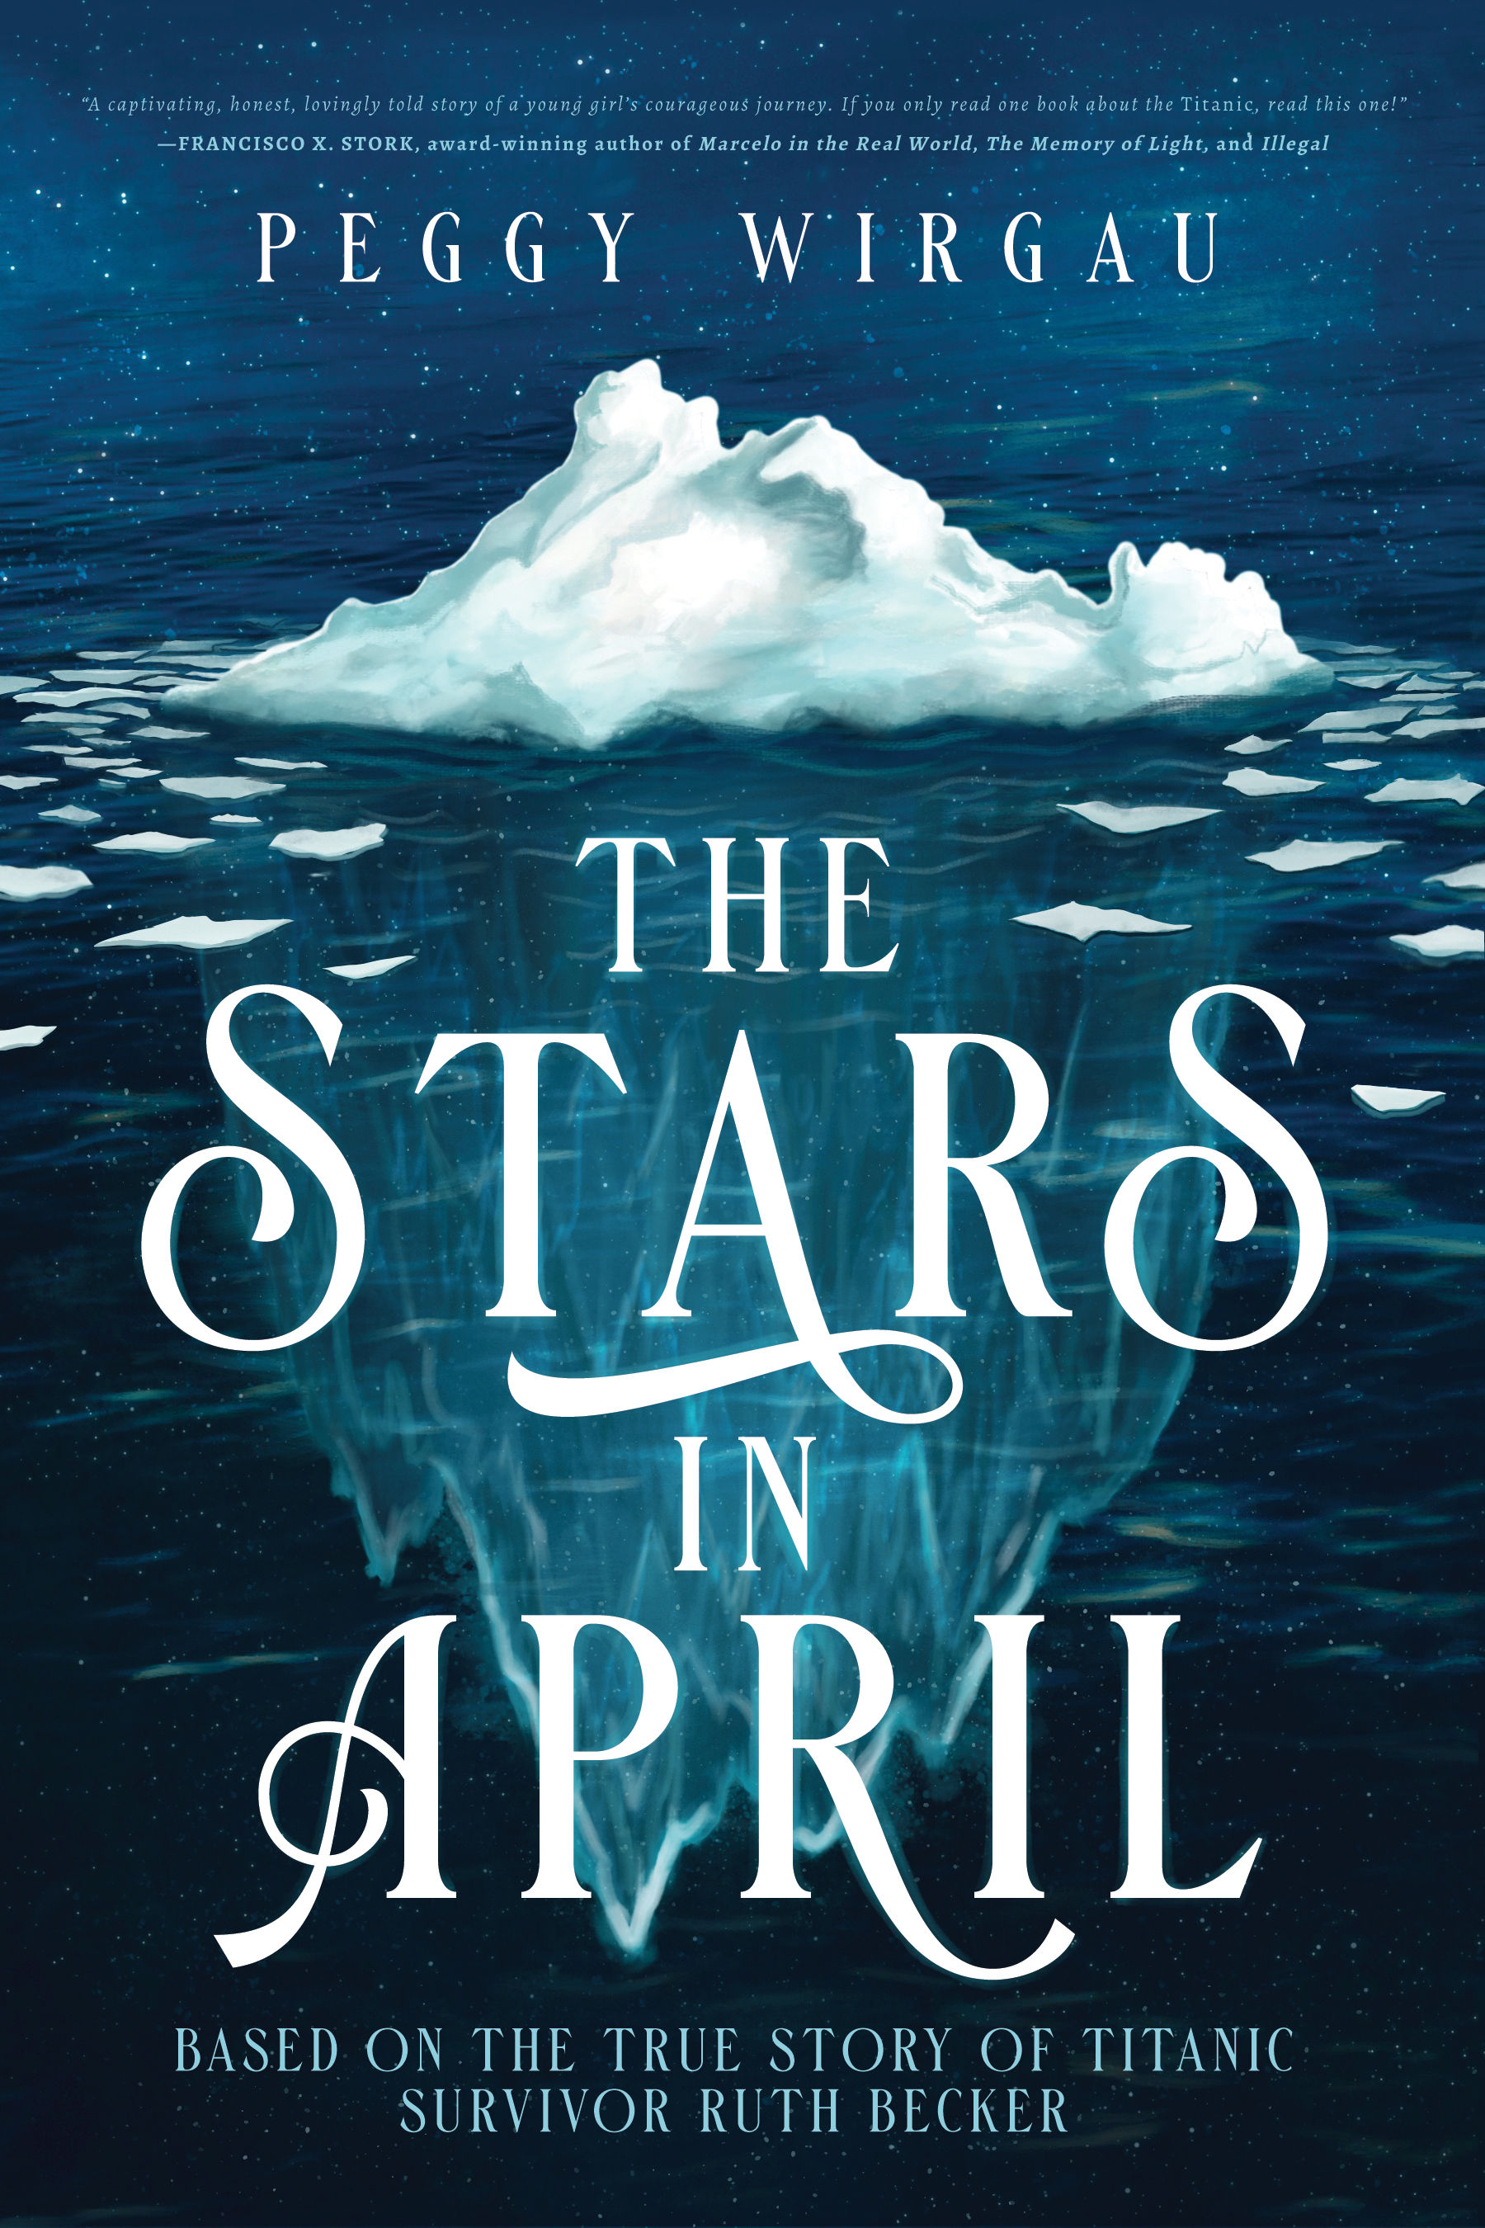

Midwest Book Review/Children’s Bookwatch: June 2021
"The Stars in April" by Peggy Wirgau is a deftly crafted novel that is based on the true story of twelve-year-old Titanic survivor Ruth Becker. A fully absorbing and memorable story, "The Stars in April" is especially and unreservedly recommended for middle school, high school, and community library YA Fiction collections for young readers ages 12-18. It should be noted for personal reading lists that "The Stars in April" is also readily available in a paperback edition (9781645263067, $14.99) and in a digital book format (Kindle, $3.99).”
Debut Novel "The Stars in April,” Based on Teen Titanic Survivor, Receives School Library Journal Starred Review

The Stars in April, by Peggy Wirgau, Illuminate YA Fiction. Mar. 2021. 248p. $24.99. ISBN 9781645263074.
Gr 5-8–Guntur, India, 1912: “Why do I have to leave?” asks angry 12-year-old Ruth Becker. Born and raised in India, Ruth is the oldest daughter of white American parents serving as orphanage directors. Her young brother needs medical treatment, so the Becker family (minus her father) travels to the United States to seek care. Ruth is sad to leave her beloved India and her best friend Sajni. She blames her mother, but especially her father. The weeks-long journey is by train, small steamer, and ultimately, the RMS Titanic. Told through Ruth’s journal entries and letters to Sajni, the story moves smoothly from depot to port cities along the way. Once aboard the opulent Titanic, Ruth and her family enjoy their position as second-class passengers. The trip allows Ruth to meet people from different socioeconomic classes and realize the difficulty of her parents’ decision to uproot their family. As the Titanic steams toward her doom, the first-person account lends tension to the impending disaster. On the tragic night of April 14th and 15th, Ruth becomes separated from her mother and siblings. Rescued by the Carpathia, Ruth cannot find her family among the survivors and fears the worst. Ruth learns how strong she is, how much her family loves her, and how thinking of others can help overcome tragedy. This is a well-researched and well-paced title. Back matter includes a bibliography, family photos of the Becker family, and additional information about the Titanic survivors.
VERDICT This historical novel moves quickly and shares a little slice of the ever-fascinating subject of the Titanic. A winner.
Reviewed by Lisa Crandall, formerly at the Capital Area Dist. Lib., Holt, MI , Mar 19, 2021

PRAISE FOR THE STARS IN APRIL

A captivating, honest, lovingly told story of a young girl’s courageous journey. If you only read one book about the Titanic, read this one!
~Francisco X. Stork, Award-winning author of many books for young adults, including his latest, Illegal

I feel as though I’m sitting in Ruth’s apartment (in Santa Barbara) and she is sharing her life story with me. This could very easily be a non-fiction account… so very well written…one can hardly stop reading.
~Floyd Andrick, Titanic Historical Society member, Personal friend of Ruth Becker

Reading The Stars in April was a bit like listening to a beautiful piece of music, filled with crescendos, dips, and breathtaking, melodic moments. From the first lovely chapter to the last, this beautifully written story draws you into Ruth’s journey and compels you to keep reading, page after wonderful page. … Highly recommended.
~Janice Thompson, Author of Queen of the Waves

A satisfying, well-written, fun-to-read book—though (of course) sad. The character of Ann, combined with Ruth’s beautiful dream, offer a way to help younger children grappling with the Titanic disaster.
~Julie Hedgepeth Williams, Author of A Rare Titanic Family, Winner of the 2014 Ella Dickey Award for Books that Preserve History

Peggy Wirgau has eloquently captured the story of twelve-year-old Ruth’s harrowing experience and tells it in an unforgettable way. Thanks to Peggy, Ruth Becker’s memory continues to survive. I felt as if I were experiencing it [the story] along with Ruth.
~Yvonne Lehman, Author of Hearts that Survive—A Novel of the Titanic, Why? Titanic Moments, and Personal Titanic Moments

I love how author Peggy Wirgau’s goal is to share stories of lesser-known strong girls and women from history, like Ruth Becker, the feisty heroine in The Stars in April. Besides the beautiful, prose-like writing, this book offers a new take on the Titanic disaster through the eyes of a teen survivor who helped others—even after being separated from her family. Especially love the side-theme on suffragettes—so important.
~Karen Bokram, Publisher, Girls’ Life Magazine

Twelve-year-old Ruth struggles to live up to her mother’s expectations as they leave their beloved missionary home in India and face the frightening unknown of a future in America in Peggy Wirgau’s engrossing debut novel, The Stars in April. Putting the needs of others before her own desires and trusting that the life she has is enough, Ruth learns, is not for the faint of heart. Based on the real-life adventures of Ruth Becker, a second-class passenger aboard the ill-fated Titanic, The Stars in April is a colorful portrait of 1912 life and the tragedy aboard Titanic as seen through the eyes of a talented girl with hopes and dreams of her own. Wirgau’s detailed historical research is spot-on in this compelling and heartwarming coming of age novel. I loved the exploration of stars and their constellations that connect Ruth with her absent father, and the informative guide to stargazing in the back of the book. For lovers of Titanic stories, young history buffs, middle school and homeschool students The Stars in April is a must read.
~Cathy Gohlke, Award-winning author of Promise Me This, William Henry is a Fine Name, and I Have Seen Him in the Watchfires

… It is difficult to leave this novel out of your hands for long, as it is a constantly moving scene as we travel every step with Ruth …. The Stars in April is a fitting title for this novel especially with so much star and constellation detail in Ruth’s regular Sky Reports throughout the novel. The sky at night was such a constant in Ruth’s travels, she felt it linked her to her “Papa” as they gazed on a shared sky from far differing locations. A wonderful read throughout concluding in rescue of the Becker family. So sad there was such great loss of life in the freezing North Atlantic of April 1912.
~Vincent McMahon, Historian, Titanic Experience Cobh Ltd., Cobh, Ireland

EVENTS AND HONORS
- Starred Review: School Library Journal The Stars in April (slj.com)
- Historical Novel Society North American Conference, June 2023
- Christian Indie Award Finalist, Spring 2023
- Book Signing and Facebook Live Author Event, Titanic Attraction Pigeon Forge, TN, June 2022
- Selah Award Finalist, Audiobook category, March 2022
- SCWC Notable Book Award, January 2022
- Literary Titan Book Award, December 2021
- School Presentations, Tallahassee, FL, November 2021 – February 2022
- Zoom Presentations, Titanic Book Club for Children and others, Oct. 2021 - present
- Longlist Finalist in Page Turner Awards, September 2021
- School Presentations, Birmingham and Southfield, MI, August 2021
- Featured Speaker at Annual Titanic Conference, TN, August 2021
- American Christian Fiction Writers Featured Author, February 2021
- Girls’ Life “Must-Read,” April/May 2021, “Beach Reads,” June/July 2021
- Featured in Florida Writers Book Expo, May 2021
- PODCAST “The Word with an Inquisitive Book Nerd,” April 2021, Baltimore Living Magazine.

NOTES AND UPDATES
- Audiobook available through Amazon Audible
- Official Book Trailer for The Stars in April
- Added to 6th grade curriculum at Our Shepherd Lutheran School, Birmingham MI
- Curriculum Guide for Educators available at https://peggywirgau.com.

MORE ABOUT THE AUTHOR
Peggy Wirgau lives in Delray Beach, Florida. She loves bringing history to life for readers and has written for Appleseeds, Insight, Learning Through History, and contributed to the anthology, Why? Titanic Moments. Her blog at www.peggywirgau.com features in-depth Titanic stories, and her followers include descendants of the ship’s real-life victims and survivors.
A graduate of Michigan State University and George Mason University, Peggy is an active member of American Christian Fiction Writers, Society of Children’s Book Writers and Illustrators, and Great Lakes Titanic Connection. She loves to travel, especially to New York City and Mackinac Island, Michigan, where she explores historical sites. Peggy is also a Registered Nurse. She and her husband have two adult children and a baby grandson.

Peggy Wirgau is available for speaking engagements and interviews.

For an author Q&A or press-related inquiries contact:
Kim McCulla, Kim.McCulla@IronStreamMedia.com.

DESCRIPTION
Based on the True Story of Twelve-Year-Old Titanic Survivor, Ruth Becker
"Sometimes we have to go a long way to find out who we are."
The year is 1912. When doctors in India are unable to treat her baby brother’s illness, Ruth’s missionary parents decide there is one solution: move her mother and the children across the world—to Michigan.
But India is the only home Ruth knows. In a matter of days, she must leave Papa and all she loves behind, abandon her dream of one day playing violin in the Calcutta Orchestra, and embark on a rollicking, four-week journey across the Arabian and Mediterranean Seas, followed by the voyage to New York aboard the luxurious, ill-fated RMS Titanic.
Ruth’s story is one of courage and self-sacrifice as she earns her sea legs and faces the unknown, culminating in a desperate, tragic night she will never forget.

To the author from personal friend of Ruth Becker
“I’ve read the book from cover to cover already…could not put it down…I cannot compliment you enough for all the detail that you have included…Such a great deal is as Ruth shared with me over the years. The Stars in April is such a wonderful tribute to Ruth…I bet she is smiling in gratitude.”

Excerpts from Q and A with author Peggy Wirgau

American Christian Fiction Writers Featured Author for February 2021

Interview by author Tara K. Ross

* * * * *
Peggy, can we start with your passion for the lives and history surrounding the RMS Titanic? What first drew you to learn about this moment in history?
I was curious about the Titanic for years, but my interest really began in 2012, which is the 100th anniversary year of the sinking, when I first read about Ruth Becker. As I learned her story and began researching in order to write the novel, my enthusiasm grew. I began a blog about various passengers and crew members, and that led me to correspond with a few of their relatives and others that were connected to the ship in some way. I was amazed to learn there is a huge network of Titanic fans, of all ages and nationalities, that share a love for the ship and the people who were onboard. It’s been a fascinating and rewarding journey.
At what point did this knowledge transform into a retelling within a fictional story?
When I read about Ruth and her family, I was first intrigued because her parents came from my home state of Michigan and were traveling there from India. But when I learned that Ruth was separated from her family during the sinking of the Titanic, yet managed to help other passengers in her lifeboat, it raised so many questions! What twelve-year-old girl, in a boat full of strangers, would be able to act so heroically? What was she like? How did she feel about leaving her home in India? And what may have happened on her journey that gave her that kind of courage? That’s when I began to envision a story that might answer some of those questions yet remain true to what we do know about her and the Titanic.
What was the most challenging aspect of writing The Stars in April?
It’s hard to pick only one, but even with all the research and a good story line, the constant challenge was how to infuse it with life. I wanted to make readers feel what Ruth felt—not only what was in her heart, but the physical things like the stifling train ride and the rocking, creaking voyage across the Arabian Sea. I wanted them to smell the food, see the stars, hear the music, and explore the Titanic with Ruth. I read many accounts of the sinking, hoping to grasp the enormity and horror of it so I could give a sense of what it really was like. I hope and pray I came close.
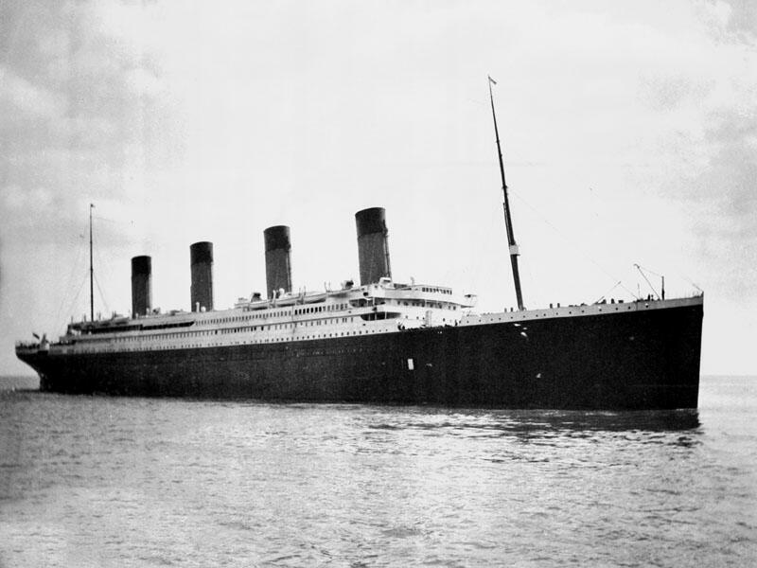

Book Title: The Stars in April by Peggy Wirgau
https://www.peggywirgau.com.

IlluminateYA Fiction/Iron Stream Media

ISBN: 9781645263074 (Hardcover)

ISBN: 9781645263067 (Softcover)

Kim.McCulla@IronStreamMedia.com

