Title: Is a Big Forehead a Receding Hairline?

Meta Description: Consult Dr. Resul Yaman Hair Clinic to fix your big forehead vs receding hairline and achieve a natural, improved look.

Keywords: Receding hairline, big forehead, bad hairline, Turkey hair transplant before and after, DHI hair transplant Turkey, hair transplant Istanbul, male pattern baldness, over-harvesting

# Is a Big Forehead a Receding Hairline?

During early adulthood, particularly among men, hair loss is a major concern. Most individuals are usually confused about their problem being a receding hairline or them having a big forehead. As men grow older, their scalp border matures and recedes, hence the question: Is this a natural matured scalp border or actual hairline receding?

It's well-known nowadays that hair loss is more prevalent among those under high stress, older men, and generally in those who are genetically predisposed. Most men experience hair loss that is either slight or moderate. And some begin to notice signs as early as their twenties.

Some of the causes of hair loss include lifestyle and health issues, heredity, age, hormonal changes, and medical conditions. In some cases, the issue may not actually be a bad hairline. And, some people have a high hairline due to their genetic.

If you are trying to determine whether you are facing a receding hairline or naturally possess a high forehead, this article explains how to tell the difference.

## Understanding the Big Forehead

We commonly say that a high hairline male has a large forehead. However, for a person with a high forehead, the hair follicles are just located higher on the scalp than on a person with a more typical forehead. A high forehead does not, therefore, always imply hair loss.

So, is it a hairline receding or just a high forehead? A person with a big forehead, who doesn't have that other areas of their scalp are thinning or balding, probably doesn't have a hairline receding. However, if someone with a high forehead notices thinning or hair loss in other areas of the scalp, this could be a sign of hairline recession and potentially indicate an issue with alopecia.

In general, having a high forehead is a genetic trait. If someone with a long forehead looks at the foreheads of their family members, they'll likely see similarities. Before panicking about hairline recession, it's worth considering whether you have an immature line or simply a naturally high hair line. This is a common condition and can easily be mistaken for regression.

As **Dr. Resul Yaman Hair Clinic** Turkey, we continue to explore the question: Does a big forehead mean a receding hairline?

## Big Forehead vs. Receding Hairline

A hairline receding and a high forehead are quite different conditions. Someone experiencing a regression is likely to face more advanced hair thinning and loss over time. Hair thinning usually starts at the temples and slowly advances towards the forehead and crown. As a result, issues like bad hairline or a widow's peak, which can lower your confidence and lead to low self-esteem.

Besides, the receding hairline is more common in men than in women, and it mainly occurs because of male pattern baldness, which is a genetic problem and can cause varied patterns of hair loss. Initially, the individual may notice a distinct M or V shape forming as the hair line recedes.

So, this is usually followed by thinning at the vertex of the scalp. In cases of severe hair loss, the hairline can eventually merge with the thinning area at the vertex, resulting in hair remaining only on the sides and back of the scalp.

## How do I Fix My Big Forehead Hairline?

Turkey is one of the leading countries in the field of hair transplant with its reputable hair clinics and professional hair surgeons. You are really going to get the most natural and fitting hair line with DHI hair transplant in Turkey.

Dr. Resul Yaman Hair Clinic, a state-of-the-art, hygienic clinic located in Istanbul, can help correct your receding hairline. As an experienced and reputable doctor, Dr. Resul Yaman redefines your bad hairline and successfully performs treatments using manual FUE and manual **DHI hair transplant Turkey** techniques.

You can assess Dr. Resul Yaman’s planning and outcomes for fixing a bad hairline, by reviewing the **Turkey hair transplant before and after** images and videos.

### Designing a Big Forehead Men Hairline

As men age, it's common for them to experience hair loss at the sides of their foreheads, particularly in the upsides and temples regions, causing the forehead to appear wider. If you wish to reduce a high forehead, it may be necessary to address the sides to maintain facial proportions.

Dr. Resul Yaman personally performs hairline transplantation and focuses on a few key aspects during the DHI hair transplant process in Turkey:

* In some individuals, the V-shape in the temples can flatten out over time. Dr. Yaman reconstructs this V-shape by implanting grafts in the corners, effectively reducing the width of a big forehead from the sides.
* When correcting a bad hairline, Dr. Yaman uses single grafts for the temples and the front. It’s essential to create micro-irregularities in both the frontal and temple areas. With single grafts, Dr. Yaman achieves a very natural appearance in the temples and forehead.
* With a blend of scientific precision and artistic touch, Dr. Yaman eliminates the gaps in the temples and the front part of the forehead by carefully angling the hair follicles.
* When designing a hairline, Dr. Yaman tailors a plan that suits each individual patient.

In conclusion, a professional hair surgeon should address a bad hairline from both angles to achieve a balanced and natural look. And, you can get more information by checking **big forehead hairline reddit**.

### Optimizing Hair Transplant Results with Fewer Grafts at the Temples

This planning allows the temple area to look natural, while covering the open space with fewer grafts. A skilled hair surgeon should prevent adverse outcomes like over-harvesting when collecting hair follicles from the donor site. **Dr. Resul Yaman** can cover the openness in the temples with fewer grafts while fixing a bad hairline.

This ensures that too many grafts are not extracted from the donor area, making the procedure more cost-effective for the patient. Since the doctor works carefully and meticulously during the hair transplant Istanbul procedure, the results obtained by the patients are satisfactory.

### Identifying Hairline Issues: Big Forehead vs. Receding Hairline

In this article, we have explained the difference between a big fore head and a hairline receding. If you genetically have a high forehead and there is no hair loss on any part of your scalp, this is not a bad hairline.

However, if your hair line is gradually receding and you’re experiencing hair loss in other areas of your scalp, then this is a bad hairline, and you’re slowly progressing towards baldness. You can consult **Dr. Resul Yaman Hair Clinic** if you wish to fix your big forehead due to a receding hairline.





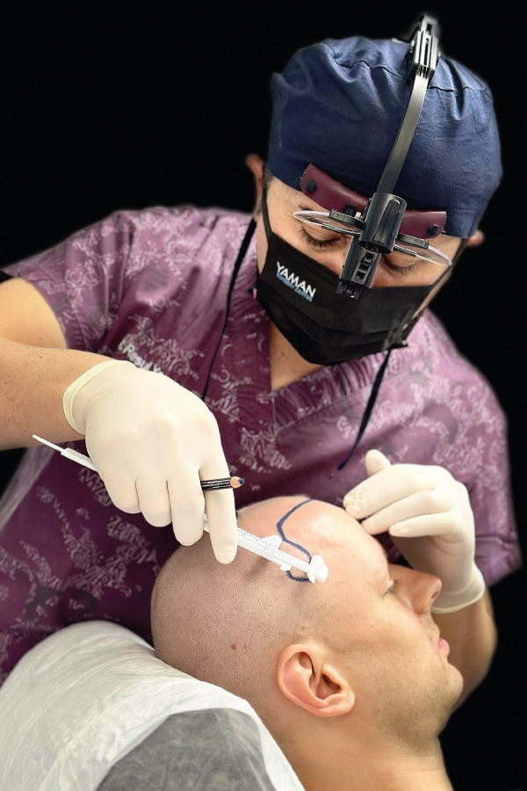One of the most common misconceptions I hear relating to hair loss is people mistaking a big forehead or a high hairline for a receding hairline. It’s incredibly important to understand the difference as it means two completely different things! In this article, I look at the bad hairline vs big forehead men debate, explain both phenomena, and what each means for your long-term follicles growth.

[vc_custom_heading text="Free Consultation" font_container="tag:p|font_size:36|text_align:center|color:%23da0067" google_fonts="font_family:Alegreya%20Sans%3A100%2C100italic%2C300%2C300italic%2Cregular%2Citalic%2C500%2C500italic%2C700%2C700italic%2C800%2C800italic%2C900%2C900italic|font_style:700%20bold%20regular%3A700%3Anormal" css_animation="fadeIn" link="url:https%3A%2F%2Fresulyaman.com%2Ffree-consultation%2F|title:Free%20Consultation"]

## Understanding the Large Forehead

Many people may think that they have a hairline regression edge and are succumbing to alopecia when in fact, they simply have a big forehead or a high hair boundary, or indeed a matured scalp border. These are common occurrences and should not be confused with a receding hair boundary.

### What Constitutes a Large Forehead?

A [large forehead](https://resulyaman.com/impeccable-solution-dhi-hair-transplant-for-natural-looking-hairlines/) or high hairline is simply when your follicles sit higher on the top of your scalp. It’s not always a sign of thinning and the main difference is that if you just have a long forehead, you shouldn’t notice any thinning or balding in other parts of your coif.

If you think that you have a high forehead, but you notice your hair thinning on the top of your head, this could actually be a sign of a receding hairline and an alopecia condition.

### Genetics and Big Foreheads

Generally, high hairlines and long foreheads are genetic and they are just a part of your genetic makeup. Here’s a simple tip - just go and look at your parent's and siblings' coif! Regardless of [hair color](https://medlineplus.gov/genetics/understanding/traits/haircolor/) and styling, you should be able to see similarities between your scalp border and thickness.

For example, my dad, and brother have a higher V-shaped forehead edge and I can just tell that my tresses are shaping in the same way as them both! So, a long forehead is oftentimes just the way you were made and your genetic disposition!

### https://resulyaman.com/wp-content/uploads/2023/10/bigforhad4-200x300.jpgHairstyles for High Foreheads

If you are conscious of your forehead and want to conceal it or minimize its size you can wear your coif in a range of different styles including:

* Side-swept fringe
* Choppy front fringe
* Curly fringe

Letting your fringe grow is a great way to disguise a high hairline but that doesn't mean all your tresses have to be long. You can have a fade, or [shave](https://resulyaman.com/can-you-shave-your-head-after-hair-transplant/) the sides, or even have a flick-back style that makes your coif taller to offset your forehead.

## Understanding the Frontal Hair Loss

Compared to a big forehead, a bad hairline is something quite different and is often a pointer towards a potentially larger looming thinning problem.

### Definition of a Receding Hairline

A [bad hairline](https://ishrs.org/noticeable-hair-transplants-are-never-in-fashion-so-why-are-they-making-a-comeback/) is when your follicles start to thin or fall out on your scalp - mainly at the front and top of your scalp from your temples. You may notice that you have developed a V-shaped scalp border with “indents” forming where your follicles are receding.

### Causes of a Bad Hairline

Bad hairlines are usually genetic and a result of different types of hair loss. They are more common in men and the most common cause is male pattern baldness.

This starts with a hairline regression where you develop a noticeable V or M shape on your forehead. After this, you may also notice thinning and a loss of follicles on the top of your head. Over time, depending on the severity of your baldness, the thinning area on top and your hair boundary may join leaving tresses only on the back and sides of your scalp.

Other causes of receding hair boundary include frontal fibrosing alopecia and traction alopecia.

## https://resulyaman.com/wp-content/uploads/2023/10/bigforhad2-300x300.jpg

### Coping With a Receding Hairline

There are many ways you can cope with a bad hairline and it is reversible with transplantation procedures like FUE and DHI. A [hair transplant clinic in Turkey](https://resulyaman.com/), for example, could devise a treatment for you where grafts are taken from the back of your scalp and implanted to redefine your hair margin and combat alopecia.

Aside from surgery procedures, you can also wear your tresses differently, and treat your coif carefully to minimize thinning and damage. For example, using a wide-toothed comb with gentle brushing is advisable, as is avoiding things like smoking and too much direct sunlight exposure.

## A Big Forehead or High Hairline Doesn’t Mean Hairloss

I hope you now have a clear idea of the receding hairline vs big forehead argument. As you can see, you may have mistaken your high hair margin for alopecia or a hairline regression but oftentimes this isn’t the case.

With bad hairlines, you often notice hair loss and thinning in other areas of your scalp too as it’s the genetic condition of male pattern baldness. If you are unsure, I advise seeking the help of a qualified hair transplant surgeon who can give you a consultation and a clear analysis of your follicles.

### Big Forehead vs. Receding Hairline: What is the Difference?Dr. Resul Yaman Holistic Approach in Hairline Planning

Dr Resul Yaman takes a holistic approach when performing [**DHI hair transplant**](https://resulyaman.com/dhi-hair-transplant/)for bad hairline. Already a professional specialist physician should consider the scalp border at the temples when planning restoration to the forehead line of his patient.

Dr. Yaman creates a small triangle from the temples of the patient for a perfect scalp border. Thus, the temple area of the patient is covered by using less grafts.

If the big forehead is caused by scalp thinning, planning the surgery procedure along the entire bad hairline, including the temples, ensures the healthiest result.