Bchex Company Fact Sheet
Company Name:
Bchex (formerly Background Investigation Bureau)
Founded:
1995
Headquarters:
Huntersville, North Carolina, USA
Founder & CEO:
Ken Monroe
Website:
www.bchex.io

Company Overview
Bchex is a national provider of background screening and safety technology that helps organizations build safer teams, workplaces, and communities. Since 1995, Bchex has combined advanced automation, smart workflows, and experienced screening professionals to deliver fast, accurate, and compliant background checks.
The company serves organizations across education, healthcare, nonprofit, corporate, and government sectors, helping them make informed hiring and risk management decisions.

Key Products & Platforms
Bchex
Comprehensive background screening services designed to deliver accurate results with industry-leading turnaround times.
ChexPass
Visitor management software that helps schools and organizations track, screen, and manage visitors entering their facilities.
Chex365
Continuous criminal monitoring platform that alerts organizations when new criminal activity is detected after an initial background check.
SecureVolunteer (Upcoming)
A volunteer management and screening platform designed for organizations that depend on trusted volunteers.
Insight+ (Upcoming)
Adjudication support technology designed to assist organizations with screening review and decision workflows.

Education & Media
Screening Hero Masterclass
A SHRM-certified training program that teaches HR professionals and administrators practical background screening strategies, compliance guidance, and fraud prevention best practices.
The Bad Hire Podcast
A podcast exploring real-world hiring mistakes and lessons learned, helping organizations understand the importance of thorough screening.

Key Differentiators
- Average background check turnaround times often under 15 hours
- National screening capabilities
- Advanced automation and AI-supported workflows
- Focus on both speed and accuracy
- Solutions designed for organizations that prioritize safety and compliance

Industries Served
- K–12 Education
- Higher Education
- Healthcare
- Nonprofit Organizations
- Religious Organizations
- Government Agencies
- Youth & Recreation Programs
- Corporate & Enterprise Businesses
- Small Businesses

Mission
Bchex is committed to helping organizations make confident hiring decisions and create safer environments through modern screening technology and responsible risk management.

Media Contact
Nathan Wright
Director of Growth Marketing
Bchex
877-439-3900
info@bchex.io

Logos

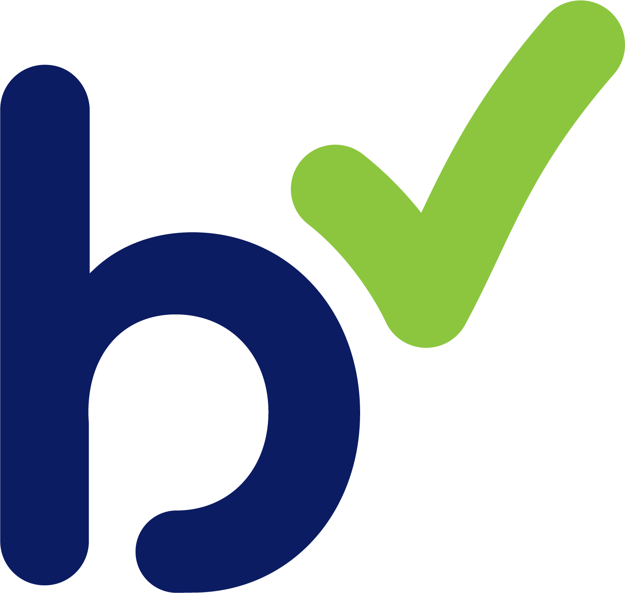


Product Images

