*NEW* Yoga Stick-e ® Towel ... For a Clean Grip!
The original Yoga Stick-e ® Towel provides a non-slip, sweat-absorbing, super soft barrier for all of your exercise needs! The back of the towel has two stick-e® panels to prevent the towel from slipping during exercise. It is portable and machine washable! MSRP: $29.95
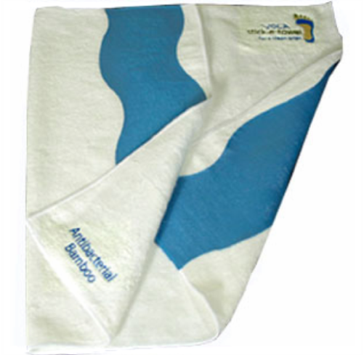
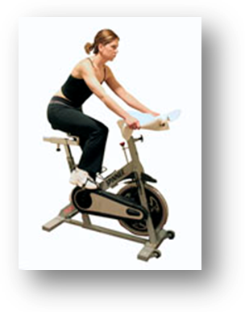

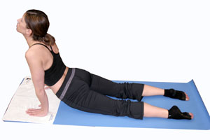

*NEW* Yoga Stick-e ® Gloves… For a Secure Grip! absorbs sweat, provides a stick-e® grip and hygienic protection from mats and equipment. No longer will sweaty hands prevent you from holding that pose! MSRP: $17.95
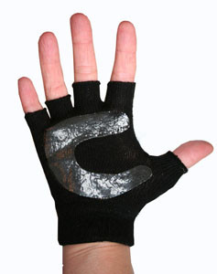
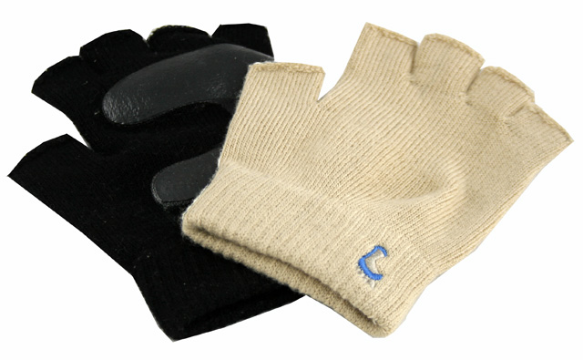
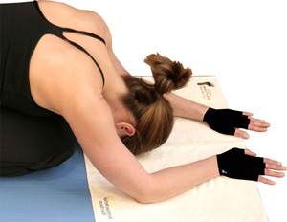

*NEW* Yoga Stick-e® Mat… The Original! The mat is black on one side and blue on the other with center lines in the opposite color on each side. It is the only Yoga mat with an attachable/detachable shoulder strap that can be used to hang the mat to air dry or hang in the shower to wash down the mat. The strap can also be used as a yoga strap in class! MSRP: $49.00
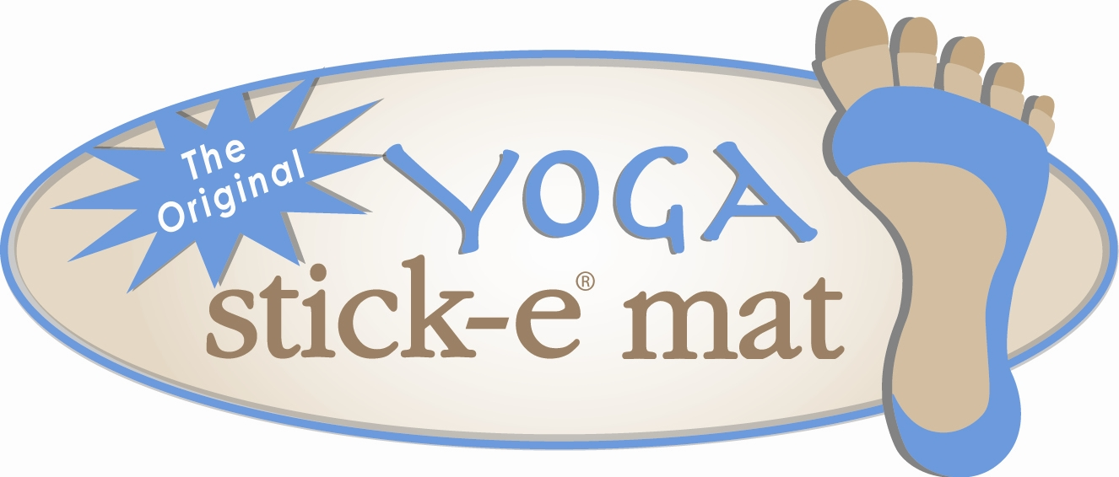
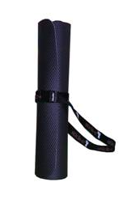
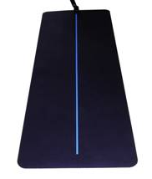
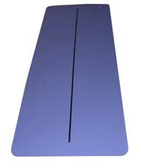

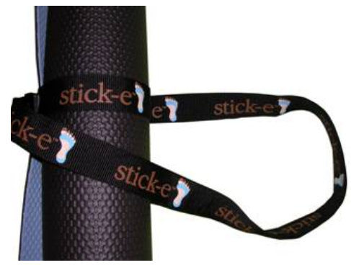

*NEW* Hot & Stick-e® Hip Hop Yoga workout DVD utilizing Yoga Stick-e® Socks. This workout begins with a Yoga warm up, then moves into an invigorating, Heart Pumping, Bootie Shaking, Fat Burning Hip Hop dance routine and concludes with a Yoga cool down. MSRP: $19.95
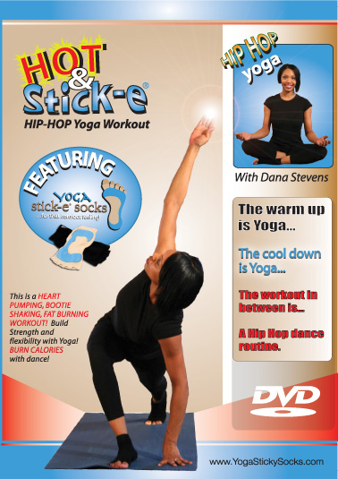
With Dana Stevens…. Hip Hop choreographer and dancer for the stars!
For more Information contact:
Libby Andrews
Owner and Inventor of the original
Yoga Stick-e ® Socks … For that Barefoot Feeling!
www.YogaStickySocks.com
phone: 708-369-5775
fax: 708-206-9992
email: Libby@Stick-e.com

