Operation Life Transformed  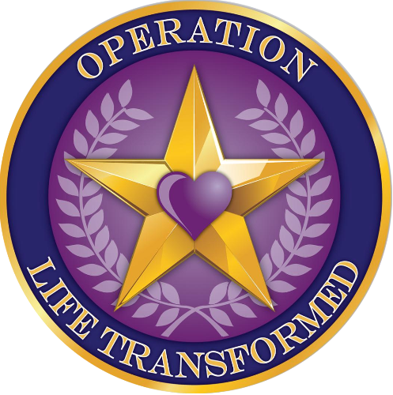 | 11758 Gailemont Court  Woodbridge, VA 22192
Press Release
Media Contacts:  Operation Life Transformed:  Jay Brethen + 1 619-884-0518  Kristina Saul +1 770-445-5286 | FOR IMMEDIATE RELEASE  9 A.M. EDT, August 10, 2009
operation life transformed celebrates culmination of 7-week ride across America
Jeannie benton to arrive in rye, nh with 50 other cyclists in final stop of america by bicycle trek;
Signature fundraising to support military families

Portsmouth, nh August 10, 2009 - Operation Life Transformed (OLT), 501(c)3 non-profit organization dedicated to supporting active duty military spouses to include the guard and reserve as well as care-givers of our wounded soldiers, today announced that it is celebrating the completion of its 2009 fundraiser, Ride Across America. Dedicating her journey to the non-profit OLT, Jeannie Benton along with 50 other cyclists, spent the last 7-weeks cycling across the United States. Beginning in Astoria, Oregon, on June 21st the America By Bicycle group cycled across 10 states arriving home in Rye, New Hampshire today.

“OLT renews hope for these families through training for employment, accredited virtual and flexible educational opportunities, and by assisting them with job placement. In many ways, these are our silent heroes in our military,” said Jeannie Benton. “Our men and women put their life on the line to protect our freedom in America. It is my privilege to partner with this non-profit to give back and protect their families.”

This year’s event is expected to attract many local supporters and military personnel. Officers and sailors from Portsmouth Naval Shipyard will be present during the events as the riders, and officials unite toward reaching their goal of raising funds and awareness for the needs of families of service men and women. Operation Life Transformed is in the midst of its second year in operation and is embolden to increase its efforts due to the outpouring of support it has received for its initiatives.

“The emotional toll that the conflict and the deployments have on families drives our mission to offer support and services to this often forgotten segment of our communities”, commented Steve Dunkle, Vice Chair Select, Operation Life Transformed. “Recent estimates tell us that there are over 500,000 pre-school children of active military members. We feel there is a way to help alleviate the stress of deployment by helping our military’s families and we are taking all the steps necessary to help in this important cause.”
The welcoming ceremony will begin at 12 p.m. ET at Wallis Sands Beach in Rye, New Hampshire.
About Operation Life Transformed
Operation Life Transformed (OLT) is a 501(c)3 non-profit organization dedicated to supporting the active duty military spouses to include the guard and reserve and of those deployed as well as care-givers of our wounded soldiers. The organization’s mission is to provide education and resources to military families and increase awareness of their long-term needs as they re-enter the workforce. Founded in March 2007, in August 2007 OLT was the only military spouse, war wounded caregiver program awarded the "Fisher House Newman’s Own award".

Learn More: http://www.operationlifetransformed.org/ra.html
Relive Jeannie’s ride: http://twitter.com/LifeTransformed or on her Blog at http://olt09.wordpress.com/

-End-

