ANNOUNCING THE ECO FRIENDLY EXPO 2010

BRINGING GREEN TO A GRAND NEW LEVEL!

New York, April 2010 – The Eco Friendly Expo in partnership with 7W New York, will be held May 25th-27th in the heart of New York City at the prestigious 7 W NEW YORK, a state of the art venue in the heart of Manhattan, across form the Empire State Building. A Boutique style setting, showcasing the best in high-end design, architecture, transportation, travel, art and fashion, the Eco Friendly Expo 2010 is devoted to bringing green to a grand new level.
This upscale, cross-industry trade show is a high-end marketplace that will attract both public and private sector buyers in the Tri-state area. The show will also feature THE POWER OF GREEN LECTURE SERIES, including Julián Zugazagoitia, director of el Museo del Barrio, Ben Jervey, author of The Big Green Apple, Robert Ferry and Elizabeth Monoian from the Land Art Generator Initiative, and members of The Bloomberg Administration. The Expo is geared to create partnerships for environmental projects, business and education while featuring unique eco friendly products and services available. It will provide a showcase for investment opportunities while stimulating environmental exposure by promoting the value of Green thinking in all aspects of our lives. The Expo will highlight New York’s environmental leadership and its commitment to the Global Community by supporting industries of the future and the US economy.
Visuals designed by PINK INC. using fabric structures as a smart choice of ECO décor. The structures are reusable and recyclable.
Over 10,000+ people are expected at this inaugural event including eco enthusiasts, architects, interior designers, store buyers, affluent homeowners, trade professionals, as well as TV and Print media from around the Tri-State area. The first 2 days will be B2B and the last day will be open to the general public as well. Media partners include CNN, The Architects Newspaper, Organic & Wellness News, Green Drinks NY and Art Nexus.
The Eco Friendly Expo was co-founded by New York City based entrepreneurs concerned about the environment: Angela Royo, Miriam Rebling-Suarez and Mariu Tovar all recognize the need for businesses to showcase their eco-friendly products and services and are committed to showcasing the best in eco friendly design, architecture, products and services in a chic and fashion-forward way. “We are committed to making 2010’s Expo as sustainable as possible. We have chosen to work with www.Carbonfund.org to reduce our carbon footprint to zero by investing in their third-party certified Renewable Energy and Methane Projects. For every paid visitor to this year’s Expo, we are donating $1 to fund projects like the New York State Landfill Methane Project. Based out of upstate New York, this project destroys methane, a potent greenhouse gas 23 times worse than carbon dioxide,” says Royo.
Tickets can be purchased online at www.ecofriendlyexpo.com, or at the door. Payments can be made by VISA/ MC, or check.
Please contact us via email at press@ecofriendlyexpo.com or via phone at (646) 649-5289 for any additional information, to arrange tickets to the event, or set up an interview with the founders.
Eco Friendly Expo, LLC
May 25th-27th 2010
7 W NEW YORK
7 West 34th Street, between 5th & 6th Avenue
New York, NY 10001

Tuesday, May 25, 2010 4:00 pm – 8:00 pm
Press Cocktail and Opening Networking event. Exhibitors open
Wednesday, May 26, 2010 9:00 am - 5:00 pm
Exhibitors open. Lecture Series Part I
Thursday, May 27, 2010 9:00 am – 5:00 pm
Exhibitors open. Lecture Series Part II
$10 pre registration at www.ecofriendlyexpo.com
$15 at the door
Free for Press and Trade, with Business Credentials

Participants include
Cosmos Communications www.cosmoscommunications.com
Cosmos has been FSC-certified since 2007 - one of the earliest printers to pursue this "green" initiative. Cosmos is meeting the highest environmental standards by using paper made from well-managed forests and following a strict "chain-of-custody" in our production workflow. Cosmos also uses soy inks and focuses on a "best practices" approach to sustainability. Our Connecticut facility currently receives 50% of its power from non-carbon emitting sources including wind and solar energy.

EL Museo Del Barrio www.elmuseo.org
El Museo del Barrio, New York's leading Latino cultural institution, welcomes visitors of all backgrounds to discover the artistic and cultural landscape of the Caribbean and Latin America. A dynamic artistic, cultural, and community gathering place, El Museo is a center of cultural pride on New York's museum mile.

Leon Tovar Projects www.leontovargallery.com
includes a sculpture by American sculptor John Angus Chamberlain (born April 16, 1927) best known for creating sculptures from old automobiles. Since the 1950s, Chamberlain has worked with crushed steel and other such materials to create his sculptures. His works have been exhibited around the world and have been included in the São Paulo Art Biennial (1961, 1994), the Venice Biennale (1964), the Whitney Biennial (1973, 1987) and Documenta, Kassel, Germany (1982) and he has had over 100 solo shows, traveling exhibitions, and retrospectives. ^{[2}
The Land Art Generator Initiative www.landartgenerator.org
The goal of the Land Art Generator Initiative (LAGI) is to design and construct Land Art / Environmental Art installations that have the added benefit of large scale clean energy generation. Each sculpture will continuously distribute clean energy into the electrical grid with each land art sculpture having the potential to provide power to thousands of homes.
Boris Bally’s Transit Chairs www.borisbally.com
Boris Bally’s award-winning work is both witty and innovative employing the use of jeweler’s skills on non-precious materials. His current body of work transforms recycled street signs, weapon parts, and a wide variety of found materials into objects for reflection. These pieces celebrate raw American street-aesthetic in the form of objects, often useful, for the home and the body.
Siw Thai Silk, Inc. www.siwthaisilk.com
Works with village artisans in Thailand to design and manufacture an elegant, eco-friendly line of handcrafted home and personal accessories by blending our modern aesthetic with time-honored weaving techniques, following fair trade practices.
Kholer www.us.kohler.com
Committed to a philosophy of environmental, social and economic responsibility in which all three elements work together and benefit one another. To help us achieve our goals, we've focused on three strategies.
Decorazon Gallery www.decorazongallery.com
Dallas based Gallery, featuring contemporary artists work. Committed to highlighting the environmentally friendly aspects of art, and green artists.

Tickets can be purchased online at www.ecofriendlyexpo.com, or at the door.
Payments can be made by VISA/ MC, or check.
Preview cocktail: On line $10 pre registered $15 at the door
Daily Pass: On line $10 pre registered, $15 at the door
Trade Pass: Free with on line Pre registration and valid credentials

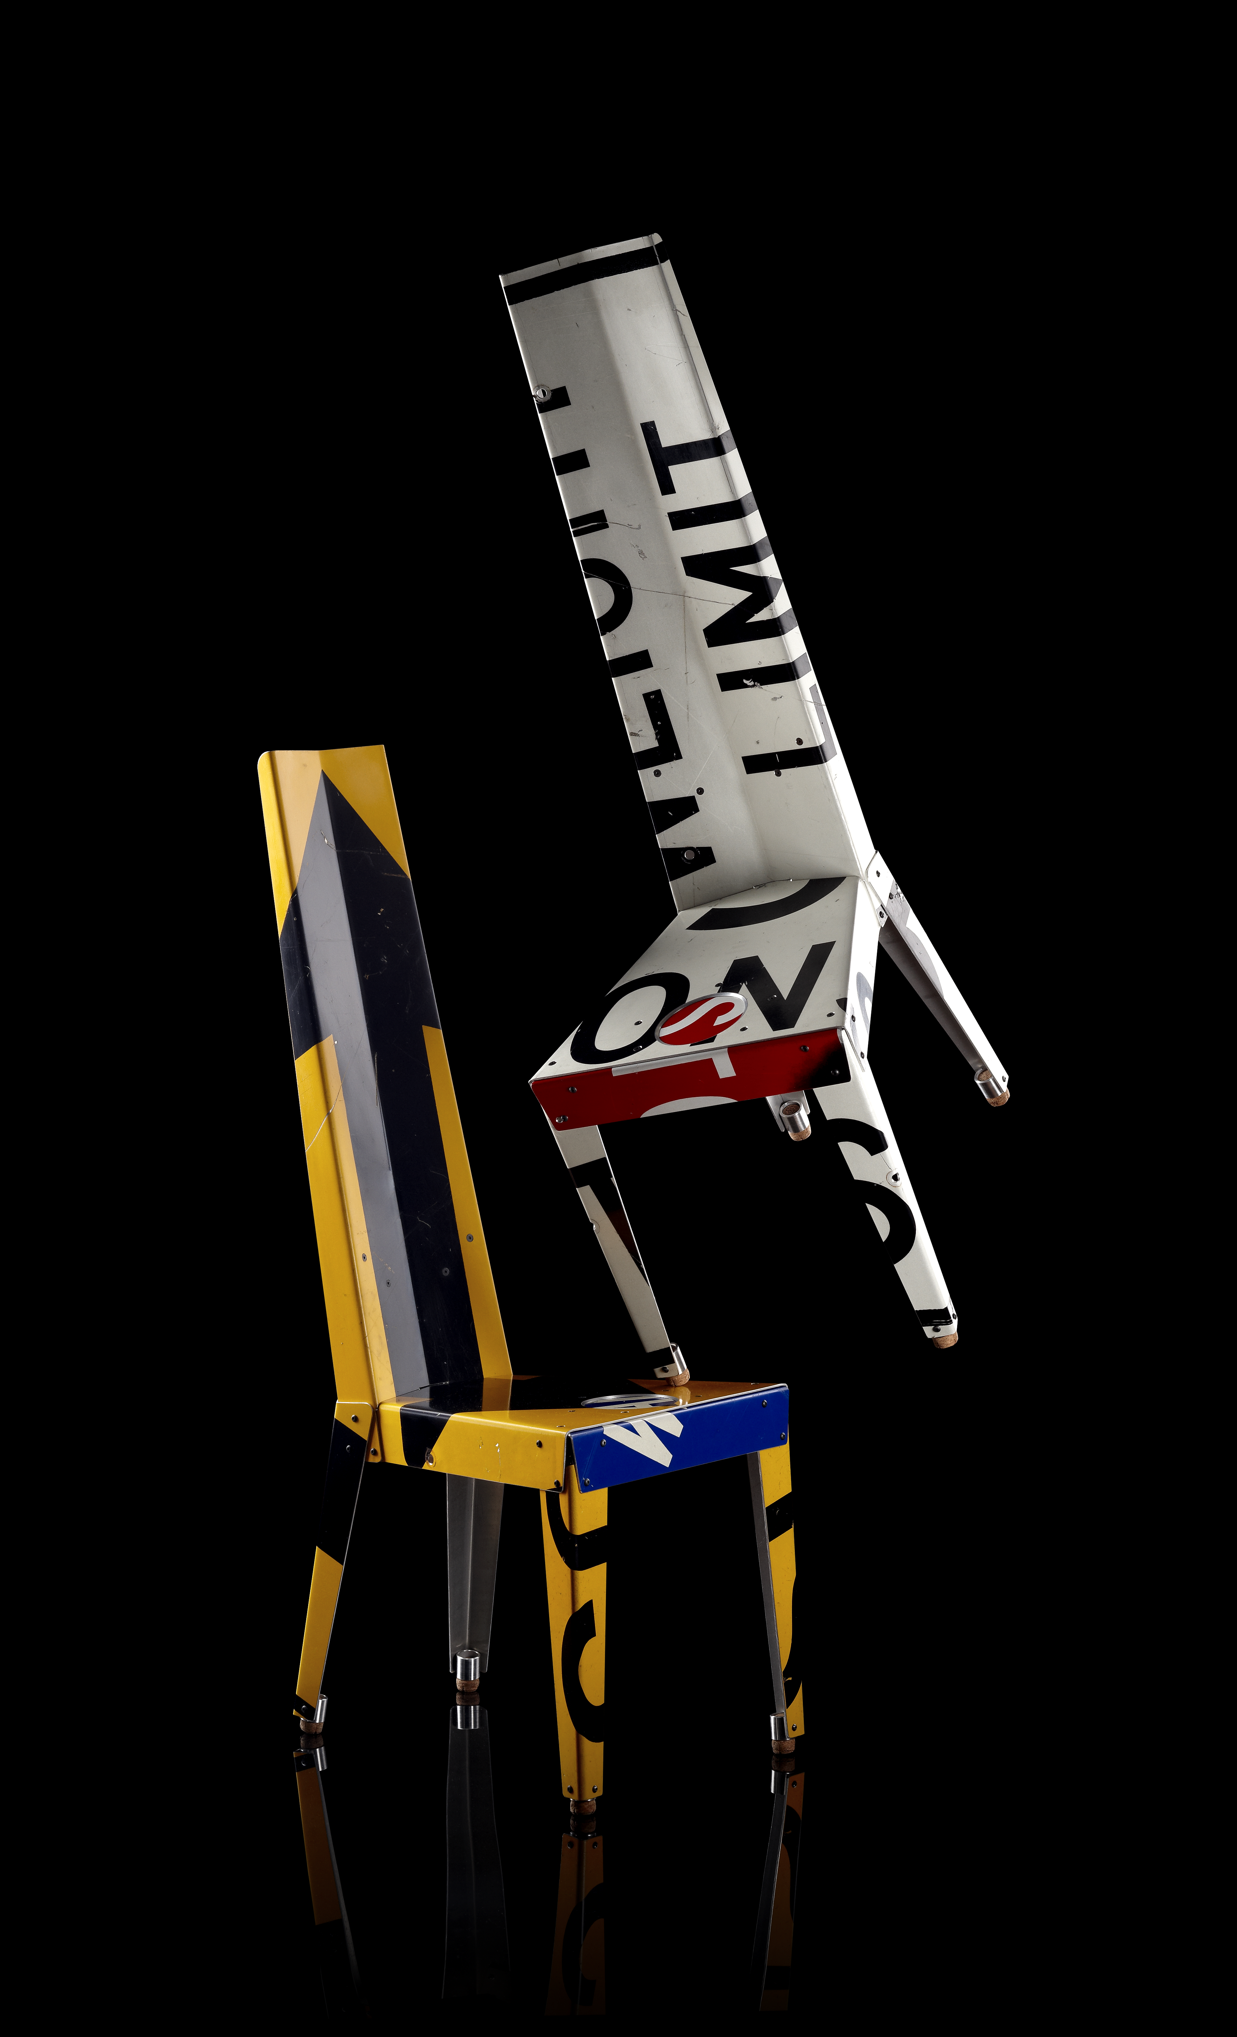
Boris Bally’s Transit Chair Materials
re-used traffic signs, champagne corks, steel hardware
Techniques
Humanufactured® (hand-fabricated, pierced, brake-formed, finished)
Dimensions
49 1/2 x 17 x 22"

