HOW TO MAKE A CLASSIC EVEN BETTER
At Artista Hair ColorGroup, Even Classic Styles Are Customized

Scarsdale, NY—Every woman deserves personalized attention and a customized hairstyle that suits her lifestyle, personal image and individual taste. At Artista Hair ColorGroup in Scarsdale, NY, Owner and Artistic Director, Rocky Plateroti even updates classic looks by re-thinking what’s traditional and using his client’s unique features and personality as inspiration. Here’s how it’s done for a ‘60s bob and a ‘70s shag:

KEEP TRUE TO YOUR BLUES
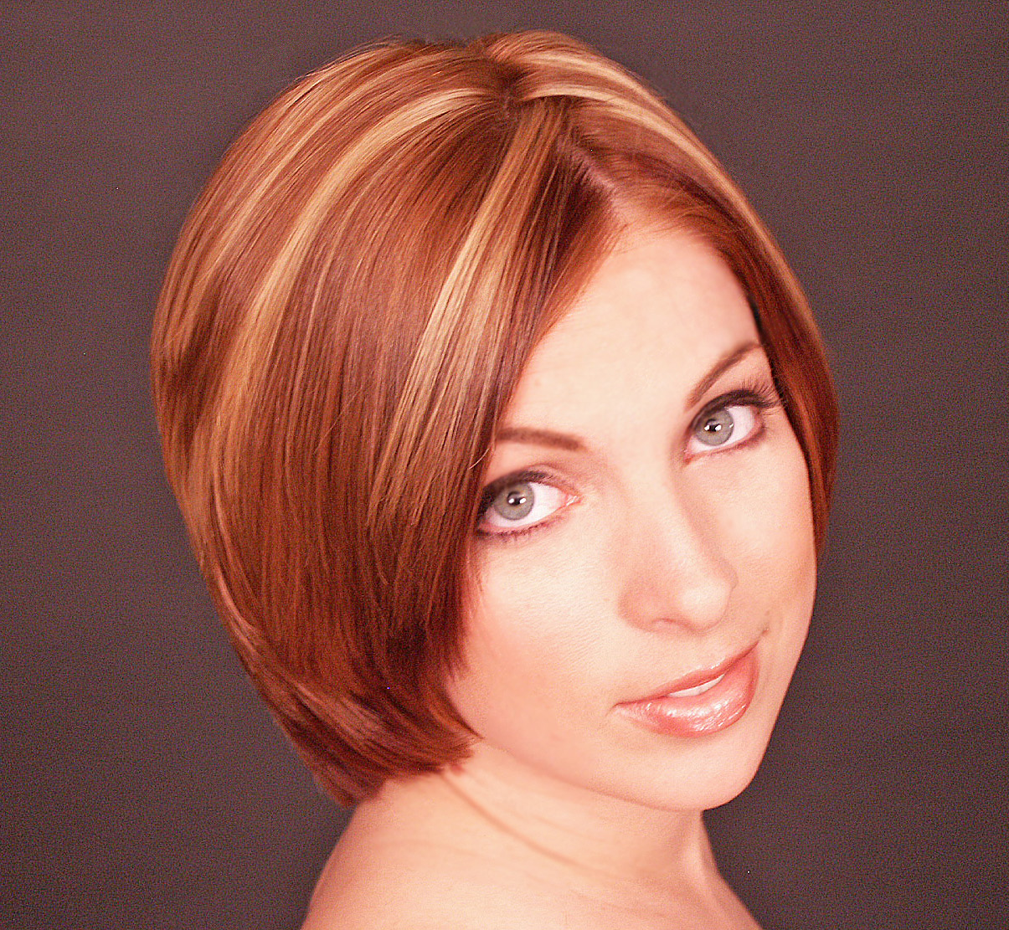
The Look: It may be true that blondes have more fun but don’t forget about those baby blues. So many natural blondes with blue eyes think that adding lighter blonde highlights is their only haircolor option.

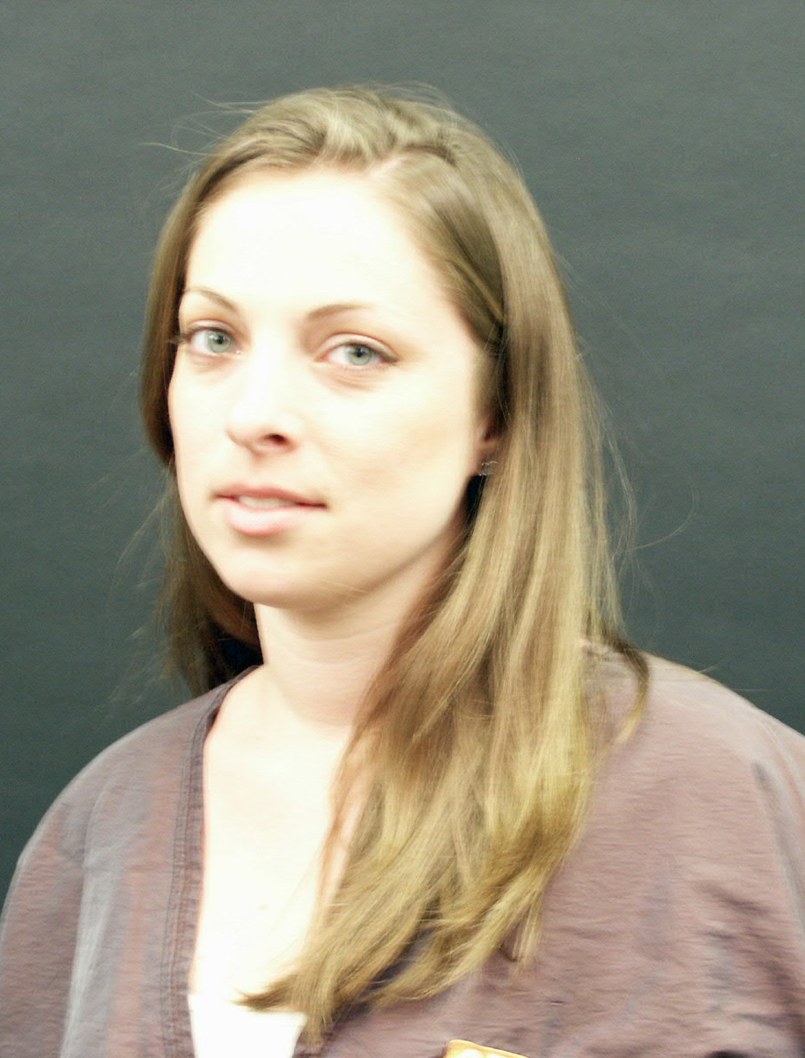
Cut: Brielle wanted a low-maintenance bob. For a fresh take, it’s modified with round lines instead of the classic straight ones. The shorter shape makes her face appear more oval—her previous long hair emphasized its rectangular shape. Other advantages of the alterations: Her jaw line is softened and the focus is now on cheekbones and eyes. Perfect for a young professional, this versatile shape is clean and sophisticated.

Color: To play-up blue eyes and porcelain skin tones, Plateroti placed warm copper hues near her hairline. Color contrast close to the face makes blue eyes appear even brighter. The chunkier blonde highlights placed throughout create movement and depth.

RETRO GLAM
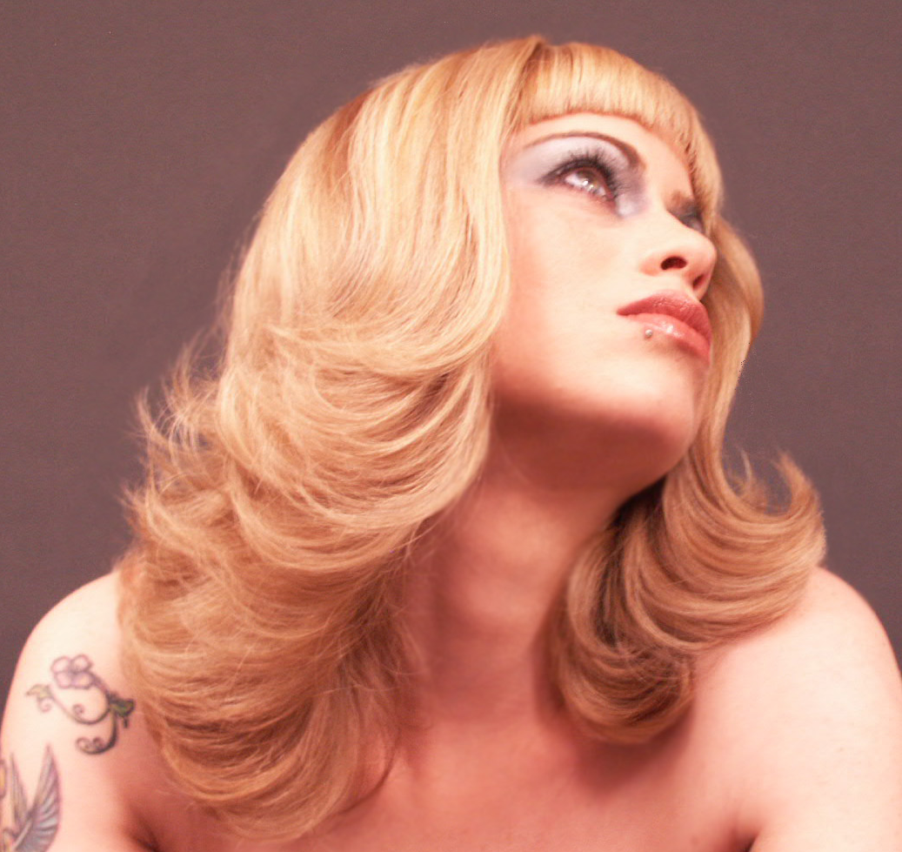
The Look: Ever find an old picture of your mom and think, “Wow—she looked amazing?” If you’ve got a trendy vibe and a flare for all things fabulous, why not take a cue from her retro style and make it your own?

Cut: By using long, round layers, Plateroti creates a more flattering version of the traditional ‘70s shag. Skipping short, top layers, he opted for a modern straight-across bang, to play-off Alisha’s rock star style.
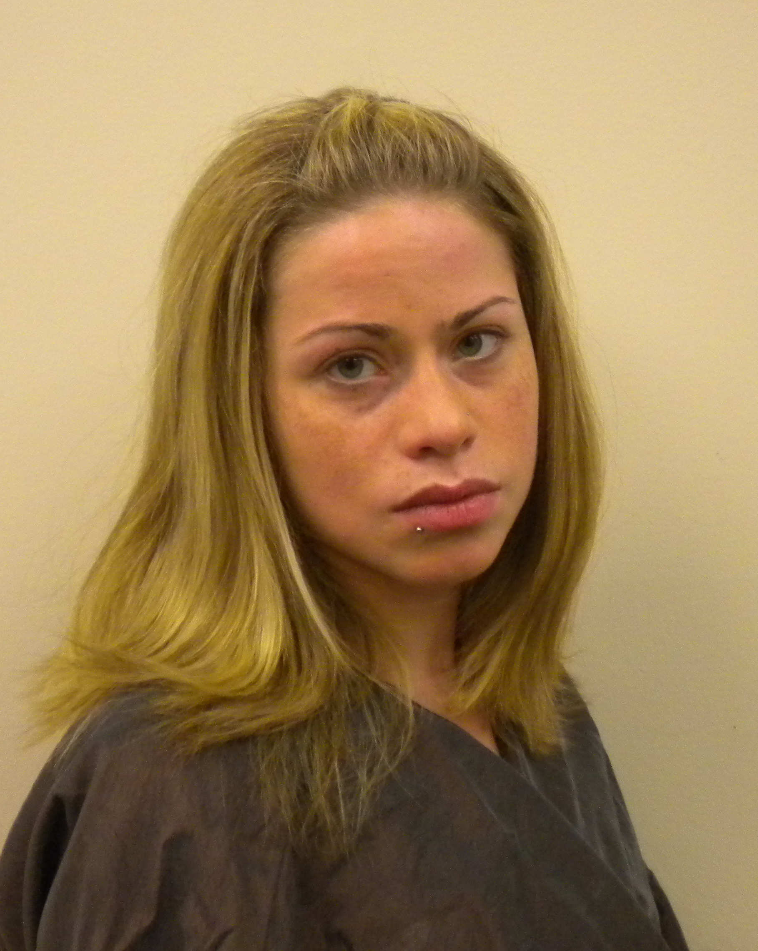
Color: The perfect complement to this high-fashion style is a full head of luscious blonde highlights. Copper lowlights break up the shape and add a contemporary club-kid touch.

Artista Hair ColorGroup is located at 455 Central Park Avenue in Scarsdale, NY. For the perfect hairstyle that’s customized just for you, visit artistahairgroup.com or call (914) 723.1311.

Photo Credits: Hair & Photography by Rocky Plateroti. Makeup by Farrah Santelia.

