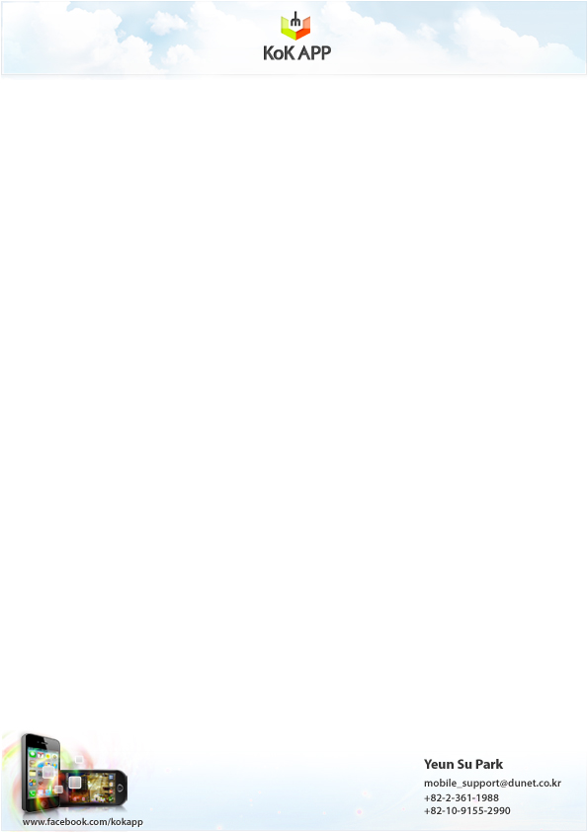
PRESS RELEASE

1st April, 2011

3D Stereo Camera

Application for Android
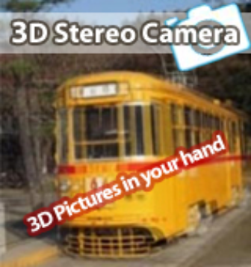
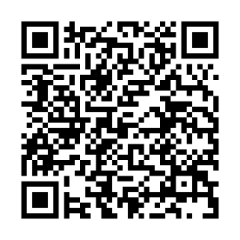

US$ 1.99

Category : Tools

→ Create your own 3D photos with your phone.
→ 3D Stereo Camera will bring your photos alive!
→ Share the 3D photos instantly with your friends.

Screenshots

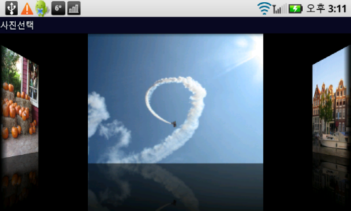

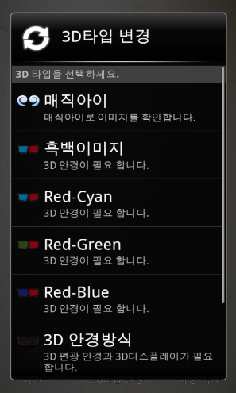
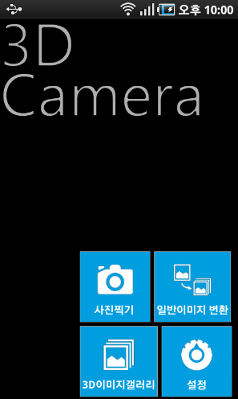

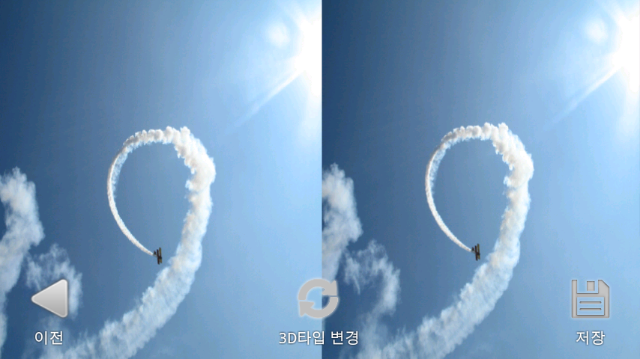

3D Photos that pop up and come into life!
Create photos that come alive with 3D Stereo Camera application!

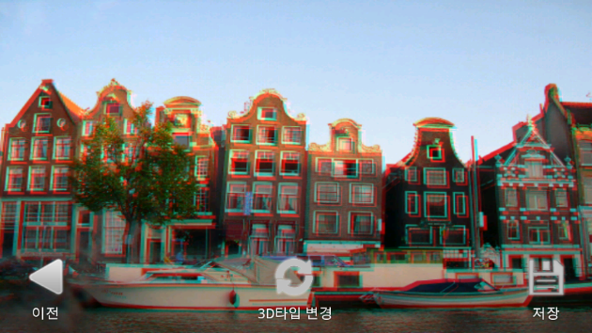
Take 3D photos using your own smart phone and bring actions and excitements into your existing photos. If you are a 3D lover, you no longer need to visit a movie theater to have fun with 3D images. What’s more you can do is creating your own 3D photos with your smart phone! Just download 3D Stereo Camera from Android market and have your 3D glasses ready for a new experience.

Don’t become bored with those ordinary photos. Just choose photos from your phone and manipulate the photos using 3D Stereo application. With a simple touch, you can make 3D pictures as well as take 3D pictures from your phone. Users can share them with your friends. The photos could be instantly emailed or uploaded to Flicker, Facebook, and Twitpic.

If you have any questions, please contact Yeun Su Park by phone or email below.

Copyright ⓒ DUNET Inc., All rights reserved.

