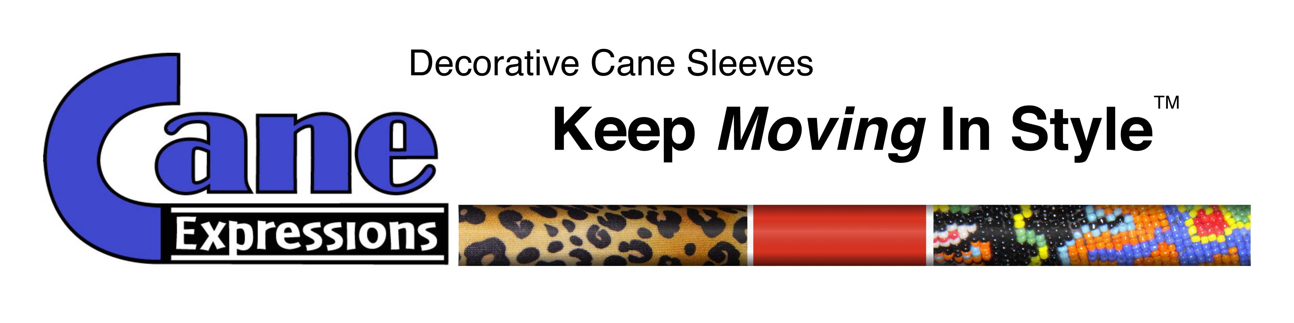
THE PERFECT HOLIDAY GIFT

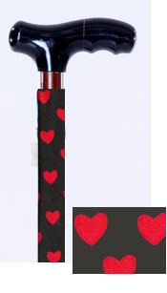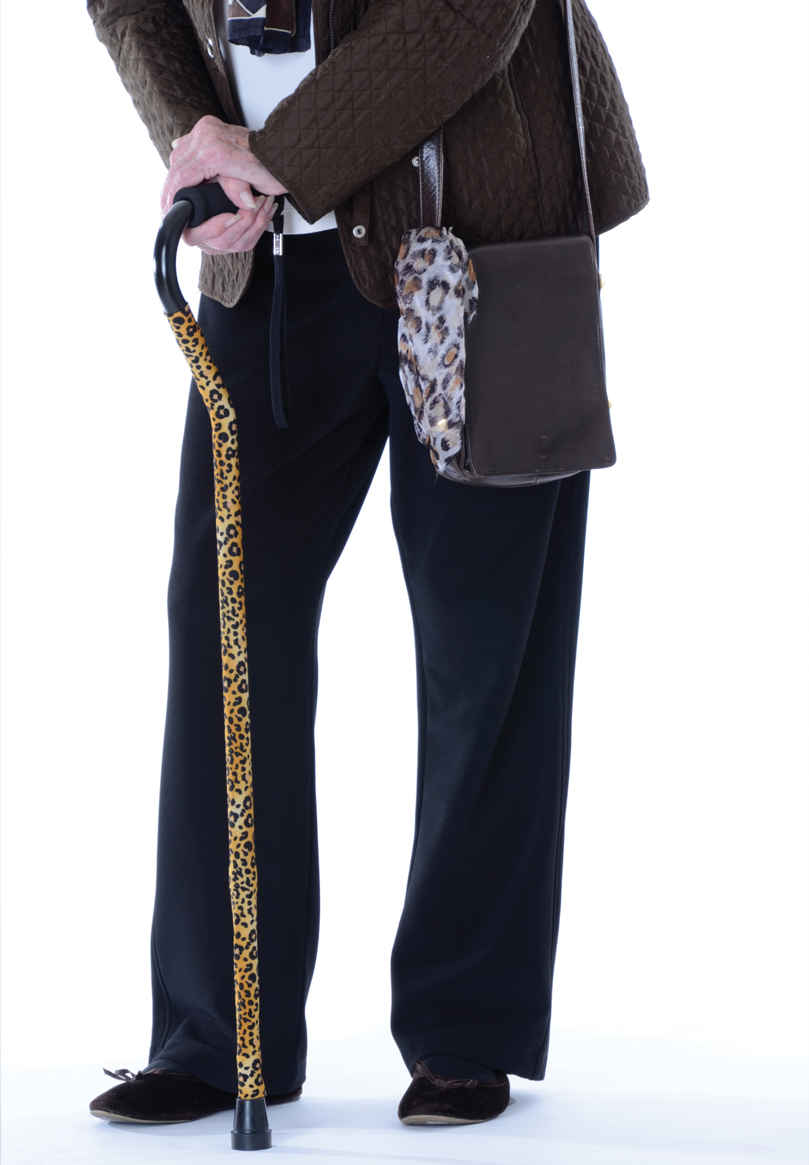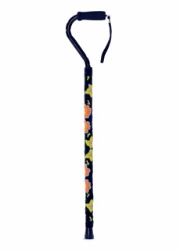

TO KEEP CANE USERS “MOVING, IN STYLE”

MEDIA CONTACT:

LYNDA LESTER

@ 310-873-8044, 818-901-1717

OR lynda@thefinestevents.com

Two entrepreneurial businesswomen saw a need when the mother of one required the assistance of a cane to walk and wanted something more fashionable than the traditional silver one. Rather than re-invent the cane, Pam Goldwasser and Dr. Rhonda Robinson created Cane Expressions™, a simple-to-use sleeve that slips over any standard cane shaft. They make the perfect gift for your favorite cane user. Retailers agree. They can be purchased from numerous online sites, including www.walmart.com, www.drugstore.com, www.wayfair.com and www.amazon.com.

Cane Expressions™ recently answered the demand from their customers by adding new colors and prints as well as a shimmer sleeve and an upscale beaded sleeve for a more dressed-up, formal look. It’s not just for women – men using canes are enthusiastic buyers of the denim and camouflage versions.

The cane sleeves are made from a stretchy, durable and machine-washable fabric. Price depends on the style with the color and print covers retailing for around $10. The elegant, beaded version designed for special occasions or the more artistic user (pictured above) retails for around $40. Cane Expressions™ has been well received in the senior community where budget can be a concern. It also makes for a practical and inexpensive gift for a family member or friend.

Customer feedback and sales have been positive, according to Ms. Goldwasser. “We have heard stories,” Ms. Goldwasser commented, “that when reluctant cane users are presented with this decorative accessory, they have been inspired to pick up their canes and literally get back on their feet. The cane sleeves are as unique and expressive as the people who use them.” “It’s important to us,” Dr. Robinson added, “that our product encourages cane use with dignity and style.” See www.caneexpressions.com for additional information.

