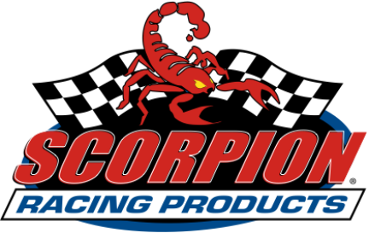

5817 NW 44th Avenue, Ocala, FL 34482 • Phone 352-512-0800, Fax 352-512-0801
www.ScorpionRacingProducts.com

PRESS RELEASE

Contact: Scott Reynolds, Executive Vice President
352-512-0800, scott@scorpionracingproducts.com

FOR IMMEDIATE RELEASE – June 17, 2013

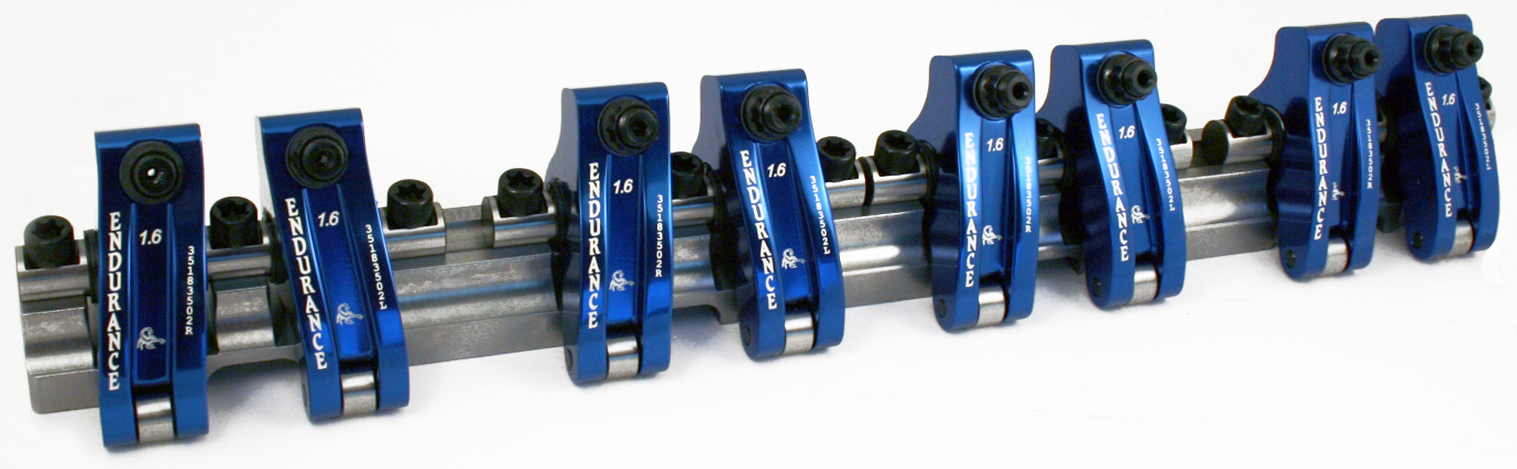

Scorpion Racing Products Introduces New
Endurance Series Shaft Mount Rocker Arms

Ocala, FL (June 17, 2013) – Scorpion Racing Products announced the introduction of their new Endurance Series shaft mount rocker arms. According to company officials, customers have been asking for Scorpion shaft mount rocker arms, and now after exhaustive testing they are available for purchase.

Scott Reynolds, Executive Vice President, states, “Scorpion takes precision manufacturing to a whole new level with its new Endurance Series shaft mount rocker arms. These rockers were designed for professional circle track, dirt track, drag racing and offshore powerboat race engines. We believe they are the best shaft rockers available today and are built to perform at the top level, lap after lap, race after race. Plus, they are priced very competitively, and they’re made in America.”

Scorpion Racing Products is well known for their superior quality valve train products produced through state-of-the-art, automated robotic manufacturing techniques, but don’t think that they’ve taken the human element out of the equation. ”Our crew is very hands-on when it comes to manufacturing our products,” says Reynolds. “Most of the people that were here when the company started are still working here today, and they monitor our automated processes very closely to ensure absolute top quality products are made for our customers.”

Scorpion’s COO, Zac Collins, adds, “Our new Endurance Series shaft mount rockers were tested in circle track racing for several years before we released them to the public. With two seasons of racing at 8600 RPM plus…we are convinced of their ability to withstand the rigors of endurance race engines and meet the high standards we set for our products.”

The research and development process began with 3D dimension modeling and Finite Element Analysis (FEA) testing on computers. Once Scorpion’s engineers felt they had the ultimate design for a shaft mount rocker arm with endurance qualities, the manufacturing crew produced prototype components for testing. Scorpion’s engineering crew represents a team of 13 people with over 250 years of valve train engineering experience.

“One of the key areas that always poses a challenge with rocker arms is the question of performance versus temperature. Through extensive testing, we have perfected our shaft mount rockers using 7000 series aluminum for extreme racing at high RPM over a long life span,” says Collins.

Scorpion’s Endurance Series shaft mount rocker arms are now available for 23-degree small block Chevrolet engine applications, and many more applications will be offered soon. Key dimensions and features include:
• .562” centerless ground shaft
• .520” centerless ground roller
• Steel parts made from ASTM certified bearing quality steel
• 4140 heat-treated steel stand
• Lightweight for maximum performance
• 120 gram assembled body
• .625” adjuster engagement
• Fully radiused bodies made from 7000 series aluminum
• .260” underside bearing strap
• Clear 1.650” valve springs
• Full compliment needle bearings
• Anodized for additional strength and protection
• Black oxide coated steel parts
• 100% CNC machined in the USA

“We over-engineer our parts for our own assurance. All of our products are thoroughly tested in-house on our Super Flow 901 engine dyno before they ever go out for track testing. That’s why we’re able to offer a lifetime warranty,” added Collins.

Scorpion Racing Products offers a full range of valve train components with the Endurance Series featured as the pinnacle of quality. For more information on Scorpion’s Endurance Series shaft mount rocker arms and other valve train components visit their website at www.scorpionracingproducts.com.

# # #

