

COMPOSER 4.0 SOFTWARE
EMPOWERMENT FOR VETERANS

BACKGROUND INFORMATION

Jack Hall, CEO
Jack.Hall@Arts-Letters.com
512-851-7666

Composer for Wounded Warriors
Arts & Letters (A&L) desires to provide their Composer software to Veterans that are disabled as a result of service related injuries or combat. We are prepared to provide software to all that wish to take it with an initial upper limit of 50,000 copies. This is not a trial and there are no hidden agendas. The estimated value of this distribution is $6 million. We plan to renew this offer if the program is successful.

The software provides professional tools for graphics production and is used by commercial artist, government agencies, business presentation producers, educators and fine artists. (Client Overviews attached providing a sample of User base.)

- A&L Composer provides the basis for employment, skills development, business start-ups and education programs. The product line has roots throughout government agencies, the military, Fortune 100 and 500 companies, public schools, higher education, SOHO business and agencies. (see attachment)
- Due to A&L’s acceptance, employment potential is increased by the skills developed using Composer
- Composer provides the foundation for start-up business like sign companies, creative agencies, screen printing companies, desktop publishing, contract art, fine art, design shops, print shops, book creations (self-help, how-to, stories, coloring book, comic books, etc), t-shirt design, art for automobiles, buses, planes, type design, credit design for film, cell animation and more. It is not limited in creation of graphics and covers a wide variety of fields with appeal on a number of levels.
- Composer is long noted for ease of use, quick learning curve and low frustration levels.

Who is Arts & Letters
A&L was founded under the name Computer Support Corporation in 1971. Working as a data processing service bureau, it quickly developed charting and graphics tools to differentiate its services. In 1982, two products were created using the company’s vector art expertise and were ported to CP/M (KayPro) and DOS (HP) systems. With the advent of Windows in 1987, Arts & Letters graphics software was created and the company soon adopted the name.

A&L has been sold in 35 countries around the world in 10 languages. It has a long history with commercial artists, fine artists, education, home, military and other government contracts and has created extensive art files to support those contracts and businesses. A&L has worked closely with NASA to create two products, Apollo 13 and Space Age. It has also published WarBirds, a collection of military aircraft art files from 1918 to modern aircraft.

The founder of the company, Fred Schoeller, passed away in 2011. In 2013, Hall, a former employee, and Poznecki bought the company and began rebuilding the software. New versions are now ready and being sold.

Why we want to do this
We believe in and support our military personnel.

Jack Hall, owner and a former A&L employee, has a history of personal and family military service. He is a Vietnam era Veteran. Hall is active in supporting non-profit causes he believes in. He uses his artistic talents and A&L software to create original art that has raised tens of thousands of dollars for non-profits.

Inspired by many of the stories concerning today’s veterans, Jack and his partner in A&L, Michael Poznecki, felt it was time they gave back to the Veterans if they could. In reading about the work that the others are doing and researching goals for these types of organizations, the A&L owners felt their software platform that would work well to deliver self-empowerment tools and opportunity.

Engaging the Veterans
We have several considerations we have addressed in order to make this program successful. Preparations include plans for getting the word out that the product is available, getting the Veteran to give it a try, helping them to succeed, protecting individual privacy and respecting the individual.

Included in our plan:

Complete and full version of COMPOSER set up for download with special code
Awareness campaign
Will seek strategic level relationship with certain Veterans organizations.
Endorsements from high profile veterans and veteran organizations (current A&L Users)
Endorsements from high profile customers
You Tube training videos from real customers (getting started, tips, techniques, tricks)
Success stories from small business, business, commercial and fine artists
Creation of ALEX, an online outlet for the sale of art created by veterans in the program
Creation of Veterans’ centric User Group
Creation of unique registration program to protect privacy and license

All press related activities are targeted to reach Veterans to make them aware of the offer and get them to engage. We currently have Veterans' organizations that have A&L Users in their ranks including American Fighter Aces. Those individuals support this effort.

Who we are
Michael Poznecki, CTO
University of Texas San Antonio, Married, two children
Programmer, security products expert, entrepreneur with C level experience, 4 startups Mike is the grandson of immigrants and has spent his life in improving his programming and tech skills. Much of his security products work has been for government and military entities.

Jack Hall, CEO
Texas State University, Married, 5 children
Artist, writer, programmer, entrepreneur with C level experience, 13 startups U.S. Navy 1971-1975: Second Class Petty Officer, specializing in flight simulators and pilot training at NAS Chase Field. He attended Aviation Electronics “A”, Training Devices “A”, Cobalt programming, Hex programming, T2C-Fam, A-4 Fam and other tech training. Honorable discharge.

Veteran Affairs Counselor-Benefits counselor for Southwest Texas State University
Veterans Outreach Coordinator-Created outreach program covering 5 counties in Central Texas
Vet’s Voice-Syndicated column: Veterans benefits, employment, medical care, family resources, aid and assistance.
Documentary-“The Confederate Air Force, award winning documentary covering a flying museum of World War Two aircraft and history.

The following is a partial listing of Arts & Letters Users. It is designed to show potential employers for Veterans with the skill set that Composer Users acquire. We have also listed other opportunities for Users that wish to start their own businesses.

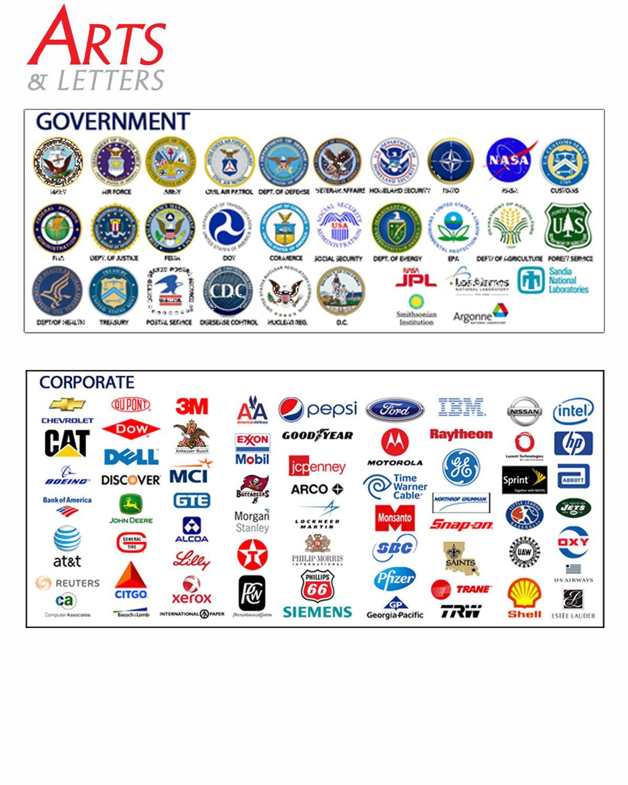



There are more than 18,000 pieces of clip art that ship with Composer and allow a new User to create final art very quickly. Composer Users will also receive additional art as it is released and there are approximately 22,000 pieces in various stages of production.

Several of the images above are straight out of the libraries or samples and require no manipulation; however each one can be fully edited. Vector art can be sized from pinhead size to billboard size without distortion.

An average User can be up and running on their first project in about 20 minutes using the online User's guide (80 languages), tutorials and help files.

We have 7, 8 and 9 year old students that send us work all the time. Almost as amazing, we have CEO's that send us art they did. We have 100's of letters and emails saying this is the easiest, best, simplest to use, most complete, fastest, most productive...etc. It is not bragging if it is true.

