 | FOR IMMEDIATE RELEASE  March 14, 2016
  Contact | Rust Bullet, LLC
  Telephone | 1-800-245-1600
  Email | sales@rustbullet.com
  Website | www.RustBullet.com

RUST bullet, LLC coatings now available at walmart.com

Superior Automotive corrosion protection products now available online
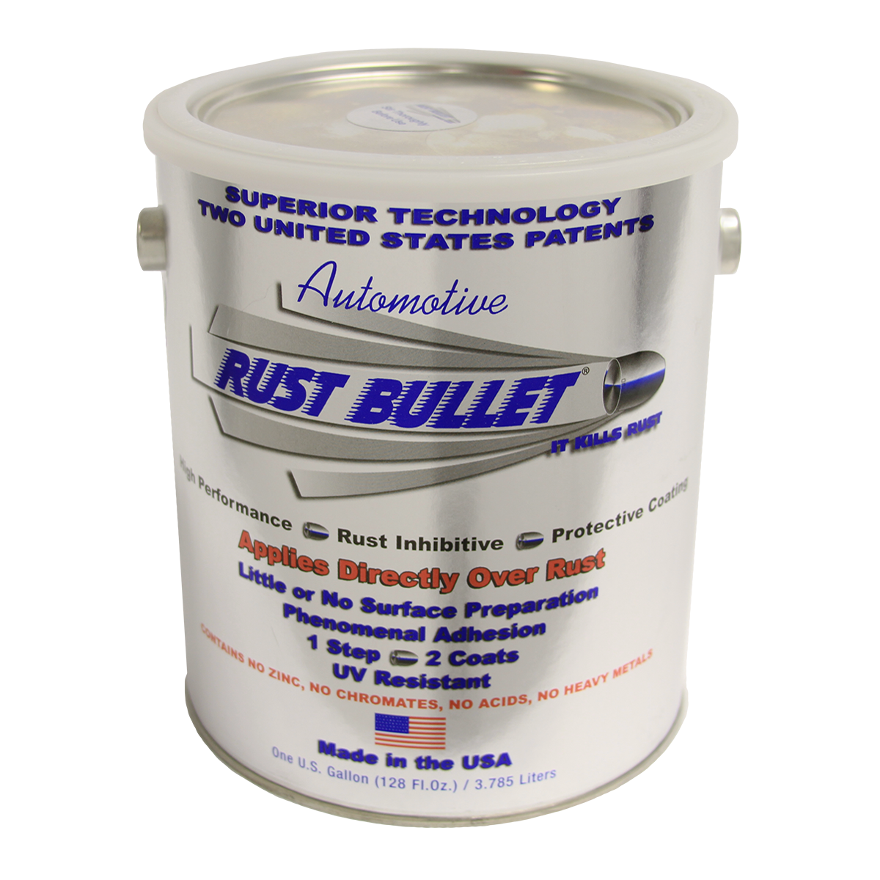
Reno, NV, March 14, 2016– Rust Bullet, LLC today announced availability of its superior, multi-patented Automotive, Concrete and top coat products at Walmart.com
“Rust Bullet’s Automotive coating products have been used to protect cars, trucks, buses, vintage automobiles and farm vehicles for many years. Our Concrete product has been delighting customers with its ease of use and long lasting durability. We are thrilled to bring these products to Walmart.com customers” said Mike Moore, CEO, Rust Bullet, LLC.

Rust Bullet Automotive provides phenomenal adhesion and superior protection and is suitable for use on undercarriages, frames, floor pans, rocker panels, suspensions and much more. Designed for use with HVLP sprayers (or a brush or roller) for a smooth finish, Rust Bullet Automotive can be used as a standalone or top coated with Rust Bullet WhiteShell, BlackShell or any of the Rust Bullet ColorShells. Rust Bullet For Concrete provides an impervious shield protecting against chemical and oil spills, hot tire lift and abrasion.
In addition to Rust Bullet Automotive and Rust Bullet For Concrete, other Rust Bullet products carried by Walmart.com include:
- BlackShell
- WhiteShell
- Metal Blast
- Rust Bullet Solvent
Rust Bullet, LLC is a coatings manufacturer, headquartered in Reno, NV, USA, specializing in protective, rust inhibitive and corrosion control coatings. Rust Bullet, LLC sells to businesses and consumers around the world through its global distribution network. For more information, please contact Rust Bullet, LLC at 1-800-245-1600 or via email at sales@rustbullet.com.
# # #

