
FOR IMMEDIATE RELEASE: March 11, 2015

The Truth About a Detox Diet and Weight Loss

Detoxing restarts the body by expelling the chemicals and toxins that we are exposed to every day. Today’s markets are filled with a plethora of over-the-counter detox supplements, drinks, diet plans and pills. Here’s a breakdown on how to detox like a pro.

Why Detox?
Detoxing jumpstarts a diet by cleaning the body’s foundation and giving it a reboot. By eliminating processed foods, people have more energy and focus. And while the kidneys and liver do most of the heavy lifting on their own, adding in the right prebiotics and probiotics can be the most effective way to achieve long-term results.

What Are Prebiotics?
Prebiotics are carbohydrates that aren’t digested by the body. This means they work in conjunction with probiotics by adding even more healthy bacteria to the system. Prebiotics can be found in foods such as garlic, leeks and onions.

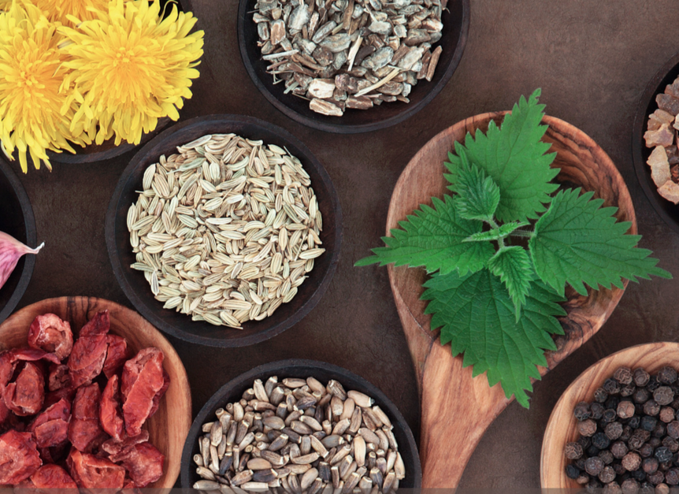
What Are Probiotics?
Probiotics are healthy bacteria that control the growth of the unhealthy bacteria in the body and keep the digestive system moving. Aside from in supplements, probiotics can be found in fermented foods like yogurt, sauerkraut, cheeses and kefir.

The Perfect Pairing: Supplements
Couple a healthy diet that includes prebiotics and probiotics with the right supplement and the benefits of healthy eliminations will lead to a clean digestive system. Supplements like the BalanceDiet 08 Detox Support Probiotic can feature over 4 billion beneficial organisms that assist in breaking down toxins to aid in digestion while strengthening the body and digestive tract, resulting in a better night’s sleep, more energy, and weight loss.

Other Benefits of Detox
According to the Mayo Clinic, probiotics can also aid in the prevention and treatment of:
- Diarrhea
- Yeast and urinary tract infections
- Irritable bowel syndrome
- Various intestinal infections
- Colds and flus

For more details on detox and the BalanceDiet™ line, visit shop.gobalancediet.com

About BalanceDiet™
BalanceDiet™’s signature detox diet, initially made popular on CNN, is part of a weight loss program specially designed for each individual client based on genetic testing and lifestyle. Each plan is then equipped with structured meal plans, programs, and nutritional supplements. The BalanceDiet™ brand includes a lineup of over 85 exclusive products manufactured by a top pharmaceutical company.

For more on BalanceDiet™, to schedule a complimentary visit, or to receive a sample, please email Christina Sears, Director of Marketing, at christina.s@joinelements.com

