Background/disclosure: I originally backed the Radiate Kickstarter project, and received two of the seven things I ordered. I won’t get into the mess that that ended up being, but I always thought that it was an interesting idea so I would skim the web periodically to check if anyone else had tried it. Eventually I found Meta Wear/Activate. Got to discussing the issues that Radiate had had, and offered to review a shirt if he sent me one. Which he did. So here we go. I only edited one picture, and that was just to color over my toilet. So colors are as they were picked up by my Iphone camera in that particular light, mainly fluorescent.
Color change: 8/10 (this particular colorway).
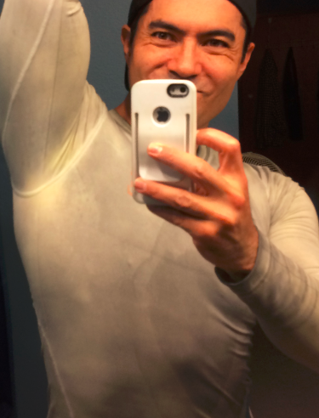
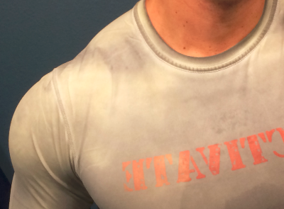
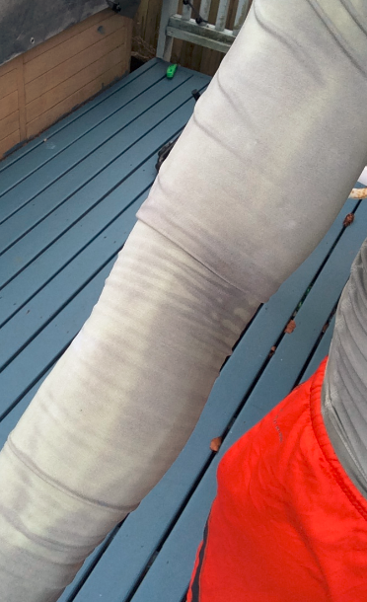
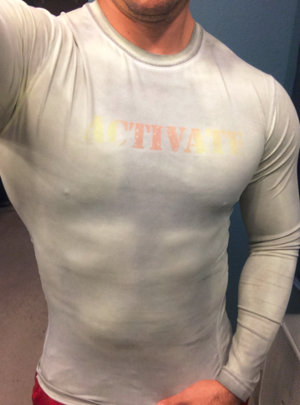
The shirt I got started off as a gray/green-ish, and changed to yellow at body temp (bright yellow with a hair dryer). It’s pretty cool to be able to see my veins and different temperature areas around my body. But the effect was somewhat subtle. Which can be good or bad depending on how much attention you want. Also, green-ish to yellow-ish isn’t a huge leap in color. It just happened that this was the shirt I got. Since there are options, I probably would go for something more striking like blue-to-red so that the color change is more noticeable. But for a less in-your-face-yet-still-noticeable color shift, this worked well. My veins were definitely visible at times even with the subtler color change.
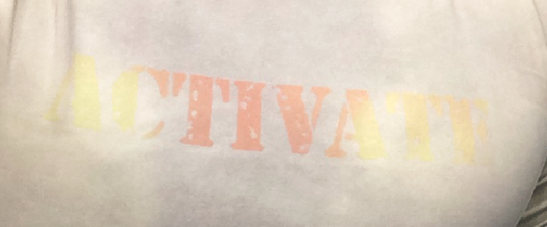
The thing about the color change is it also has a lot to do with the external temperature and what temp the shirt is designed to shift at. So if the shift temp is close to your body temp, or close to the gym temp, then the whole shirt will change instead of just specific areas. The one I got, a low to mid 60’s external temp probably would have been best, but the two places I worked out at were both 68-ish, so I think that affected how striking the color shift was. My armpit was probably the brightest area, due to being the hottest. Areas where the shirt pulls away from the skin will be the coolest due to lack of contact, so right by my clavicle/trap was pretty dark. (The pics with the iron or the video with the hair dryer are showing a radical color shift because the heat from an iron or hair dryer is going to be a lot more than what your skin is going to create.)
The ACTIVATE logo also started out as a pinkish-orange and slightly glittery and changed to a yellow-ish. Logo was printed on, looked like with some pad printing, but the color change was strong and striking. I’m actually impressed by how well the logo shifted color.
For best color change results, I would say keep in mind the temp where you’re exercising at, and the difference between the before-and-after color. Red-to-purple or red-to-orange would probably be a lot more subtle than red-to-blue or black-to-pink.
Fit: 9/10, but be careful.
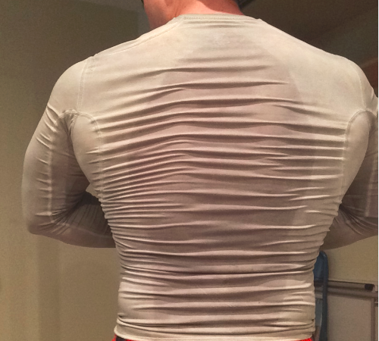
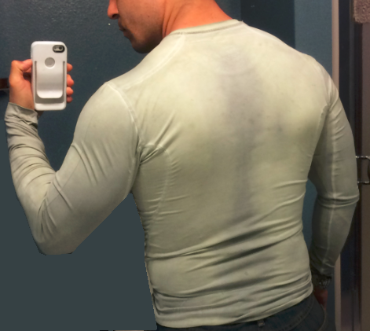
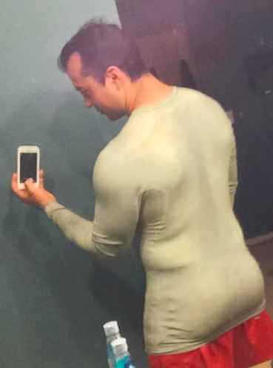
I normally wear a medium shirt size because they fit pretty snug without being arrogantly tight. The shirt I got is a Large, but fits me skin tight. It’s not “too” tight in terms of comfort, but it is skin tight enough to where the fabric makes a tight fit against my skin, which is needed to pick up on the skin temperature. Any tighter and I would probably feel like a sausage. Any looser and the fabric wouldn’t read my skin temp as well. So I think I got just the right size.
It’s a bit long, but I’m only 5’6”. However, the bottom edge can go down to the bottom of my butt. So when I pull it up to my waist, it bunches up. It’s still tight, but the extra fabric isn’t pressed right up against my waist and lower back so it loses the color change ability. Not a big deal since I can just pull it down and tuck the extra fabric in to my shorts. But it did mess up a couple pictures since I didn’t realize it was doing that at first.
So when you go to order, keep in mind that you’ll probably want to order AT LEAST one size up (which is why I said “be careful”).
Fabric: 9/10
The fabric isn’t as filmy or smooth as other quick-dry athletic clothing I have. It feels kind of… paper-y/crinkly in my hands. But once I put it on, I don’t notice that at all. So it’s just a thing I happened to notice. Nice fabric otherwise, not too heavy, not too light. Seems to dry reasonably quickly while I’m wearing it. Manufacturer mentioned he was going with a different fabric, so this probably won’t be relevant after the switch.
Durability: 10?/10
So far I’ve only washed it once or twice, so it’s tough to speak to long term durability (which is why I put the “?”). I turned it inside out the first time (at the manufacturers recommendation), and ran it through the standard wash and dry cycle with the rest of my clothes. My immediate feeling when I pulled it out of my clean clothes after washing it the first time was that it actually looked slightly better than it had before. Not sure how that was, but it was just a feeling.
If it had required any special care, I would have graded far far down, since I just wash all my clothes at once, but this seems to hold up to normal washing and drying. Even the manufacturer said he didn’t know if it would make a difference to have it inside out or not, but recommended it anyway. Since the logo is printed on, I’m thinking the slight difference that turning it inside out might have is to keep the logo only rubbing against the softer fabric of the shirt, instead of something rougher like denim jeans, while everything is washing and drying. That would probably keep the logo fresher looking over time. Not sure the difference it would make on the actual color change dye/ink/stuff.
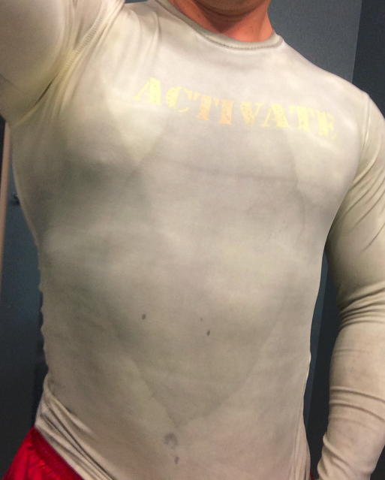
Also, the manufacturer does have some videos where he has shirts in a washing machine and straight up pours a cup of bleach in there to show that it doesn’t have any effect, and runs the washing machine without soap so you can see the water stays clear (to show that no ink is bleeding out), so make sure to check out those videos too.
Misc: 7/10
One thing I did notice is that that shirt shows dried sweat pretty well. So the sweat rings on my chest from previous workouts were pretty noticeable (I wore it for more than one workout without washing it GASP!) My other black/gray/blue quick-dry workout shirts never show sweat marks on them afterward, and I know I sweat a similar amount in them (and re-wear them GASP!) So if you’re planning on buying one Activate shirt and wearing it twice before washing, keep that in mind.
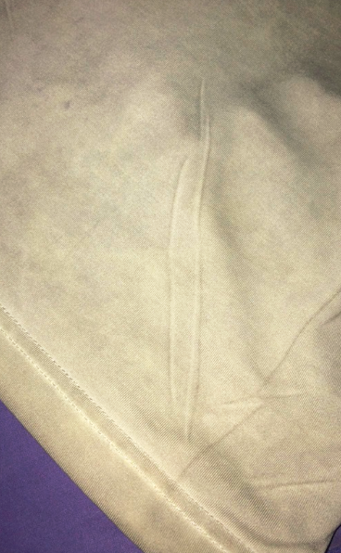
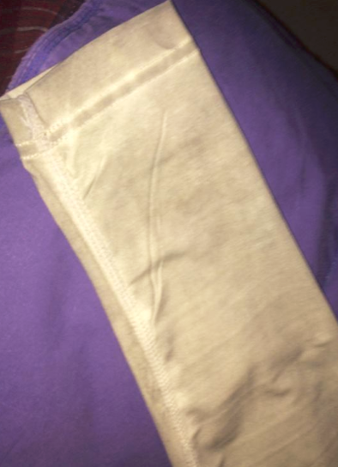
Also, I think the shirts were sublimation printed due to finding some printed creases in a couple places, and the seams being lighter than the rest of the shirt. This would have been a little annoying to find on a shirt I’d purchased, but discussing it with the manufacturer, he said the artifacts and creases aren’t in current shirts made now. So guess I got an early model, and this should be a non-issue now.

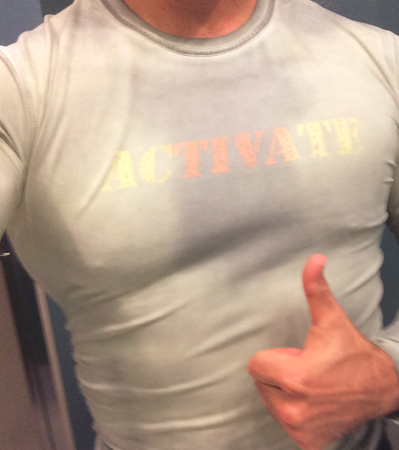
Overall: Looking to buy AT LEAST two more shirts /10
I really like the one I got. It’s cool. It works. The color change is a bit subtle, so I want to get something that’s a bit more striking like I mentioned earlier` (blue or black to red, if possible)(and hopefully hides sweat better). And my best friend also went in on the Radiate Kickstarter and didn’t get anything, so I want to get her one also. Will depend on what cost point these come in at.
But overall, this is the shirt that Radiate should have been. It fits good, feels good, washes up without any second thoughts (beyond “did I turn it inside out? Does it matter?”), doesn’t run or bleed. And looks great.

