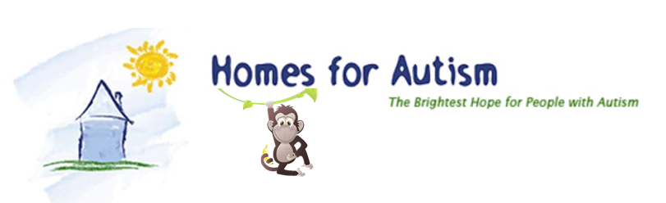
PRESS RELEASE
BIRMINGHAM, MI (2017)
Contact: 248-890-5870 or MONKEYAROUNDATTHEZOO2017@gmail.com
MONKEY AROUND AT THE ZOO With Homes for Autism
Homes for Autism will host Monkey Around at the Zoo on Saturday, August 5, 2017, at the Detroit Zoo in Royal Oak, Michigan. Participants can register at www.crowdrise.com/monkey-around-at-the-zoo.
Monkey Around at The Zoo will be a family-friendly “FUN DAY” coordinated and contained within the Detroit Zoo. Check-in and Registration begins at 7:30AM and the day’s event will officially begin at 8:30AM. All event participants must be registered by 10:30AM and are welcome to stay and enjoy the Zoo until closure. Monkey Around at The Zoo is a charity event with all proceeds supporting Homes for Autism’s mission and services within our local Michigan community. Though there is no “registration fee,” the recommended pledge funds raised per participant is $40 per adult and $50 per family; however, additional pledge-raising is certainly encouraged as every dollar helps our cause!
Please join us in support of this great cause and experience a wonderful day at the Detroit Zoo!
All who attend this year’s event will be entered into a raffle for a $50 Amazon.com gift certificate…must be present to win.
Autism has been called the "hidden epidemic"...the nation's fastest growing, serious developmental disorder. Government studies estimate one in every 68 children--five times more likely to strike boys (one in 42) than girls (one in 189)--are diagnosed with autism. It is more common than Down Syndrome. It afflicts more children than cancer. No one knows its cause and no one has a cure. What happens to these children when they become adults?
About Homes for Autism
Homes for Autism provides and maintains houses for adults with autism and developmental disabilities. Homes for Autism exists to help people with autism achieve their best and to live and grow towards a better quality of life. We specialize in creative solutions to meet the needs of the people we serve and their families.
Homes for Autism was created for people with autism, by people who have children with autism, concerned citizens and caring professionals. Our founders continue to serve Homes for Autism through its Board of Directors, Advisory Board, volunteering and various committee works.
END

