PRESS RELEASE
Contact:
Jennifer Ferguson, Marketing Director
308 Enfield Street, Enfield, CT 06082
jferguson@touchstoneadvisors.com
Tel: 860-253-9087 Fax: 860-752-6223
http://www.touchstoneadvisors.com

Touchstone Advisors LLC Announces New Partners

(Enfield, CT) July 18, 2017 -- Touchstone Advisors LLC of Hartford, CT has named Jeffrey Rich, CFA and Steven Pappas, M&A MI as Partners in the firm. Prior to their promotion, Jeff and Steve were M&A Advisors at Touchstone and will continue to work directly with clients providing Merger and Acquisition and Exit Planning advisory services.

Jeff is an experienced M&A professional with 6 years as an M&A Advisor. As a CFA Charter holder (Chartered Financial Analyst) with FINRA licensed broker, Jeff is well versed in the intricacies of financial markets, and the particular challenges business owners face as they look to maximize the value of their business. He is also a business owner who has bought and sold his own companies profitably, and prior to working in M&A was a hedge fund trader.

Steve is an experienced M&A professional with 13 years as an M&A Advisor and over 20 years in business management and sales leadership. He is President of Hartford Connecticut’s Exit Planning Exchange (XPX) Chapter, a community of trusted advisers helping business owners build valuable businesses to eventually execute successful transitions. Steve is also a member of Association for Corporate Growth (ACG), a global association of professionals involved in mergers and acquisitions. In addition to these professional organizations, Steve is a member of New Haven Manufacturers Association (NHMA) an active association of business owners and advisors.

Steve holds a designation as a Mergers and Acquisition Master Intermediary (M&AMI), the professional standard in middle market transactions, and he specializes in manufacturing, distribution, technology and B2B service companies.

About Touchstone Advisors
Touchstone Advisors is a mergers and acquisitions (M&A) firm that advises the owners of small and midsize companies ($3 million to $50 million in revenue) seeking to sell their business. They work primarily with manufacturing, distribution, and companies that provide services to other businesses. Each of the team members has unique experiences to better serve the firm’s clients. To learn more about Touchstone Advisors, please visit the company’s website at http://touchstoneadvisors.com.

-more-

Contacts:

Jeffrey Rich, CFA
Partner
Touchstone Advisors LLC
860-253-9087 ext. 5 (Office)
860-818-6064 (Mobile)
jrich@touchstoneadvisors.com

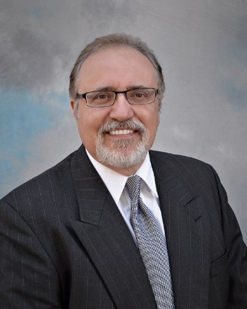
Steven Pappas, M&A MI
Partner
Touchstone Advisors LLC
860-669-2246 (Office)
spappas@touchstoneadvisors.com

###

