The (Breaking) Bad Path to Enlightenment and Sobriety: Learn From Walter White’s Mistakes
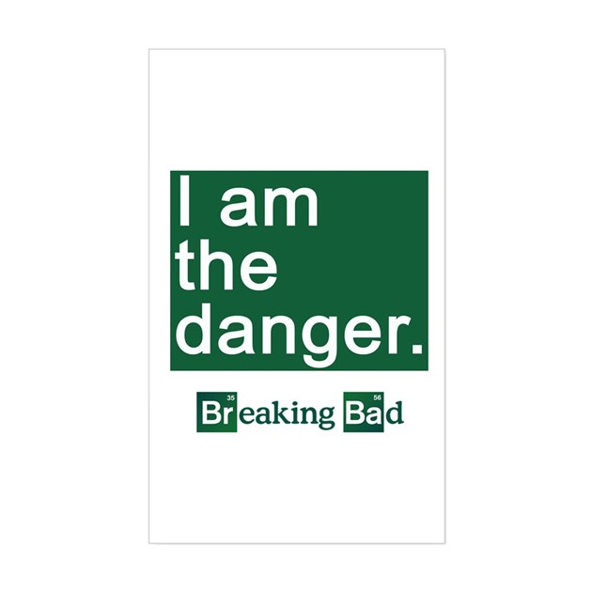
By Lee A. Eide

