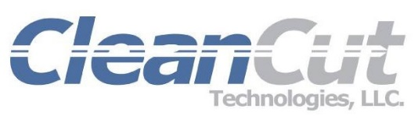
For More Information Contact:
Brian Whalen, Dir. Sales & Mktg.
Ph: 714. 864.3500 x3502
Email: brian.whalen@cleancuttek.com

For Immediate Release
CLEANCUT TECHNOLOGIES ANNOUNCES “VAULT” PACKAGING SYSTEM FOR MEDICAL DEVICES
Optimum Retention and Safety for Medical Devices Achieved with Pouch Card and Tray Combo

ANAHEIM, Calif. (September 18, 2017) -- CleanCut Technologies, a leader in medical device packaging, has announced the latest in the company’s portfolio of packaging products. The “Vault” packaging system is an innovative alternative to pouch-style packaging that protects and retains medical devices. The system combines a universal thermoformed tray with the flexibility and versatility of CleanCut’s HDPE pouch cards.
With almost limitless retention elements and design flexibility, CleanCut’s pouch cards are manufactured to the unique requirements of medical device manufacturers’ products.
By inserting the customized pouch card into a universal tray, changes to the card can be made quickly and easily - without the cost and long lead time associated with revising and manufacturing a mold for a tray change.
Benefits of the Vault packaging system may include shorter validation times associated with product changes, line extensions and the release of similar “family” devices. Once the Vault has been validated, additional devices may be launched utilizing the same tray and small modifications to the card that may not warrant full validations based on density, design and proper justification.
Pouch cards are manufactured in CleanCut’s ISO certified Class 8 cleanroom and then transported into a Class 7 cleanroom for assembly, cleaning, inspection, double poly bagging and labeling.
CleanCut’s HDPE pouch cards meet the Packaging and Packaging Waste Directive (94/62/EC and 2004/12/EC) for limiting packaging weight and volume, while meeting green initiatives for the utilization of recyclable packaging materials.
For more information, visit: http://www.cleancuttek.com/medical-device-packaging-products/#hdpe-pouch-cards
####
About CleanCut Technologies, LLC
CleanCut Technologies is an FDA QSR registered and ISO 13485 certified one-stop source medical device packaging company located in Anaheim, California. Its products are manufactured in Class 7 (10,000) & Class 8 (100,000) certified environments with full traceability. For our full line of products and services, visit: www.cleancuttek.com

