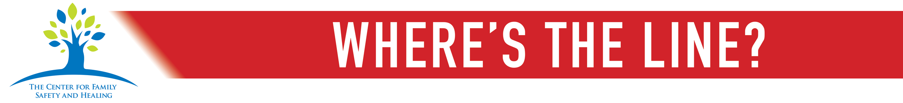

FOR IMMEDIATE RELEASE
CONTACT:
Karen S. Days 614.722.5960 or Toi Vivo 614.774.9219

October 12, 2017
The Center for Family Safety & Healing hosts’ inaugural Where’s The Line? Event
Columbus, Ohio--Join us tonight for a “Taste of Easton” featuring the best cuisine Easton has to offer and support awareness of Domestic Violence month (October 2017). The event will benefit the Bystander Education Campaign, which includes media promotion throughout Central Ohio in print, television, online, radio and outdoor billboards.
The campaign is a first-of-its kind effort designed to increase awareness of family violence and to provide appropriate resources to individuals who witness potential acts of family violence. The Center’s President, Karen Days states, “In order to give bystanders in Central Ohio a resource to safely and appropriately help victims, the Where’s The Line? Campaign is designed to increase awareness of family violence and to change the behavior of individuals who may be witnessing such acts.” We have enclosed more information about the campaign and you may also visit http://wherestheline.info/ for additional details.
The fundraising event will take place Thursday, October 12, 2017, from 5:30pm-8pm at Germain Lexus of Easton.
The Center for Family Safety and Healing fully addresses all aspects of family violence, including child abuse and neglect, teen dating abuse, domestic violence, and elder abuse. Our multidisciplinary team approach includes a one-stop, coordinated response to family violence for individuals and families through partnerships with law enforcement, child protective services, prosecution, and a wide range of community resources along with an expanded forum for education, advocacy, and ongoing research. Partners include CHOICES for Victims of Domestic Violence, the Columbus Division of Police Special Victims Bureau, Franklin County Children Services, the Franklin County Prosecutor’s Office, Nationwide Children’s Behavioral Health Services, and Nationwide Children’s Division of Child and Family Advocacy.
For more information, go to www.familysafetyandhealing.org or www.facebook.com/familysafetyandhealing/

###

