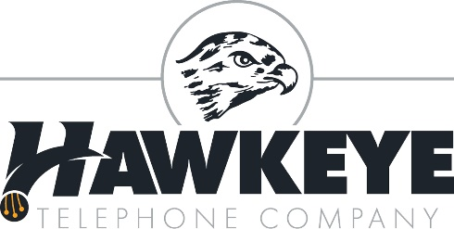
FOR RELEASE ON: October 16, 2017
Hawkeye Telephone Company
Alex Soderquist
563-427-3222
Manager@hawkeyetelephone.com

Hawkeye Telephone Company Announces Free Internet for Customers

Today, Hawkeye Telephone Company (HTC), a local company providing Hawkeye and the surrounding northeast Iowa communities with modern phone and Internet services, announced it will be offering FREE Gigabit Internet to new and existing customers. HTC believes the digital divide between rural America and the urban centers must be closed to provide the quality of life that rural Iowa deserves.
HTC has been working tirelessly to install and upgrade the new fiber-optic system to its customers. The rural Iowa company is dedicated to offering the best in internet and phone services, which is why it is rolling out its new fiber-optic Internet. It is the fastest form of broadband technology on the market today, and HTC is excited to offer this service, free of charge, to all customers in the Hawkeye exchange.
While some may believe landline phone service to be obsolete, Hawkeye Telephone Company still recognizes the importance of reliable home and business phone service, which it has provided to its customers for over 104 years. HTC telephone service includes features such as caller ID, call waiting, conference calling, and much more. It is because of this continued belief in the importance of landline phones that HTC has decided to make their internet complimentary when bundled with its telephone service, so customers can enjoy the continued ease and use of land line phones, along with the new fiber-optic system.
About Hawkeye Telephone Company:
Hawkeye Telephone Company was established in 1913, and is an independent telephone company located in Hawkeye, Iowa, serving the city of Hawkeye and the telephone exchange in the surrounding area. Hawkeye Telephone has developed several services and partnerships to provide the best technology to its customers. Please contact us for all your communication services at 563-427-3222 or toll free at 1-800-369-9131.

# # #

