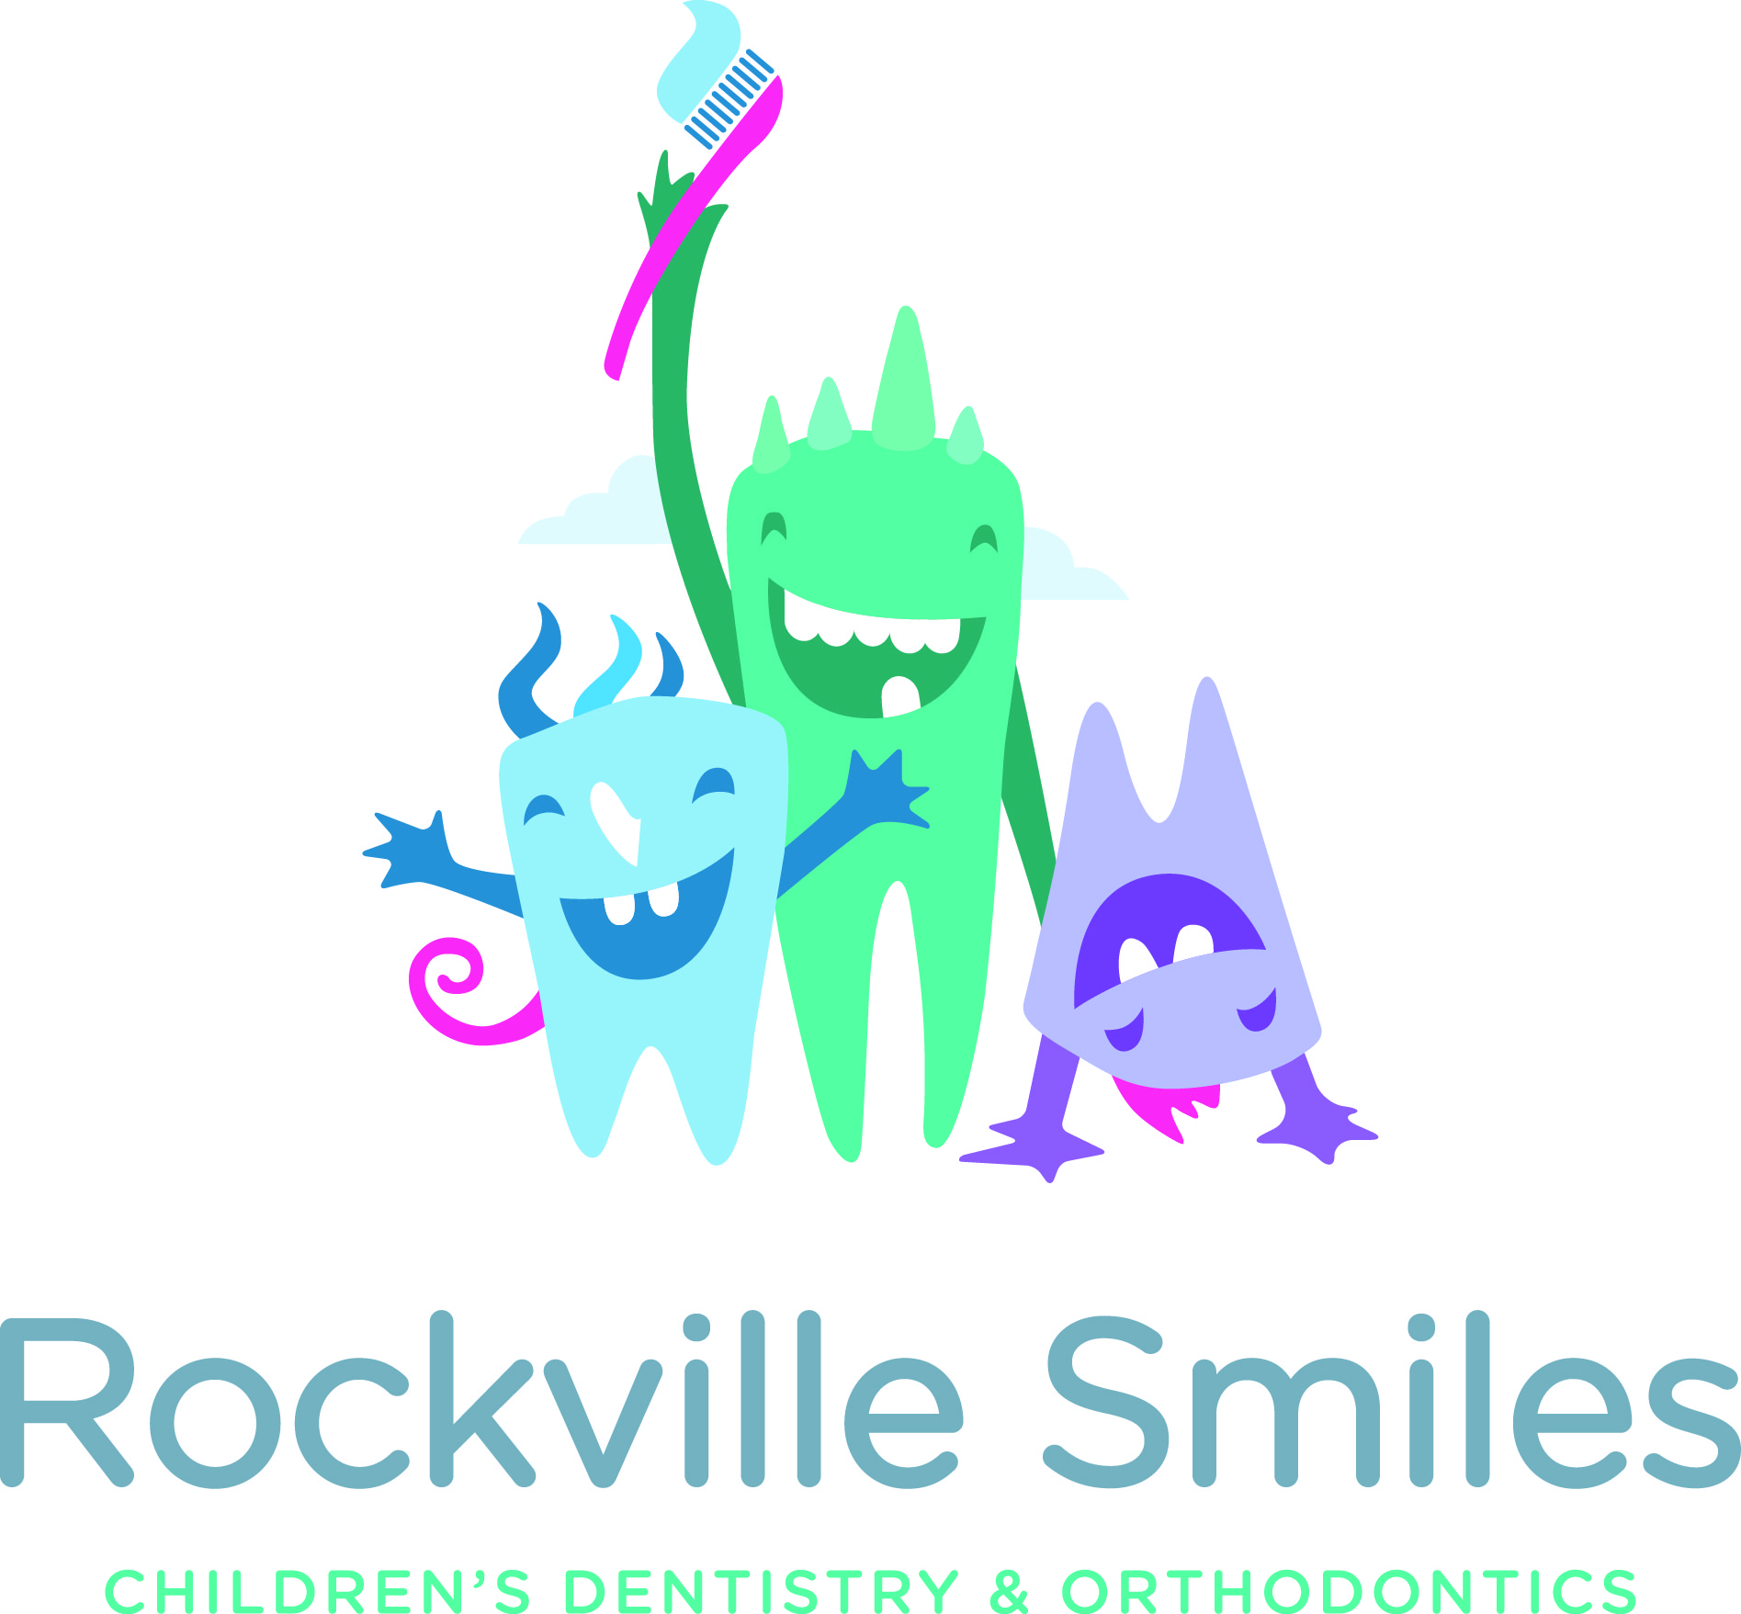
For Immediate Release
Colleen@imageorthodontics.com
916-261-6483

ROSEVILLE CHILDREN’S DENTIST AND ORTHODONTIST GIVES CASH FOR CANDY To SUPPORT THE TROOPS – Rockville Smiles Announces Halloween Candy Buy-Back Program
Roseville, California – Rockville Smiles is once again holding its annual Halloween candy buy-back program, November 1 – 3, 2017.
This is the second year that Rockville Smiles has offered the program which is designed to accomplish two goals. First, the program entices young patients to donate candy that might be harmful to their orthodontics and secondly it encourages children to give back by donating their candy to the men and women serving our country overseas.
“I see more cases of broken brackets, wires and liners after Halloween,” said orthodontist Dr. Marina Milstein. “Our candy buy-back program gives our patients and the Roseville community a cash alternative to eating candy. Plus, our staff loves working with Move America Forward to donate the candy for care packages to our troops.”
“Limiting excess sweets, daily brushing and flossing go a long way to preventing tooth decay,” said pediatric dentist Dr. Dmitry Pivnik. “People in the Roseville community are very generous with candy. Last year we gave away over $1000 to local kids and patients. We really hope we can double that this year!” added Pivnik.
The program is simple. Any trick-o-treater or patient can come into our practice at 721 Pleasant Grove Blvd. in Roseville from November 1-3, 2017. Our staff will weigh the child’s candy and give each child $1 for every pound of candy they bring in. We also invite local schools to join the fun. For every pound of candy they collect, we will donate $2 per pound back to the school.
Rockville Smiles has partnered with non-profit Move America forward to process all the candy, pack and ship it to our troops. We have also partnered with Make-a-Wish. Any child donating their candy on behalf of Make-a-Wish will receive $1 per pound of candy plus, Rockville Smiles will donate $1 per pound to the non-profit on the child’s behalf.

About Rockville Smiles
Formerly Image Orthodontics, Rockville Smiles was founded in 2016 and expanded to include pediatric dentistry as well as orthodontics. Rockville Smiles uses the latest technological advancements in the industry, such as invisible ceramic braces, lingual braces, and Invisalign® to treat patients. The practice also specializes in pediatric dentistry and is dedicated to the oral health of infants, children, adolescents and patients with special health care needs.

About Move America Forward
Move America Forward (MAF) is a nonprofit military charity based in Sacramento, California and the nation’s largest grassroots pro-troop organization dedicated to supporting the brave men and women of our Armed Forces. Their mission is to provide care packages and letters from grateful Americans to the troops deployed in combat areas around the world. MAF has sent over 345 tons of care packages to deployed troops and continues to this day. MAF is supported by hundreds of thousands of pro-troop activists, veterans, and military families all across the nation. They work with other non-profits, military service organizations, corporate sponsors, community networks and private citizens to support the U.S. Military and demonstrate affirmatively their appreciation and admiration for their service to America.

About Make-a-Wish
Make-A-Wish® Northeastern California and Northern Nevada was established in 1983 as one of the early local chapters of Make-A-Wish® America, which is the leading wish-granting organization in the country. Since then, it has granted nearly 5,000 wishes to children within its 37-county service area. The mission of Make-A-Wish® is to grant wishes to children, age 2 ½ to 18, with life-threatening medical conditions to enrich the human experience with hope, strength, and joy.

