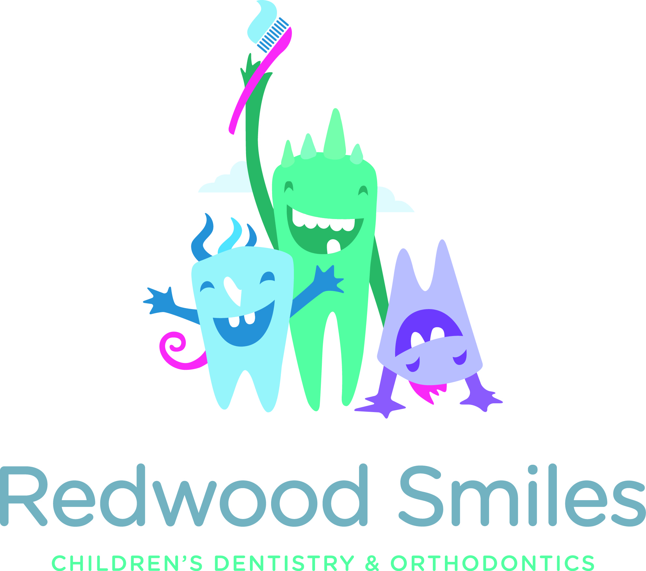
For Immediate Release
Colleen@imageorthodontics.com
916-261-6483

SWEET WAY To GET RID OF HALLOWEEN CAND -Redwood Smiles Takes a Stand Against Sweets this Halloween
Redwood City, California – Redwood Smiles is once again holding its annual Halloween candy buy-back program, November 1 – 3, 2017.
This is the second year that Redwood Smiles has offered the program which is designed to accomplish two goals. First, the program entices young patients to donate candy that might be harmful to their orthodontics and secondly it encourages children to give back by donating their candy to the men and women serving our country overseas.
“Eating sticky, chewy candy can do a lot of damage to braces or liners. The buy-back program allows us to offer a way of still rewarding the child with cash for candy and it gives us a chance to participate in a program designed to bring good will and cheer to the men and women in the military. I myself served in the U.S. Navy and was deployed to Afghanistan in support of Marine operations and it was wonderful to get care packages from home!” said orthodontist and retired Navy Lieutenant, Dr. Christopher Oviedo.
“We would love for everyone to minimize the number of sweets they eat,” said pediatric dentist Dr. Kerthi Golla. “Visiting your dentist every six months, and brushing and flossing daily, are great preventative measures, but doing away with excess sweets altogether would really be beneficial to your teeth. Kids should still dress up, go out, have fun and even eat some candy, but after picking out some favorite pieces, they will probably have about 10 pounds left, and nobody needs that much candy”
The program is easy. Any trick-o-treater or patient can come into our practice at 160 Birch Street in Redwood City from November 1-3, 2017. Our staff will weigh the child’s candy and give each child $1 for every pound of candy they bring in.
Redwood Smiles has partnered with non-profit Blue Star Moms to process all the candy, pack and ship it to our troops.

About Redwood Smiles
Formerly Image Orthodontics, Redwood Smiles was founded in 2016 and expanded to include pediatric dentistry as well as orthodontics. Redwood Smiles uses the latest technological advancements in the industry, such as invisible ceramic braces, lingual braces, and Invisalign® to treat patients. The practice also specializes in pediatric dentistry and is dedicated to the oral health of infants, children, adolescents and patients with special health care needs.

About Blue Star Moms
The Blue Star Moms is a non-political, non-sectarian, non-racial, non-profit Military/Veteran support organization with a charitable 501(c)(3) tax-exempt status. Members are proud mothers, stepmothers, grandmothers, foster mothers and female legal guardians who have children serving in the military, guard or reserves, or children who are veterans. They support Veterans, Service Members from all branches of the U.S. Armed Forces (regardless of their hometown), and honor our Gold Star Families and remember their children.

