Contact: Dave Madden  Compass Wines and Spirits, LLC  Phone: (708)-548-5363 | 7440 Santa Fe Drive  Hodgkins, IL 60525  www.compasswinesandspirits.com | 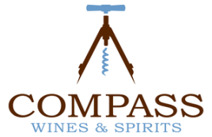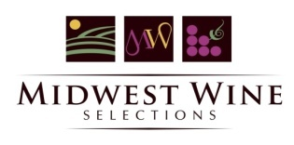

Press Release

Compass Wines and Spirits, LLC announces the acquisition of Midwest Wine Selections, LLC.
Accelerates strategic growth initiative of diversifying wine and spirits portfolio.
Chicago, October 1, 2017: Compass Wines and Spirits, LLC announced today that it has acquired Midwest Wine Selections, a leading distributor of several Midwest regional wine brands distributed throughout the Chicago metro market and surrounding 8 counties.
The company is pleased to also announce that Paul and Donna Goodwin, owners of Midwest Wine Selections, will be joining Compass as part of the Compass executive team and assist in the continued growth of the Midwest portfolio as Brand Managers. “We are extremely excited that Paul and Donna have agreed to stay on and continue the great work they have done over the past 10 years in building consumer awareness for some of the most iconic wine brands from the Midwest part of the country”, said Dave Madden, General Manager for Compass.
“The combination of the two companies is intended to strengthen the diversity of wine and spirits products distributed to both on-premise and retail accounts, thus making Compass a more valuable supplier to its customers”. Madden also said “This acquisition is consistent with our long term plans for Compass focused on both organic and strategic growth initiatives”.
Headquartered in Hodgkins, IL, Compass Wines and Spirits, LLC was established in 2011 by Joe Jensen and is one of the fastest growing wine and spirits distributors in the Chicago, IL and surrounding metro market.
Midwest Wine Selections, LLC was established in 2007 by Paul and Donna Goodwin who have been instrumental in assisting leading regional Midwest wineries expand their market presence throughout the Chicago area and the entire state of Illinois.

