Contact Rust Bullet, LLC  Telephone 1-800-245-1600  Email sales@rustbullet.com  Website www.RustBullet.com | FOR IMMEDIATE RELEASE  November 8, 2017

RUST bullet, LLC Introduces INDUSTRIAL-low voc coating

INDUSTRIAL-Low VOC: A High-Performance Rust Inhibitive Coating for Tough Commercial Jobs
Reno, NV, November 8, 2017– Rust Bullet, LLC introduces INDUSTRIAL-Low VOC, a professional grade rust inhibitive coating.
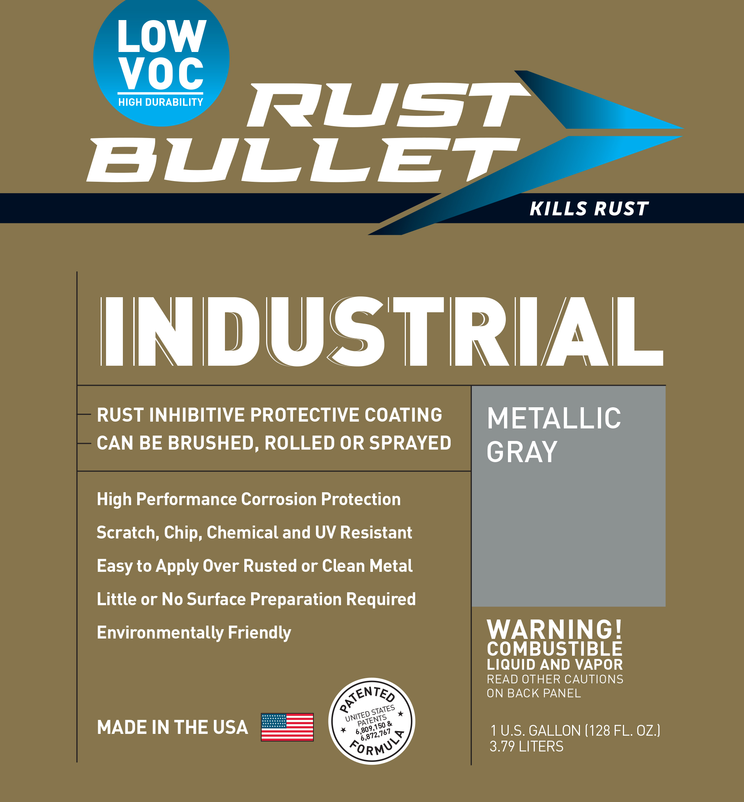
“Until now, professional applicators have not had coatings that deliver both exceptional performance AND VOC compliance in places like the South Coast Air Quality Management District. Today, Rust Bullet introduces INDUSTRIAL-Low VOC, a one component, 97 VOC g/l solution that delivers industry leading performance that is compliant in all 50 states and districts. Applicators and asset owners can solve corrosion problems with an easy to use coating backed by a 10-year warranty. ” said Mike Moore, CEO, Rust Bullet, LLC.

Rust Bullet went on to describe some of the key benefits of Rust Bullet Industrial-Low VOC:
- Outstanding adhesion and excellent resistance to abrasion
- 97 g/l VOC – 50 states and South Coast Air Quality Management District compliant
- High-performance corrosion protection
- Scratch, chip, chemical, and UV resistant
- Little to no surface preparation required
- 10 year limited warranty
- Two United States Patents
Rust Bullet, LLC is a coatings manufacturer, headquartered in Reno, NV, USA, specializing in protective, rust inhibitive and corrosion control coatings. Rust Bullet, LLC sells to businesses and consumers around the world through its global distribution network of distributors, resellers, and independent contractors. For more information, please contact Rust Bullet, LLC at 1-800-245-1600 or via email at sales@rustbullet.com.
# # #

