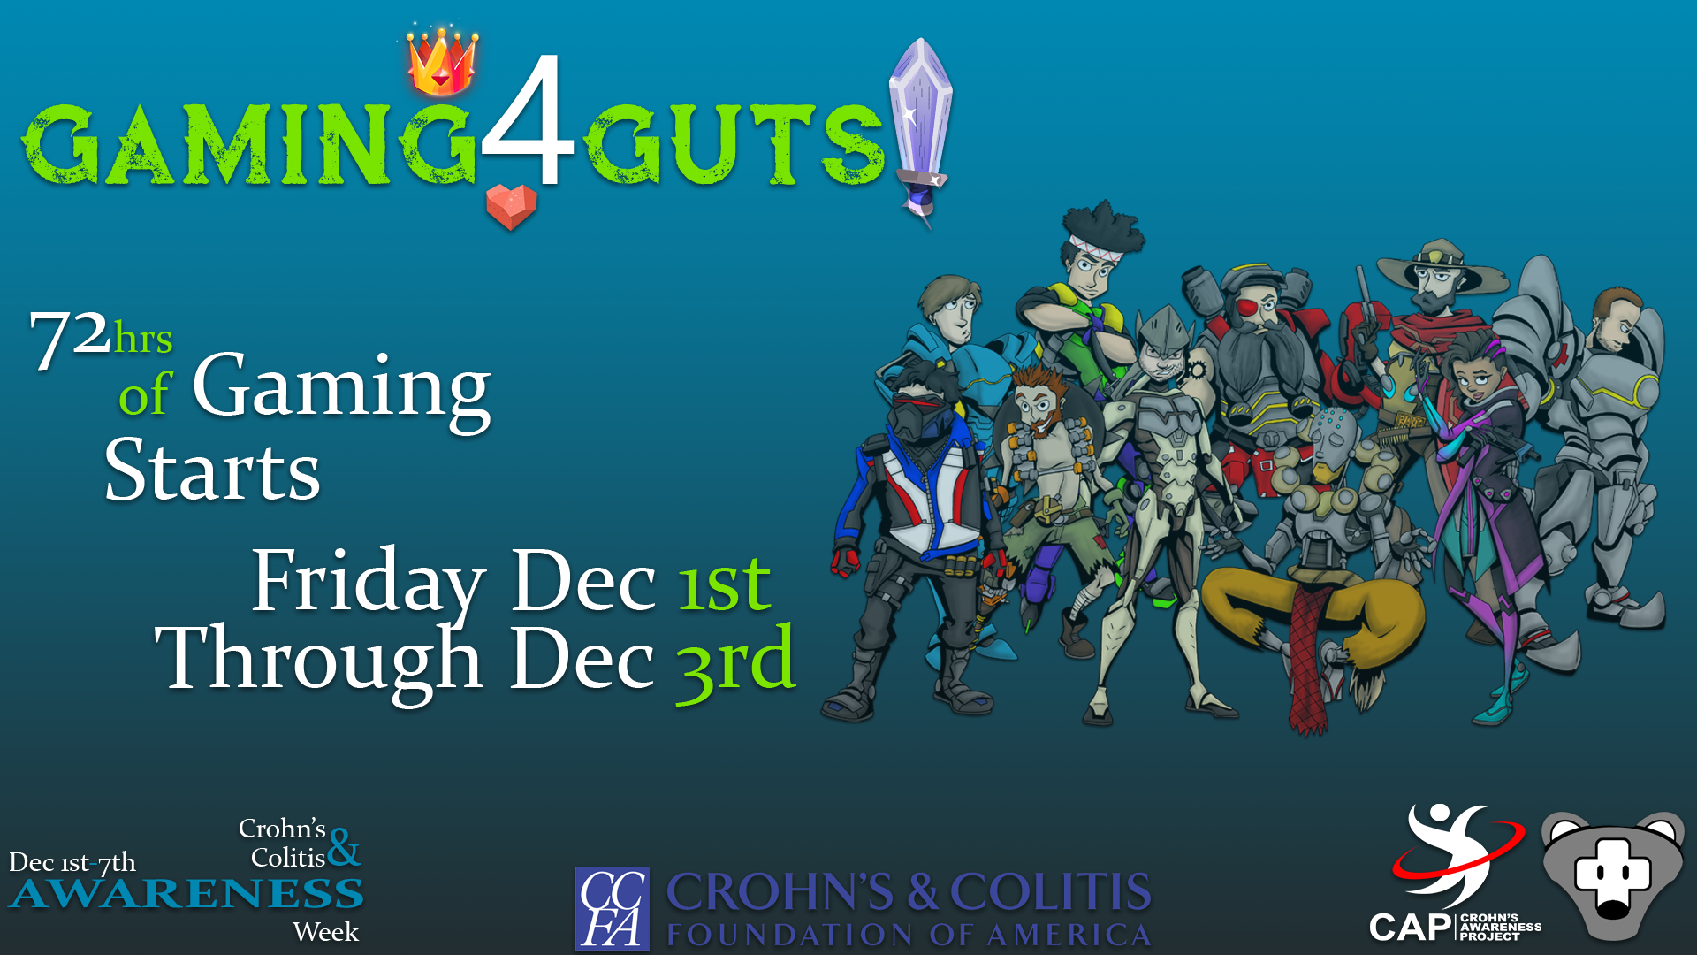

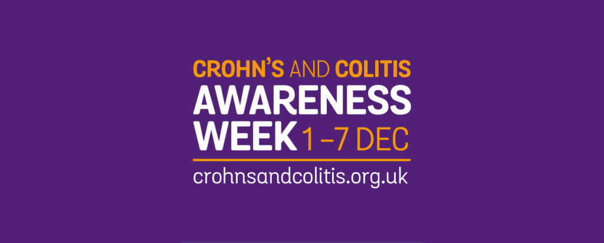

GAMING4GUTS – A NEW ONLINE GAMING COMPETITION BLAZES FUNDRAISING TRAIL FOR CROHN’S & COLITIS FOUNDATION OF AMERICA (CCFA)
72-Hour Gaming4Guts Event to take place December 1-3, 2017
Goal: $10,000
Innovative Initiative Created by Former Chicago Area Fire Fighter in Partnership with Others Afflicted with IBD (Inflammatory Bowel Disease)

Chicago, IL -- Inspired by the loss of his young mother from Crohn’s disease, Robby Barkoo (Palatine), who also suffers from the disease, co-created Gaming4Guts, an engaging online gaming initiative to raise awareness and funds for Crohn’s & Colitis Foundation of America (CCFA.)
“My goal was to combine my passion for online gaming with my commitment to helping people who suffer from this insidious disease. For many years, Crohn’s has kept me from pursing my dream of being a firefighter, kept me housebound, in constant pain, and feeling helpless. I knew I was not alone,” said Barkoo. “I needed to turn my feelings of isolation into a productive way to help others. The Internet connected me with dozens of people across the country who love gaming and want to help,” he added.
Barkoo forged a partnership with Canadian Brad Watson-Davelaar, who has severe Crohn’s, and Jon Trenbeath and his wife Jen from Beaumont, Texas, whose children suffer from Crohn’s. They immediately stepped up to collaborate with Barkoo. “We wanted to create alternative ways to donate to this cause – it inspired us. We even added Overwatch Heroes, the hottest game on the market, to add new energy to the fundraiser,” he concluded.

-more-
Page 2
Here is how to participate in Gaming4Guts:
The video games broadcast via an online service through Youtube or Twitch.tv.
- Create a Twitch.tv or YouTube Account
- Gameplay is easily accessible if you have a PlayStation 4 or X Box One as both of these can broadcast straight to Twitch.tv
- Sign on to www.tinyurl.com/g4g2017 and join a team, or start one of your own. You can even play solo
- It doesn’t matter what, how long, or how well you play, Gaming4Guts has gamers of all ages, skill level, and dedicated playing times
- Please promote CCFA and Gaming4Guts while you play by adding the donation link to your profile or mention it while you play
- To donate you simply go to the same link that you would use to sign up to play with us -- www.tinyurl.com/g4g2017 you donate as much or as little as you like. Anything is greatly appreciated

The 2017 Fundraising goal is $10,000. To date, Gaming4Guts has raised $2,125.

“Last year, we had live streaming for 48 hours. This year, Gaming4Guts is increasing our playing time to 72 hours – December 1-3. With the help of those who have this disease or love someoe who does, we believe we can reach – and exceed our $10,000 goal,” said Jon Watson-Davelaar.

More about Crohn’s Disease

According to the Crohn’s Colitis Foundation, approximately 1.6 million Americans suffer from this disease, including about 80,000 children. Extreme abdominal pain, diarrhea, weight loss, anemia, and fatigue are symptoms. Some people may be symptom free most of their lives, while others have severe chronic symptoms that last a lifetime. Crohn's disease cannot be cured. Medications such as steroids and immunosuppressants are used to slow the progression of disease. If these aren't effective, a patient may require surgery. Patients with Crohn's disease often need to have regular screenings for colorectal cancer due to increased risk.

More about Robby Barkoo
Born premature and with dyslexia, Robby grew up in Skokie watching his young mother, Marcia, suffer from this insiduous disease. Inspired by how she gracefully managed unrelenting pain and countless medical appointments while tirelessly raising funds for East Prairie School’s PTA , Robby pursued his childhood dream: To become a fire fighter.

In 2003, he graduated from The Firefighter Training Academy before joining the Northfield Fire Rescue Department, a place he felt immediately at home. After just one year, due to increasingly painful and debilitating symptoms, Robby had to quit his dream job. What followed were dozens of surgeries, one of which had a life-changing result, leaving a perpetual open wound, preventing him for sitting for any length of time or pain-free mobility.

-more-

Page 3

Determined to not let this condition define him, Robby and three other Crohn’s patients formed an online community called “The Crohnies,” who have designed “Gaming4Guts,” an online gaming site that raises money for the National Crohn’s and Colitis Foundation. For more information about “Gaming 4Guts” go to:
https://fundraise.ccfa.org/campaign/gaming4guts/c148725
Contact:
Joanie Bayhack at jebayhack@gmail.com or 312-543-4242.

###

