### PRESS RELEASE ###

For Immediate Release
Contact: Emilia Crotty
Executive Director, Los Angeles Walks

Emilia@LosAnglesWalk.org
508-916-7863

Events Across the Southland Mark
26th Annual World Day of Remembrance for Road Traffic Victims

When it comes to fatal traffic crashes, Los Angeles is #1 - the deadliest of nine peer cities in the United States. Over the last few years, the problem has gotten worse. As the U.S. economy improved and gas prices declined, more people took to the roads than ever before. Here in Los Angeles, they merged onto streets that have not been re-designed since the 1950’s. The result: fatal traffic collisions in L.A. have increased by 28 percent in the last two years. More than 1,000 people suffered severe injuries in traffic collisions in L.A. in 2016 and 263 were killed.

In 1995, European nations also faced this public health problem, as traffic fatalities occurred at an alarming rate. In response, the European Federation of Road Traffic Victims (FEVR) held the first World Day of Remembrance for Road Traffic Victims, known as "World Day," on the third Sunday of November. The day honored the lives of hundreds of thousands of people killed in preventable traffic collisions that year. Within a few years, annual World Day events were held not only across Europe but Africa and Asia as well. By 2005, the United Nations recognized and ratified World Day of Remembrance for Road Traffic Victims as an official "UN Day" to be recognized by all member nations. Last year, the number of recognized World Day events increased to 100.

Of the top 10 richest countries in the world, the United States is the deadliest for traffic fatalities. More than 40,000 people died on U.S. streets and highways in 2016, a jump from the roughly 35,000 annual fatalities that had become standard. World Day of Remembrance only gained traction here recently, though. 2016 was the first year that advocates marked World Day in Los Angeles, where traffic collisions are the leading cause of death for children.

Today, more funding than ever before is dedicated to traffic safety improvements in Southern California, where this problem is being recognized as a public health crisis affecting everyone. The City of Los Angeles has embarked on an ambitious effort to eliminate traffic fatalities and severe injuries by 2025 through a program called Vision Zero.

In this context, World Day of Remembrance activities expanded in Los Angeles this year. Across three days, the theme of World Day events centered around the realization that fatal and severe traffic collisions are preventable - a core principle of the Vision Zero program. Numerous studies have found that between 93% and 99% of all traffic crashes are caused by human error. World Day events held simultaneously across the country highlighted these facts.

The first Los Angeles event was held Friday, the 17th of November outside City Hall East in Downtown Los Angeles.
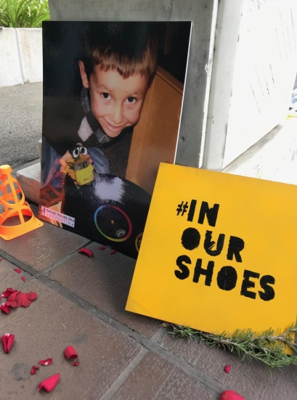
Called #inourshoes, the event was a collaboration of Southern California Families for Safe Streets and the L.A. Vision Zero Alliance, both led by Los Angeles Walks. SoCal Families for Safe Streets is a group of individuals who have lost loved ones in traffic crashes or have suffered their own traffic-related injuries. The L.A. Vision Zero Alliance is a coalition of community-based organizations, non-profit special interest groups, and concerned citizens that supports and influences the City of Los Angeles’ Vision Zero initiative. Members include: AARP of Southern California, Advancement Project CA, Los Angeles County Bicycle Coalition, Youth Policy Institute, Streets Are For Everyone and many more organizations.

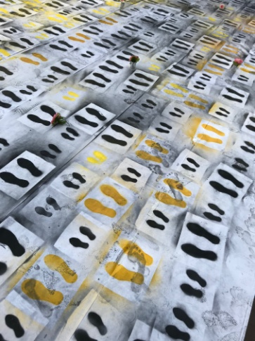
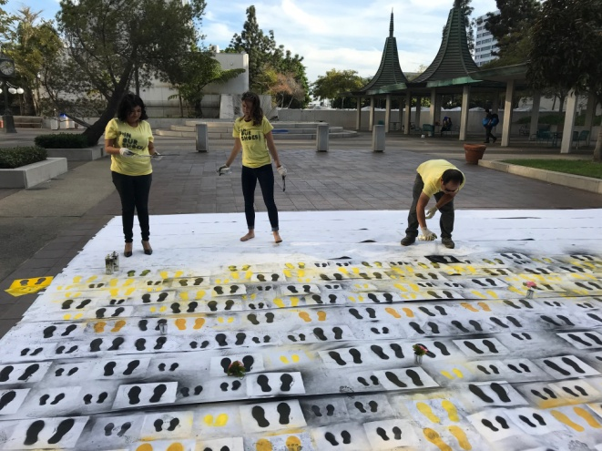
Together, they hosted an interactive memorial that honored the more than 500 people killed on L.A. city streets since August 2015, when the city launched Vision Zero. SoCal Families for Safe Streets, Alliance partners, and event participants spray painted 503 footprints to represent those killed in preventable traffic crashes.

They also added shoes and personal mementos to the memorial and were asked to consider what life is like for families shattered by preventable traffic deaths.

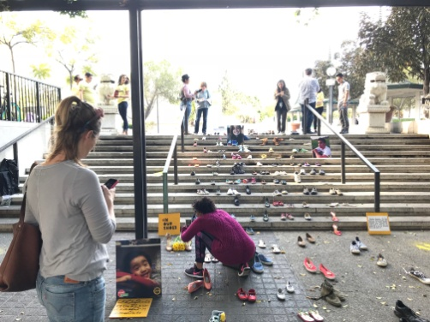

They encouraged passersby to sign a safe streets pledge that urged Mayor Garcetti and Los Angeles City Council members to use all of the tools available to create safer streets.

On Saturday, November 18th, Streets Are For Everyone (SAFE) hosted a Finish The Ride® Memorial Ride around the one-year anniversary of the death of Jeff Knopp -- a military veteran, father and Sunland-Tujunga resident who was struck from behind and killed while riding his bicycle on a particularly dangerous stretch of Foothill Boulevard with no bike lane.

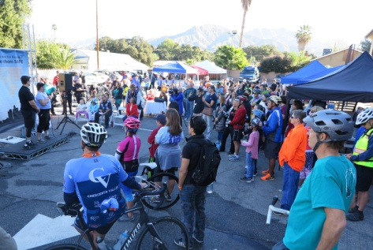
While this memorial ride was touted as a celebration, there was not a dry eye in the crowd of hundreds when (as part of the opening ceremony) Jeff's widow, Jennifer Knopp, brought Joshua (the driver who killed Jeff) onto the stage, publicly forgave him and hugged him. Joshua then went on to tell all in attendance how his life was also crushed the day he hit Jeff and how he now stands with Jennifer in efforts to make streets safer for all road users.
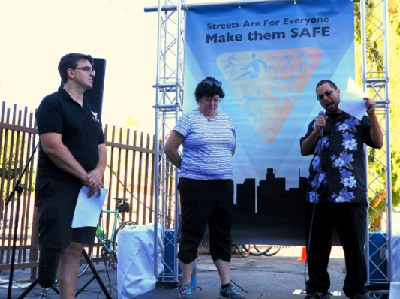
Joshua closed his speech by saying, "I thank God for Jennifer's forgiveness, for the opportunity to be here to face all of you, and to tell you that in whatever way I can, I will fight for safer streets so none of you become another Jeff Knopp."

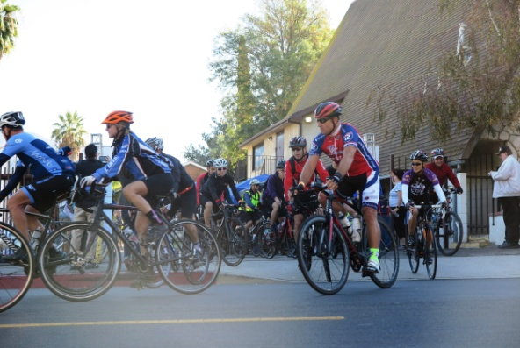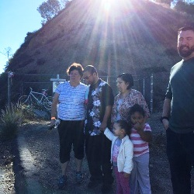
Cyclists taking off to Finish The Ride Jennifer consoling Joshua and
his family at the location of
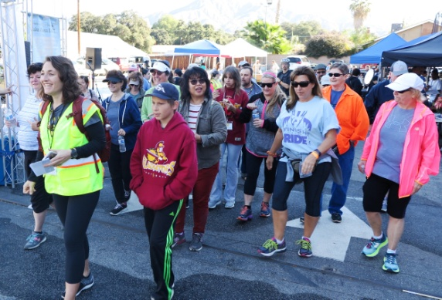
Jeff’s Ghost Bike

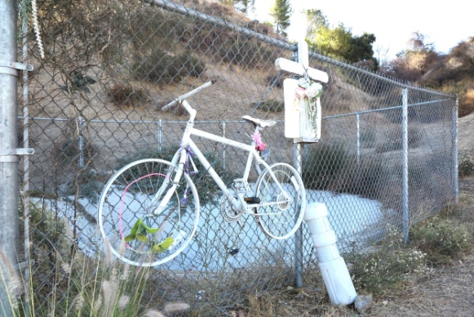

Jeff’s Ghost Bike The memorial walk to the
Ghost Bike location.

The three days of events wrapped up on Sunday, November 19th with a vigil on the steps of Pasadena City Hall lead by Pasadena Complete Streets Coalition and Day One.

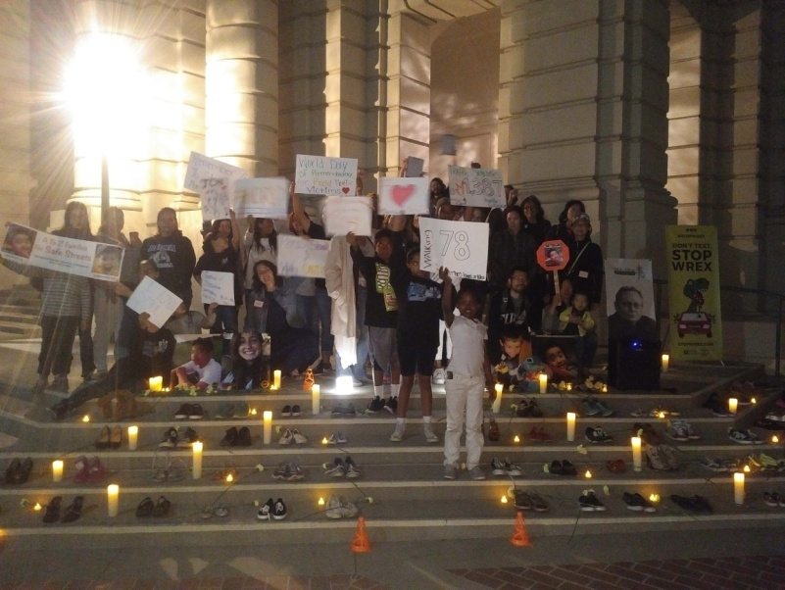

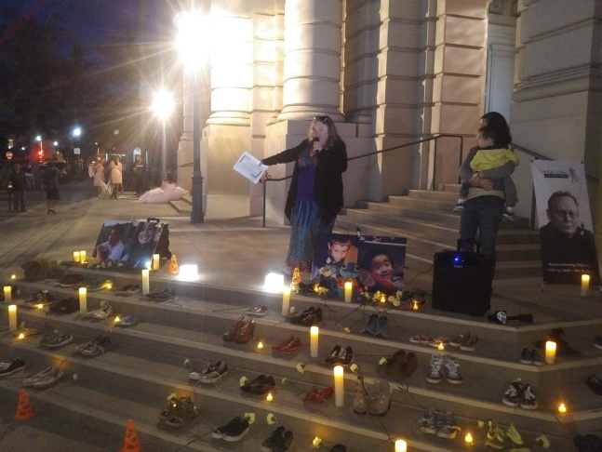
Members of SoCal Families for Safe Streets shared stories about the loved ones they’ve lost forever; encouraged people to be responsible, respectful drivers; and urged policymakers to take action to create a safer street system that no longer results in death and severe injury.

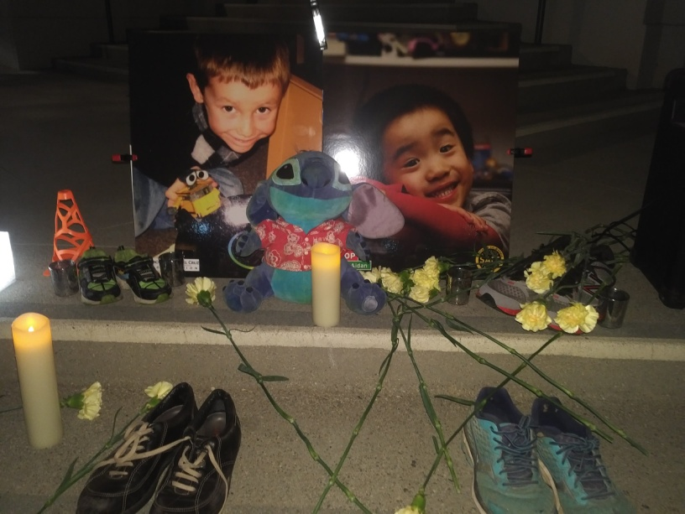
Emilia Crotty, Executive Director of Los Angeles Walks, explained the motivation behind the events,

"The tragic and horrific deaths and severe injuries that occur every single day on Los Angeles streets are FULLY preventable. As a city, we can no longer accept the status quo and need to apply every tool available to prevent these traffic collisions."

-----------------------------------------------

Information about traffic fatalities in Los Angeles and the Los Angeles Vision Zero initiative can be found at http://visionzero.lacity.org/. For more information on the L.A. Vision Zero Alliance go to http://www.visionzeroalliance.org/. For information on Southern California Families for Safe Streets go to http://www.losangeleswalks.org/socal_families_for_safe_streets.

Information about the nonprofits featured in this release can be found on their respective websites. Additional interviews are available upon request. Please contact Emilia Crotty at: emilia@losangeleswalks.org.

© 2017 Los Angeles Walks. Finish The Ride is a Registered Trademark owned by Streets Are For Everyone and used with its permission.

