Ski Boot Fitting Myths Debunked
By Roger Neiley

Most of us use seatbelts religiously. We try to avoid “unhealthy” foods. We exercise. We floss. In many parts of our lives, we fall in line with conventional wisdom that makes life easier. In selecting our ski equipment, conventional wisdom- like having our bindings regularly checked- is often a good thing.
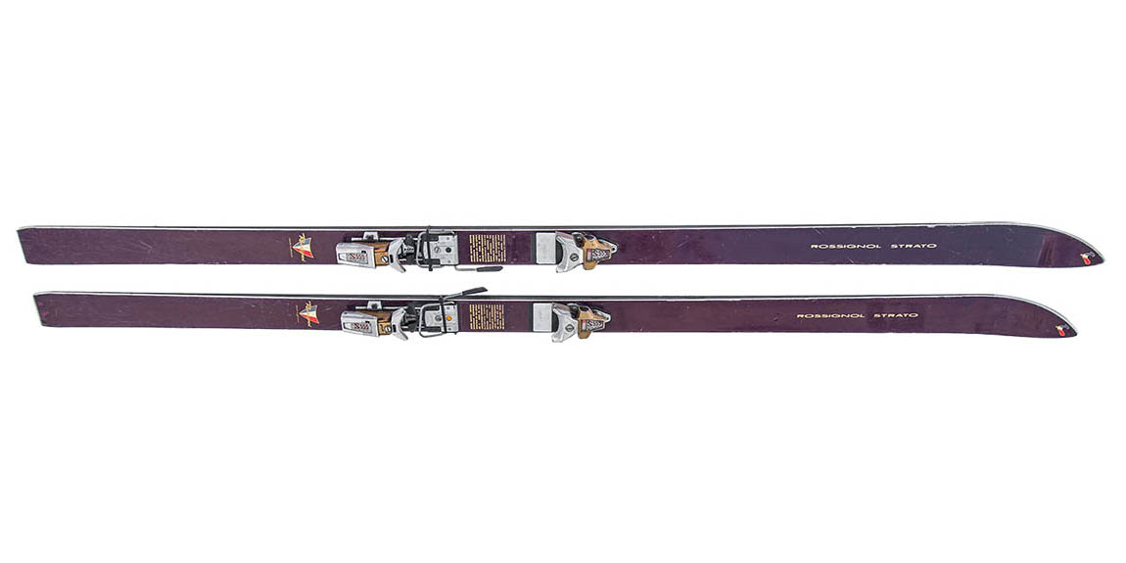
But, conventional wisdom can fail us when its advice is outdated, like when technology brings new products into sports. You don’t need a heavy wool sweater when a breathable soft shell is warmer and drier.
One of the biggest improvements in ski equipment design over the past twenty years has been in ski geometry and construction. Can you imagine going back to 207cm Rossi Stratos for bumps or powder??? Me neither.

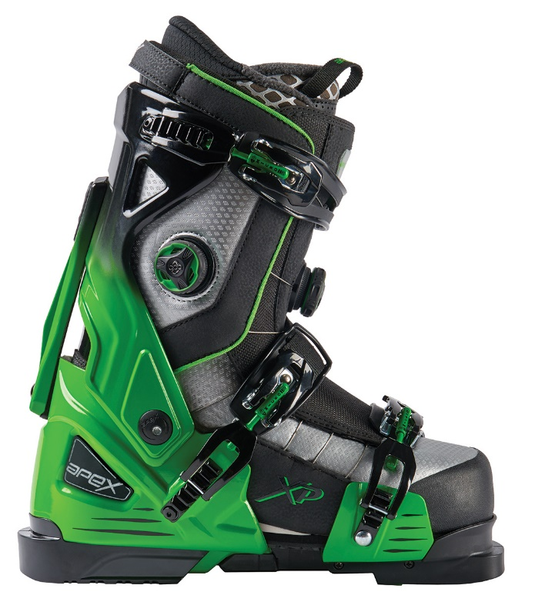
Yet, when it comes to ski boots, a lot of conventional wisdom is a holdover from the days of long, narrow, straight skis. Those designs were unwieldy, hard to turn and even harder to carve. Boots had a lot of heavy lifting to do back then, and while there are many good quality boots on the market, most of the basic boot designs are unchanged from the 1970’s!
At Apex, we believe that modern skis demand a modern approach to ski boots.
We reject the idea that your feet should be packed into a shell two sizes too small to create enough support to edge effectively. We reject the need for extreme forward stiffness, or for the folly of buying a boot based on a fictitious “flex index,” when there is no need to load up a ski tip that’s way out yonder. We reject boots that bulge and compromise lateral support when modern skis are specifically designed to respond to subtle edging. And, we reject having to accept cold achy feet caused by an unyielding, hard-to-get-into overlap shell. Enough of all that!
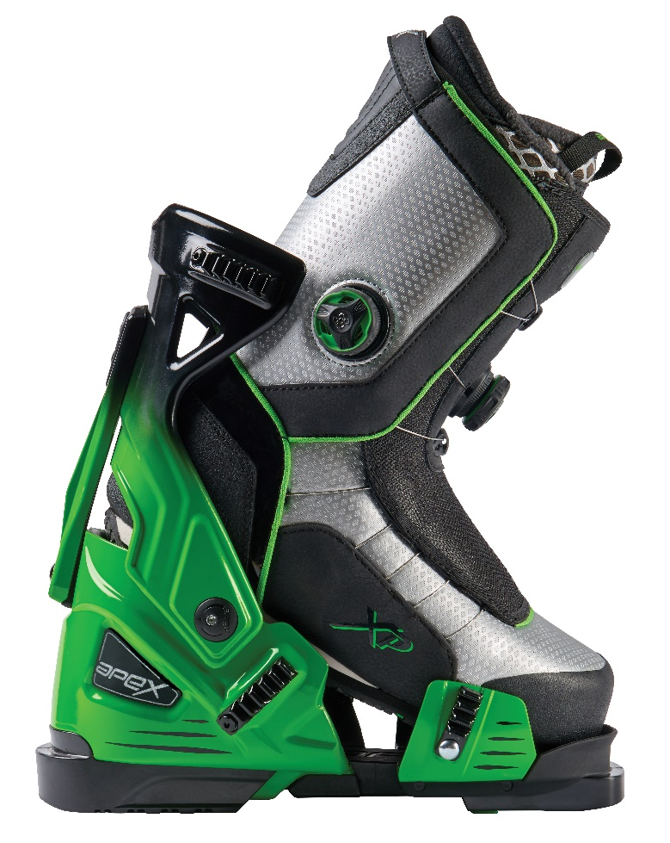
The patent-pending Apex design is different and thousands of skiers have found that it’s better. A super-comfortable, Vibram soled walking boot provides individually contoured fit via almost infinitely adjustable Boa closures. The walking boot fits perfectly into a three-buckle Open Chassis that integrates with any alpine binding.
Forward flex- easily adjustable via Apex’s Tri-Flex inserts- is moderate and comfortable. Medial support, on the other hand, is firm, consistent and super responsive. This is the way modern skis are designed to be driven, and since the Apex chassis is open in front for easy entry, the medial and lateral support structure can be much stiffer than your old overlap shell. That design had to be a compromise: soft enough to be pried open to get in, but stiff enough to provide some measure of medial-lateral support. By contrast, the Apex design allows the chassis to do one thing extremely well; it transfers your leg energy efficiently and powerfully to your skis for control like you’ve never felt before.
Now, it IS possible to get Apex quality responsiveness in a conventional boot- - downsize. Crush your foot. Grind and stretch. Minimize insulation. Accept unneeded extreme-forward stiffness to get reasonable lateral support when the shell bulges. How is all that going to feel after lunch? Are your feet up to it? To consider the alternative, check out the smiles on the faces of Apex converts from first chair to last, day after day.
Our advice: take conventional wisdom with a grain of salt. Challenge authority. Consider whether a boot designed when Nixon was president will let you access all the performance in your modern skis. Our friendly suggestion, as committed skiers ourselves, is to give Apex a try and see what you’ve been missing!
You can check out the latest Apex models and get expert advice here.

