Contact Rust Bullet, LLC  Telephone 1-800-245-1600  Email sales@rustbullet.com  Website www.RustBullet.com | FOR IMMEDIATE RELEASE  December 1, 2017

RUST bullet, LLC Introduces Automotive-low voc coating

AUTOMOTIVE-Low VOC: High Performance Corrosion Protection for

Cars, Trucks and all Vehicles
Reno, NV, December 1, 2017– Rust Bullet, LLC introduces AUTOMOTIVE-Low VOC: Long Lasting Durability and VOC Compliance Everywhere.
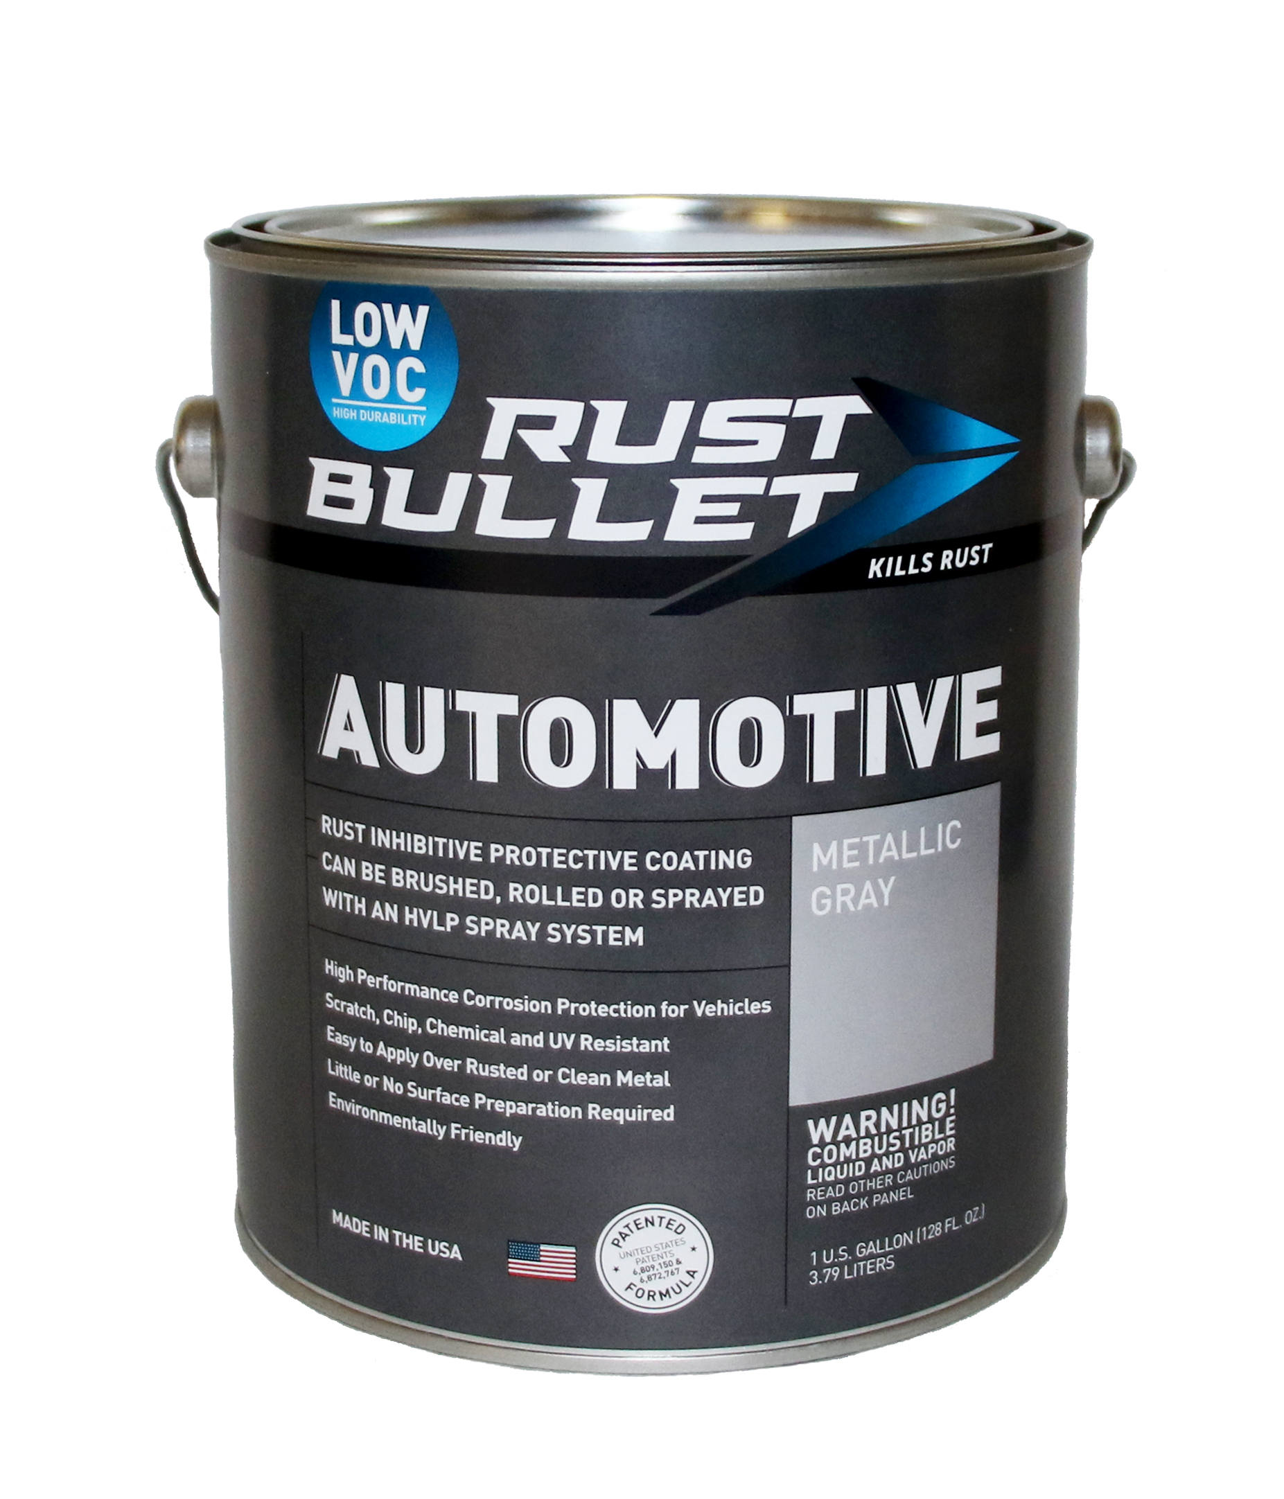
“One of the big challenges do-it-yourselfers and auto repair shops face is the choice between high performance rust inhibitive coatings and VOC compliance. No longer. Rust Bullet, LLC's new AUTOMOTIVE-Low VOC coating has all the same great performance as our legacy product AND is compliant in every state and air quality management district. With just 97 g/l of VOCs AND a 10 year limited warranty, solving automotive rust problems just got a lot easier.” said Mike Moore, CEO, Rust Bullet, LLC.

Rust Bullet went on to describe some of the key benefits of Rust Bullet AUTOMOTIVE-Low VOC:
- Outstanding adhesion and excellent resistance to abrasion
- Designed to work with automotive spray systems
- Environmentally friendly
- 97 g/l VOC – 50 states and South Coast Air Quality Management District compliant
- High-performance corrosion protection
- Scratch, chip, chemical, and UV resistant
- Little to no surface preparation required
- 10 year limited warranty
- Two United States Patents
Rust Bullet, LLC is a coatings manufacturer, headquartered in Reno, NV, USA, specializing in protective, rust inhibitive and corrosion control coatings. Rust Bullet, LLC sells to businesses and consumers around the world through its global distribution network of distributors, resellers, and independent contractors. For more information, please contact Rust Bullet, LLC at 1-800-245-1600, via email at sales@rustbullet.com, or on our website at RustBullet.com
# # #

