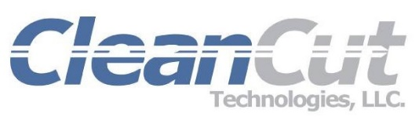
For More Information Contact:
Karen Koenes, Marketing Coordinator
Ph: 714. 864.3500 x3556
Email: karen.koenes@cleancuttek.com

For Immediate Release

CleanCut Technologies Named “2017 Top Workplace in Orange County” by the O.C Register
Company Ranks Number 20 out of 80 in Small Business Category

ANAHEIM, Calif. (Dec. 12, 2017) -- CleanCut Technologies (www.cleancuttek.com), a leader in medical device packaging, is proud to announce the company was recently named as a “2017 Top Workplace” by the Orange County Register.

This county-wide awards program was designed to shine a spotlight on local businesses in Orange County that operate with a clear mission, strong leadership and a vision for success. The O.C. Register honors companies that have strengthened the economy and community and genuinely care about their employees.

“Our employees are the cornerstone of our success”, said Tim Bell, President of CleanCut Technologies. “We are committed to creating a work environment where employees are appreciated and empowered to succeed, which ultimately results in the success of our customers,” he explained.

The Top Workplaces lists are based solely on the results of an employee feedback survey that asks about work life and company culture.

###

About CleanCut Technologies, LLC
CleanCut Technologies is an FDA QSR compliant and ISO 13485 certified one-stop source medical device packaging company located in Anaheim, California. CleanCut Technologies products include the Clipless Catheter & Guidewire Dispenser, HDPE Backer Cards, Pouches and Lids, and Cartons and Shippers. In addition, services include free design and prototyping, 3D printing, tube flaring, pad printing and contract manufacturing services. Products are manufactured in Class 7 (10,000) & Class 8 (100,000) certified environments with full traceability. www.cleancuttek.com

