KICKSTARTED: iA WRITER FOR WINDOWS

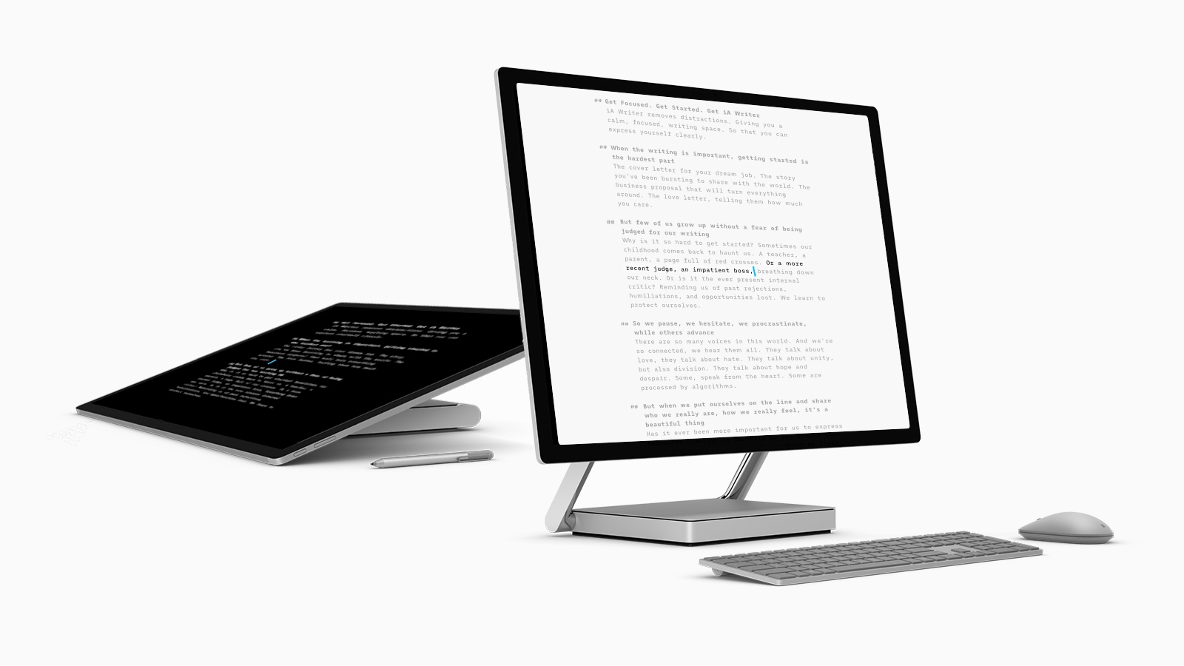

iA Writer is a professional writing app that removes distractions, offering a calm, focused writing space. In its seven years in production, iA Writer has been downloaded over two Million times on Mac, iOS, and Android. Next, iA turns to Windows to bring that same focused approach to the world’s largest desktop platform. To fulfill the vision they have for this app, iA has launched a Kickstarter campaign.

iA Writer removes distractions, providing a calm, focused writing space: It strips away everything that might stand between writers and how they feel, so that they can focus on the text.

iA Writer comes with Focus Mode, Full Screen And Markdown. Focus Mode is an experience where everything fades away except the sentence the writer is working on. According to iA, Focus Mode encourages diving into the flow and Full Screen puts the writing slate at center stage. Markdown provides a way to add structure and formatting using only text, which is faster than switching to a mouse.

What people have said about iA Writer for iOS, Mac and Android:

“Beautiful and Simple.” -The Guardian

“Writer has out-innovated Apple” -Fast Company

“Astonishingly simple. Everything goes away except for the writing experience.” -Stephen Fry

“Thanks for the simple - life seems to be to always throwing complex, simple and beautiful is best.” -Grant Frost.

“A couple of weeks ago, I forgot my iPhone at home while I went out to take care of some business. While taking care of my business, it was quite nice to feel isolated from the outside world. My only care was what was in front of me. Suddenly, I was feeling a lot less worried. This is sort of what I feel like when I'm working with iA Writer. With every other system, there is some distraction whereas with iA Writer I can easily dig into what I'm working on.” -Can Surmeli.

“iA along with vim have made it in my immortal list of must use apps, and they aren’t leaving it.” -Piotr Yordanov.

“Its simplicity betters my focus. Its beauty keeps my attention. I don’t remember not feeling good about writing in iA Writer. This is like having a room dedicated to deep thinking. Every time I would enter that room my mind would do its best. Maybe that is why this is hard to explain: you have to use it for a while before you experience it fully.” -Mostafa Hajizadeh.

“I guess it‘s the clean slate that it offers. It reminds me of a piece of paper I just need to put on my desk and start writing on. Thoughts can flow and as soon as I‘m ready I can go through the text and edit it like I would do on paper. But more efficiently as I don‘t have to use correction fluid. So it‘s like Super-Paper?” -Kevin Wammer.

“iA Writer was the first app I've ever bought on the AppStore. It was when I realised moving to Mac was a good decision.” -David Garcia.

Screenshots, video and more info on: ia.net/writer/blog/kickstarting-ia-writer-for-windows/
Kickstarter campaign on: https://www.kickstarter.com/projects/reichenstein/a-focused-writing-app-for-windows

