FOR IMMEDIATE RELEASE

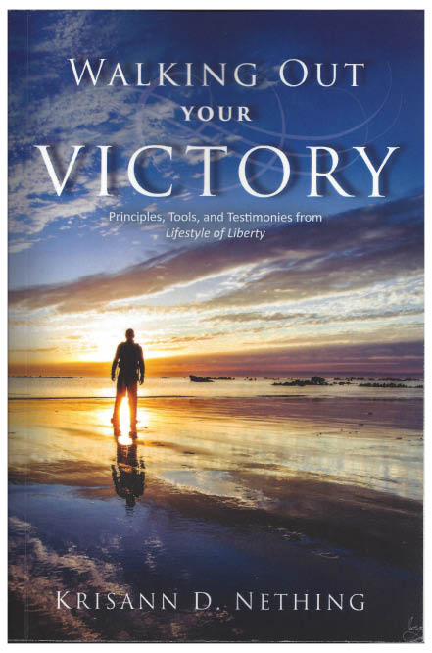

Walking Out Your Victory Receives the
2017 Christian Literary Award!
This Uplifting, Encouraging Book Empowers Readers to Live Life Victoriously
Don’t miss out on your destiny – become all you were created to be

Dallas, Texas, United States – December 9, 2017
Written by Krisann Nething from Lifestyle of Liberty Ministry, “Walking Out Your Victory” deals with the struggles many people have with negative emotions or habits that keep them from gaining the freedom to live the joyful, abundant lifestyle promised by God. In her compelling book, Krisann equips and empowers readers to overcome fear, anger, shame, addiction and other obstacles to victory. End the cycle of defeat and enter your purpose and destiny with the profound biblical insights found in this incredible award-winning book!
“Each person has been uniquely created with value and purpose by Almighty God,” says Krisann. “My passion is to help others overcome the hindrances of the past and soar in their true identity. No matter what our circumstances may be, we NEVER have to live a defeated life.”

About the Author:
Krisann Nething and her husband Gary live in Houston, Texas, where Krisann has led Lifestyle of Liberty Ministry since 2012. “LOL” was designed as a vehicle of healing for God’s people. After growing up in an alcoholic family, being widowed at age twenty-four, and spending ten years as a missionary/church planter in Spain, Krisann realized that often we do not have the tools to confront and overcome all that we deal with in life. This caused her to press into God for answers and help. Her desire is to transfer the tools and knowledge gained through her experiences and relationship with God so that others can truly live overcoming adversity and the adversary.

Synopsis:

God desires that we walk in extraordinary victory as individuals and His church. He invites us to carry a living message of triumph and hope to share with families, cities, nations, and the world.
Through “Walking Out Your Victory,” you will learn how to experience joy like never before, find your significance and value to God, His Kingdom, and His people, explore the limitless love of God, recognize the power of forgiveness, and break free from the chains of negative emotions. You will be encouraged and equipped to cooperate with God so you can indeed become all you were created to be.

Contact:
Krisann Nething
Email: LifestyleOfLibertyKN@gmail.com
http://www.lifestyleoflibertyministry.org
Telephone: 832-766-6025
*Press Review Copies are available from the Media Contact
*The Author is available for Interviews

Available in English or Spanish editions, “Walking Out Your Victory” is available for purchase now in paperback or eBook on Amazon.com, and can be picked up by bookstores through Ingram Distributors.

Reserve your spot in Krisann’s calendar:
Book Krisann for one-on-one coaching, “LOL” classes, retreats or speaking engagements.

###

