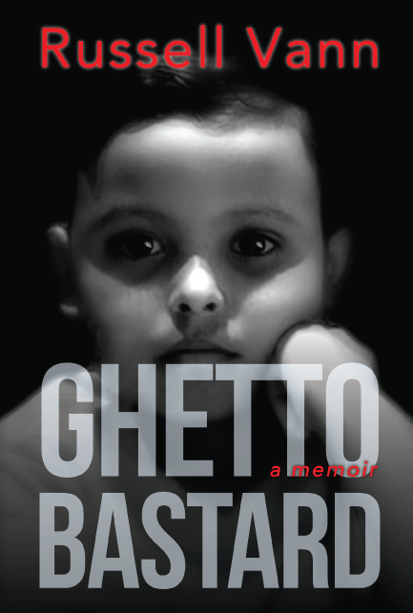
BOOK PRESS RELEASE
Publication Date: October 11, 2017
Title: Ghetto Bastard A Memoir
Russell Vann
Bronx, New York
Ghetto Bastard is a story of survival. Malik was born into these circumstances--with no father to teach him how to be a man, and to a mother who didn't want him. Malik must navigate his way to adulthood with only the streets as his guide. One wonders, would Malik become the next dope fiend? The next dope dealer? The next one to go to prison? The next unwed teenage parent?
Ghetto Bastard is the intimate journey of Malik Russell, an innocent child in search of love and self-worth. He just wants what we all want. He was not born with any 'quit', so he's got that going for him, but neither was his opponent: the ghetto.
Ghetto Bastard A Memoir is published by Russell Dynasty LLC, $15.95 paperback/$3.99 eBook, ISBN 978-0999154007. Available on Amazon and Kindle.
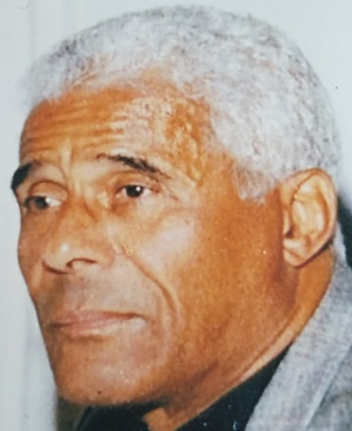
When Russell Vann left the ghetto behind for prosperity and personal fulfillment, he had no idea that his sordid past would evolve into a bestselling series of five books about his life. Ghetto Bastard and Ghetto Bastard 2 released in October 2017 and instantly rose to #1 on Amazon. With three more books in the series to follow, this story has captured the imagination of those who have read and immersed themselves in tales of the world where he grew up.
About the Author
“I was born in the South Bronx in the late sixties to a drug-addicted mother, who didn’t know who my father was, and into a world that didn’t want me. Growing up, I faced life or death situations every step of the way, it seemed. Not only have I struggled to overcome my own specters, but also those of my environment. I started to write these books as a form of therapy. In doing so, I realized that all the people around me, throughout my life, had been dealing with their own misfortunes. That’s when it hit me that I was writing my memoirs to convey that “current situation” neither determines nor defines “final destination.”
Richard Delaney, a reader, says, "Malik Russell was born without a father and to a drug-addicted, abusive mother. ​ At six, he pointe​d to a tree ​adorned with ornaments in his great grandmother's living room and asked, 'What's that?' for he had never known Christmas. ​And that​ was​ just the beginning for a kid who ​​want​ed​​ what everyone wants​--to love and be loved. Thanks to Russell Vann’s ​indelicate but uplifting narrative style, Ghetto Bastard takes us on a unique​journey of surviving the ghetto against all odds." ~Richard Delaney
Media Inquiries:
Russell Vann
Ghettobastard1968@gmail.com

