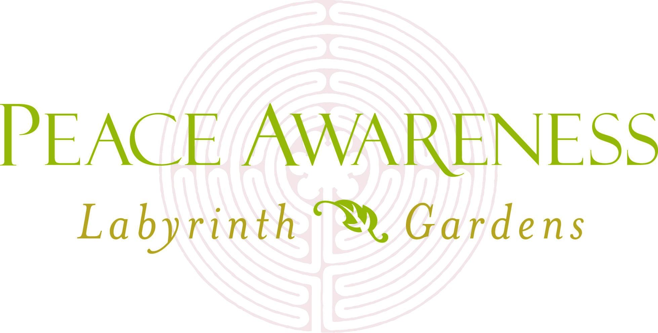

FOR IMMEDIATE RELEASE:
March 14, 2018
Kim Watkinson
Peace Awareness Labyrinth & Gardens
Tel: (323)737-4055, Ext. 1130
Email: Registrar@peacelabyrinth.org

CELEBRATE THE UN’S INTERNATIONAL DAY OF HAPPINESS
AT PEACE AWARENESS LABYRINTH & GARDENS
-Retirement Event for Betty Lou Walton,
President of Angelus Vista Neighborhood Association

Los Angeles, CA: The United Nations has designated March 20th as the International Day of Happiness. Peace Awareness Labyrinth & Gardens is celebrating with three special events. This is a wonderful opportunity to connect with community leaders and visit a hidden gem in the heart of the city.
12:00 pm – 4:00 pm Tours and Meditations If you have not visited come to the Gardens. Featured in LA Weekly, Los Angeles Magazine and 111 Places in Los Angeles That You Must Not Miss.
5:30 pm – 7:00 pm Retirement Celebration for Betty Lou Walton, President of the Angelus Vista Neighborhood Association (AVNA) and a member of the United Neighbors Council (UNNC).
Since 2004 when she became President of AVNA she has been a strong advocate for her community and forged relationships with civic leaders while speaking her mind. Respected and loved by all, Betty Lou Walton has helped create one of the most diverse and welcoming communities in Los Angeles.
So far the following people are coming to honor Betty: Deputy City Attorney Veronica Soto, Captain David J. Kowalski and Senior Lead Officer Susan Garcia of the Los Angeles Police Department, Olympic Division. Jeff Camp, Deputy at the Office of Los Angeles City Council President Herb Wesson Jr.

7:30 pm – 9:30 pm The Way of Happiness – Popular meditation instructor and author, Paul Kaye and communications expert Anna Sugai lead a lighthearted but profound exploration of happiness. Paul says The Way of Happiness differs for each person. They will help participants unlock personal keys to happiness.
For Additional Information: Visit PeaceLabyrinth.org.

###

