April 25th 2018: Medix Wellness Launches New Collection of Cannabis Products
Medix CBD, one of today’s leading CBD oil manufacturers, is releasing two new collections of cannabidiol products! Medix will be releasing 4 additional products to their edible product line which include CBD gummy bears, rainbow bites, and sour worms. Additionally, Medix will also be releasing an entire CBD oil line for dogs.
For many years, scientists and researchers have been making advances toward uncovering the medicinal mysteries contained in the marijuana plant. Scientific studies have confirmed some of the best naturally-kept secrets and capabilities of the plant; the therapeutic benefits of cannabidiol (CBD). Cannabidiol is one of over 100 chemical compounds found in the cannabis plant, as well as the hemp plant. This chemical compound has naturally healing remedies that are not harsh to our systems, unlike many prescription drugs.
The cannabis industry is one of the fastest growing industries in the world today. Governments are reducing the tight grip on punitive laws that have delayed the growth within this business sector. However, thanks to recent FDA approval of drugs containing cannabinoids, researchers and manufacturers, have been able to openly and rapidly formulate high quality custom CBD products.
To respond to the surging demand for superior quality products, Medix CBD has consistently set out to expand its product offering to their customers and furry companions. The company is focused on bringing people the best natural remedies, on a worldwide scale.
Products from Medix CBD are infused with 99.9% pure CBD and contain zero Tetrahydrocannabinol (THC), is the chemical compound responsible for the “high” and psychoactive effects of marijuana. Therefore, if you’re a consumer interested in trying Medix CBD products you can rest assured they’re THC free and you will enjoy all of the enriching and therapeutic benefits of the cannabis plant without the high.
Medix’s new collection of edible CBD products will not only provide you with the healing benefits of CBD, but they are also a delicious treat! With gummy bears, sour bears, rainbow bites, sour snakes, and citrus strawberry chews to choose from, there is something sure to satisfy your tastebuds no matter who you are. These soft, sweet treats are infused with premium quality phyto-cannabinoid-rich hemp oil.

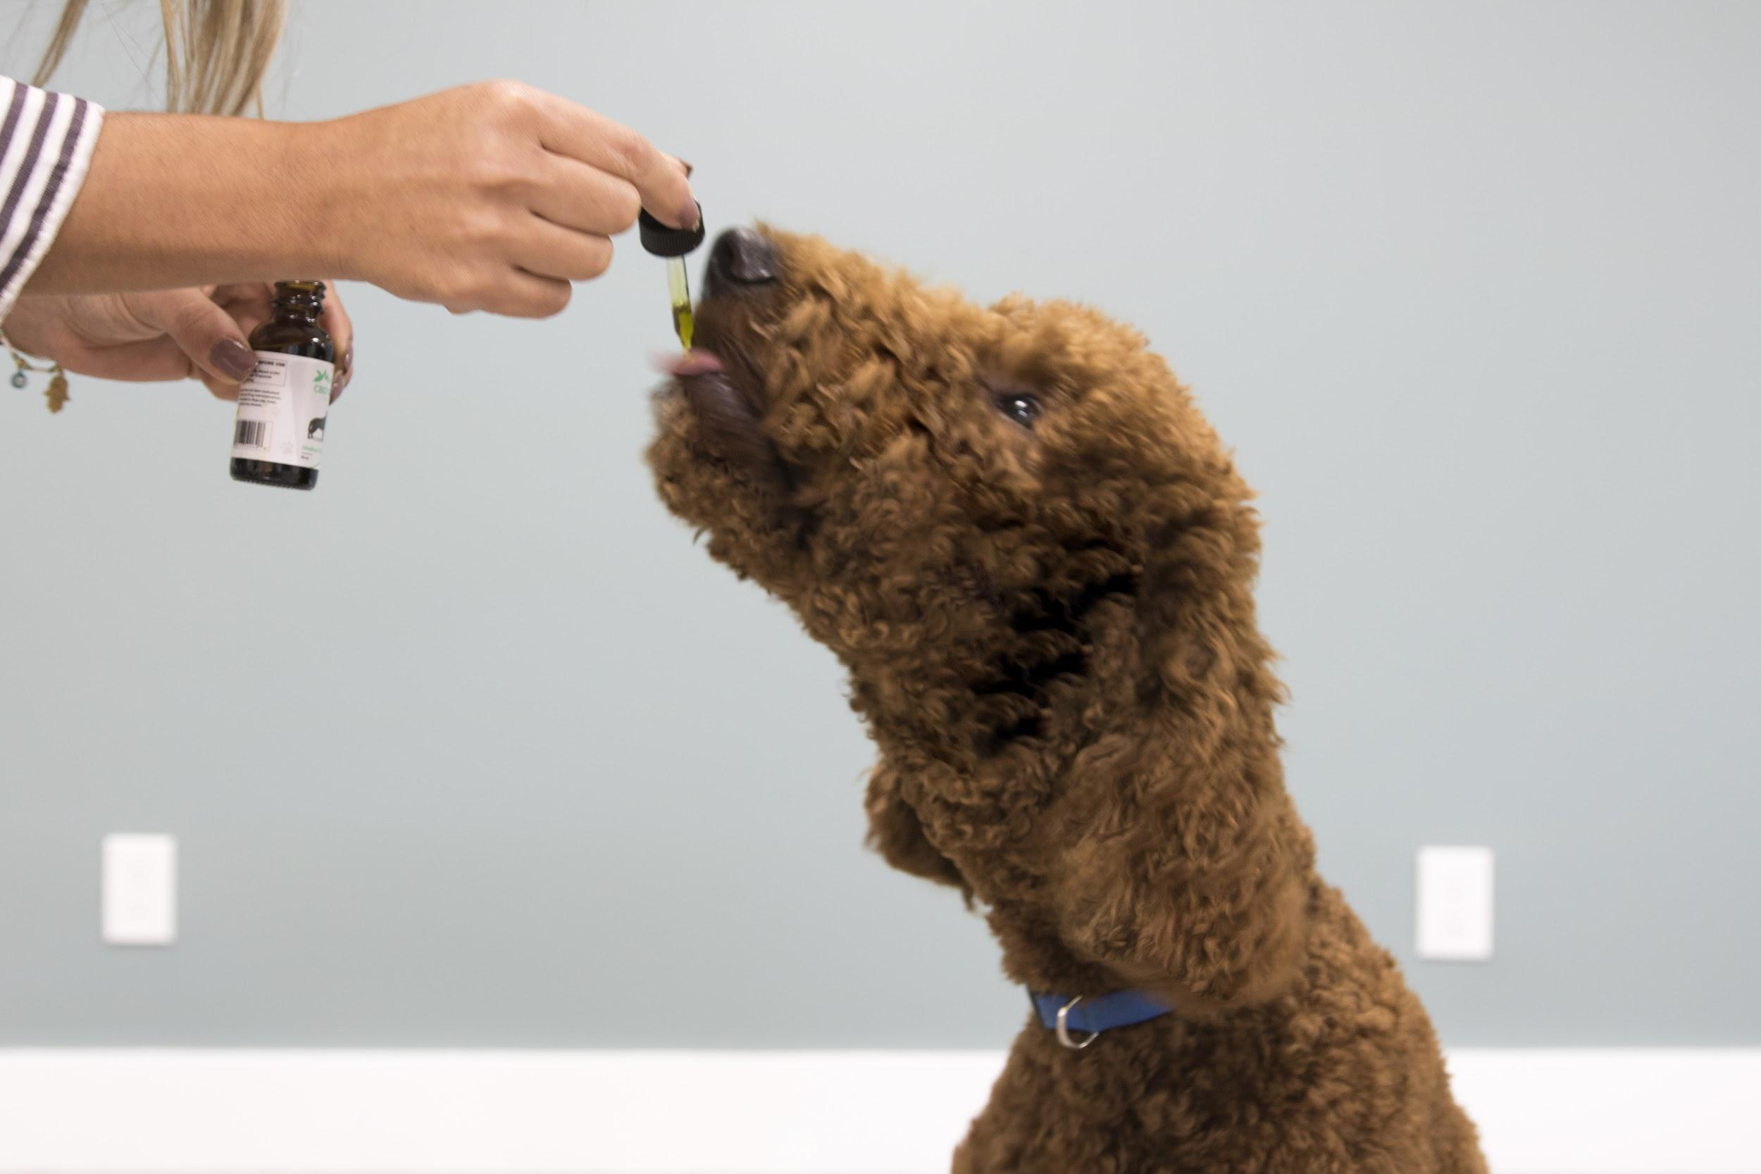
Additionally, The new CBD oil for dogs also caters to your furry friend’s cravings with our delicious bacon infused CBD oil. This custom pet formula came with extensive lab testing and research. Colorado State University recently began a series of clinical trials to put CBD oil for dogs to the test by placing them under 6-week CBD treatment programs. One of their very first studies began with a Newfoundland named Riley who had arthritis. She had undergone multiple surgeries, yet still could not play for too long without needing rest, and even cried at night from the pain. After just four weeks of receiving a daily dosage of CBD, Riley was signaling her owner to go out for walks and wanted to play more often with her brother, Tank! Studies are not yet conclusive, say Dr. McGrath and Duerr at Colorado State, but so far the effects are wonderful. You and your pet can enjoy a healthy lifestyle, together!
Medix is dedicated to bringing you the essentials for healthier living through premium products at an affordable price. The company is expanding its borders to achieve its initiative and you can be apart of their mission and purchase Medix Wellness CBD products online at www.medixcbd.com

About Medix CBD
Medix CBD is a leading manufacturer of a wide array of CBD products in the United States. The company is inspired by the need to provide CBD infused products to those in need worldwide for relief against conditions such as anxiety and pain.

For more information, Contact;
Miguel Lozano
CEO
Email:
Phone:

