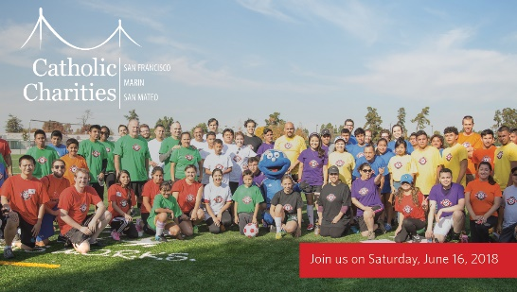
MEDIA ADVISORY
CELEBRATING IMMIGRANT YOUTH, THE POWER OF COMMUNITY, & THE WORLD CUP
Community Members Support Unaccompanied Minors on the Field and Off
WHAT: Catholic Charities of San Francisco, San Mateo, and Marin, one of the Bay Area’s largest human services agencies, hosts its third annual Futbol con Corazon soccer tournament in support of unaccompanied minors and to raise vital funds for the Catholic Charities programs that serve them through their Refugee & Immigrant Services. Sixteen teams of unaccompanied minors and supportive community members will vie for championship at this fun and hopeful community event.
WHO: Catholic Charities unaccompanied minor clients; Jilma Meneses, Catholic Charities Chief Executive Officer; Carlos G Bolanos, San Mateo County Sheriff; Julio Huerta, Community Affairs Consul, Mexican Consulate General; Stan Maupin, Fire Chief Redwood City and San Carlos Fire Departments; and representatives from San Mateo County Supervisor Warren Slocum’s office and Santa Clara County.
WHY: Since 2015, more than 20,000 unaccompanied minors – children who bravely left their families and countries to escape persecution, violence, exploitation, and/or deprivation – have flocked to the U.S. southern borders seeking refuge with many living in the Bay Area. The event hosted by Catholic Charities Refugee & Immigrant Services will raise vital funds to respond to the dramatic increase in demand for affordable legal assistance and services for unaccompanied minors as they make their homes in our communities.
WHEN: Saturday, June 16, 2018
1:00-5:00 PM
WHERE: Sacred Heart School
150 Valparaiso Avenue
Atherton, CA 94027
CONTACT: Liza Cardinal Hand: 503.621.8024 (cell); lhand@CatholicCharitiesSF.org
Catholic Charities, Communications & Marketing Manager

