 | FOR IMMEDIATE RELEASE  July 20, 2018
  Contact | Rust Bullet, LLC
  Telephone | 1-800-245-1600
  Email | sales@rustbullet.com
  Website | www.RustBullet.com

RUST bullet, LLC ANNOUNCES Rust Bullet® DuraGrade Concrete
High-performance, high-build, superior protective coating for concrete

Reno, NV, July 20, 2018 – Rust Bullet, LLC today announced availability of a high-performance, high-build, superior protective coating for concrete
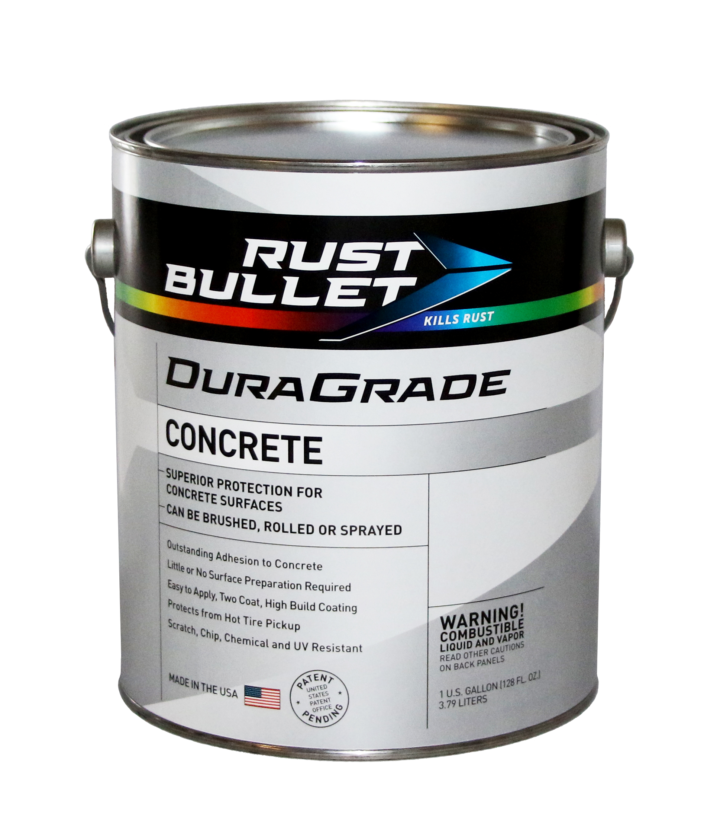
“Our DuraGrade products not only provide a lower VOC option for those concerned with the preservation of our environment, or are required to comply with stricter VOC regulations, they provide phenomenal protection with best in the industry performance! DuraGrade Concrete exceeded the capacity of the ASTM testing apparatus/limits in three of the five tests. During the pull-off adhesion bond strength test, the concrete broke apart before DuraGrade lost adhesion. This is unheard of in our industry!” said David Ciglar, General Manager, Rust Bullet, LLC.
“We used DuraGrade Concrete to seal our warehouse floor and mezzanine. The product was easy to apply, and adhesion appears unbreakable. We couldn’t be happier,” said John Dunlap, CEO, CashMyGuns.com.

DuraGrade Concrete has outstanding adhesion to concrete surfaces and is scratch, chip, chemical and UV resistant, requiring no primer, basecoat, or topcoat. DuraGrade’ s patent pending formula is low in VOCs (49 gram per liter - 170 gram per liter) providing VOC compliance in all 50 states and is available in 18 standard colors or a custom color option. It is easy to apply by brush, roller, or spray equipment. It protects from hot tire pickup. It is ideal for indoor or outdoor surfaces.

Additional Rust Bullet® products are available to further enhance DuraGrade Concrete. Rust Bullet® Color Flakes can be applied on top of DuraGrade Concrete for a stylistic finish, and DuraGrade Clear can be used as a sleek topcoat for maximum aesthetic value. Rust Bullet® Color Flakes are specially formulated paint aggregates used to enhance the aesthetic qualities of Rust Bullet’s Concrete Coatings. This unique product is random in shape, sized within a standardized range and are available in five popular color blends.

Available Rust Bullet® Color Flakes Color Blend Options:
- Electric Blue Blend
- Midnight Blend
- Black Marble Blend
- Desert Sand Blend
- Autumn Brown Blend

Rust Bullet, LLC reports the following impressive ASTM test results:
- Taber Abrasion (ASTM D4060): 38 mg / 1,000 Cycles
- Impact Resistance (ASTM D2794): >40 inches (exceeds max test limits)
- Mandrel Bend (ASTM D 522-13): >32% without cracking (exceeds test)
- Pull-off Adhesion Bond Strength (ASTM D7234-05):
- 50mm dolly: >525 PSI (Dollies unable to be removed at ~525 max psi)
- 20mm dolly: >1485 PSI (the concrete broke apart before DuraGrade lost adhesion)

Rust Bullet, LLC is a coatings manufacturer, headquartered in Reno, NV, USA, specializing in protective, rust inhibitive and corrosion control coatings. Rust Bullet, LLC sells to businesses and consumers around the world through its global distribution network.

For more information, contact Rust Bullet, LLC at 1-800-245-1600 or via email at sales@rustbullet.com.
DuraGrade Concrete is currently available in quart, gallon, and 5-gallon unit sizes. Purchase DuraGrade Concrete on Rust Bullet, LLC’s website or on Amazon. Purchase DuraGrade Clear on Rust Bullet, LLC’s website or on Amazon. Add some style to your project with Rust Bullet® Color Flakes from Rust Bullet, LLC’s website or Amazon.

# # #

