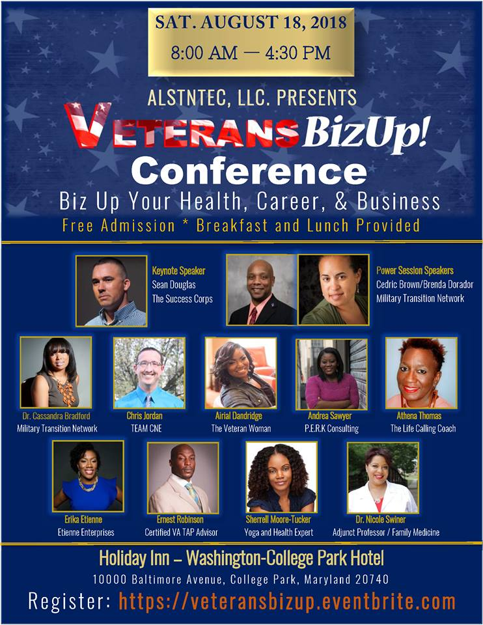
PRESS RELEASE – Air Force Veteran Inspires at Veteran’s Business Conference
FOR IMMEDIATE RELEASE
College Park, MD
August 18, 2018 - Sean Douglas speaks to Military Veterans, Active Duty, and Vendors about transitioning to civilian life, building a business, and life out of the uniform. VeteransBizUp is a one-day conference developed to educate and empower Military, Veterans and their families about the necessity of health/wellness, career and Entrepreneurship. The Speakers are Veterans who established strong businesses in their community and will provide education and resources in health/wellness, career, and entrepreneur via workshops, lectures and information from exhibitors who want to give attendees much needed assistance. The mission is to provide positive reinforcement on how to manage life challenges related to transitioning from military to civilian life and provide information that can help them leverage lucrative career or entrepreneurship opportunities.
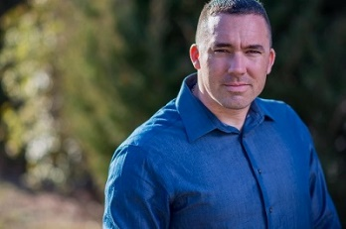 ABOUT THE SPEAKER: Sean Douglas is a U.S. Air Force Veteran, TEDx Speaker, Master Resilience Implementer, Suicide Awareness Trainer, Performance Enhancement Expert, International Radio Show Host, and Author. His WHY is he’s a suicide survivor who hit rock bottom with no purpose or passion. He believes that you were created for a purpose, and once you unlock your true potential, you will elevate your life, which is why he founded The Success Corps. In a highly interactive and engaging environment, utilizing online mentoring sessions and face to face workshops, Sean provides a framework for success to Millennials up to 50-year-old Professionals, Military Veterans, Speakers, Entrepreneurs, and Business Owners that reduces anxiety, stress, and depression in your personal and professional life. Sean equips people with the tools necessary to live EPIC lives, and leaves people better equipped to manage change effectively. Sean has built three successful businesses while serving on Active Duty Orders.
Considered an “Icon of Influence in the New Media Space”, Sean hosts the popular live online
radio show, Life Transformation Radio, heard in over 58 countries and thousands of weekly
listeners.

CONTACT: Sean Douglas 801-682-0322 sean@TheSuccessCorps.com

