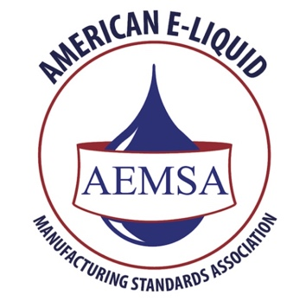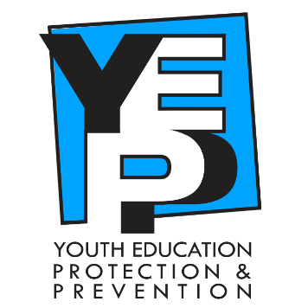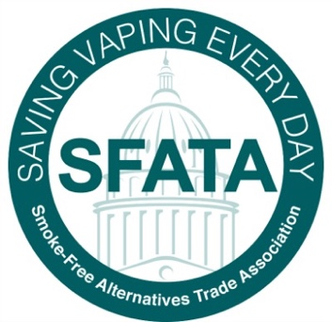

For Immediate Release

October 1, 2018

The American E-liquid Manufacturing Standards Association (AEMSA) and the Smoke-Free Alternative Trade Association (SFATA) announce the launch of a joint-venture, comprehensive Youth Education, Protection, and Prevention program – the YEPP program.

As industry leaders in youth vapor product access prevention, both AEMSA and SFATA agreed to begin work on the YEPP program after their individual meetings with FDA Commissioner Dr. Scott Gottlieb and the Center for Tobacco Products this past spring, where the youth issue was addressed as an area of common interest and concern to all parties.

Since those meetings, Commissioner Gottleib has vigorously called attention, more than once, to new statistics that demonstrate ever-growing numbers of youth vaping, most recently calling it an “epidemic.”

In that same statement, Commissioner Gottleib said, “They say they’ve changed from the days of Joe Camel. But look at what’s happening right now, on our watch and on their watch. They must demonstrate that they’re truly committed to keeping these new products out of the hands of kids and they must find a way to reverse this trend.”

Although the Commissioner calls out pod or cartridge style systems specifically to be the largest problem, and AEMSA and SFATA predominantly represent the open tank systems and primarily small business industry organizations, both associations firmly believe they are duty-bound to address the youth access issue.

AEMSA and SFATA are industry leaders known for education, advocacy, and responsible, professional industry manufacturing standards, so it is not surprising that following the advent of Gottlieb’s announcement both associations thought it was important to launch the youth prevention campaign as it aligns with their longstanding positions to prevent access by youth of vapor products. Those announcements served to affirm the need for the program and resulted in today’s launch of the YEPP website and "WE CARE" program.

As the YEPP website indicates, the YEPP program takes a three-pronged approach to youth access issues. First, it educates youth on the dangers of vaping and nicotine addiction, and encourages young people to make better choices. Secondly, the YEPP program educates parents on what vaping is, as well as what to look for in their homes, so parents can readily identify vapor products their minor may be experimenting with. This same section offers suggestions on how to open a dialogue with their minor about vaping. The last section addresses retailers and provides different methods of identifying minors and suggests ways to avoid unintentional sales to minors. Lastly, the YEPP program includes a "WeCare" program that retailers will be able to subscribe to in the future. The WeCare program will provide marketing tips, policies, procedures, and training methods that can be implemented immediately, as well as other guidance for small businesses to be proactive in identifying minors.  The WeCare program is still in development but is expected to be fully operational within a matter of months.

When asked why this campaign is so important to their organization, April Meyers, Board President of SFATA emphatically responded, "There is lip service, and then there is action. We believe in action.”

Meyers went on, “SFATA was the first to institute an Age-To-Vape program ahead of any state laws. Once most of the states had age laws in place—many with our assistance and support—we opted to partner with WeCard. Although WeCard does still benefit our members, it doesn’t offer the other pieces needed to attack the youth issue; those being education of youth and their parents or caregivers. The YEPP program does all of that and is absolutely necessary to demonstrate that our industry is committed to keeping vapor products out of the hands of kids, and that we are working on a way to reverse the current usage trends.”

Although Center for Disease Control numbers suggest that youth smoking rates have declined, and the last released data shows youth vaping rates have also declined significantly, Gottlieb states that new data will show a spike in youth use of vapor products. This is concerning to small business owners in the vapor industry and their trade associations, enough so, that many are excited about joining this new program and the ways it can be implemented in their daily business practices.

­­­­­­­Schell Hammel, AEMSA Vice President, stated, "It is our duty to be responsible with these products, to be proactive in identifying minors, preventing unintentional sales, and educating our parents, educators, and the like on what these products are and how to identify a minor experimenting with them.

She continued, “This program has the ability to reach all of those who can make an impact on these troubling numbers, and empower the front line contacts in our industry and at home with the tools they need for reform. These products are intended for adult users and are invaluable to the quality of life of millions of those adult users who no longer smoke because they have successfully transitioned to vaping. Therefore, this program is imperative."

AEMSA and SFATA both support age-to-vape laws and minor prevention, education, and training. Both organizations have been proactive in educating retailers, legislators, and communities on the science and facts on vapor products. Both also support and educate their member businesses on responsible business practice techniques.

For more information, visit each at [aemsa.org](http://aemsa.org/) and [sfata.org](http://www.sfata.org).   
  
For more information on the YEPP program, visit [YEPPWEID.ORG](http://yeppweid.org/)

Press contact AEMSA:

Larry Flick, Executive Director

[lflick@aemsa.org](mailto:lflick@aemsa.org)

Press contact SFATA:

Mark Anton, Executive Director

[mark@sfata.org](mailto:mark@sfata.org)

https://ssl.gstatic.com/ui/v1/icons/mail/images/cleardot.gif