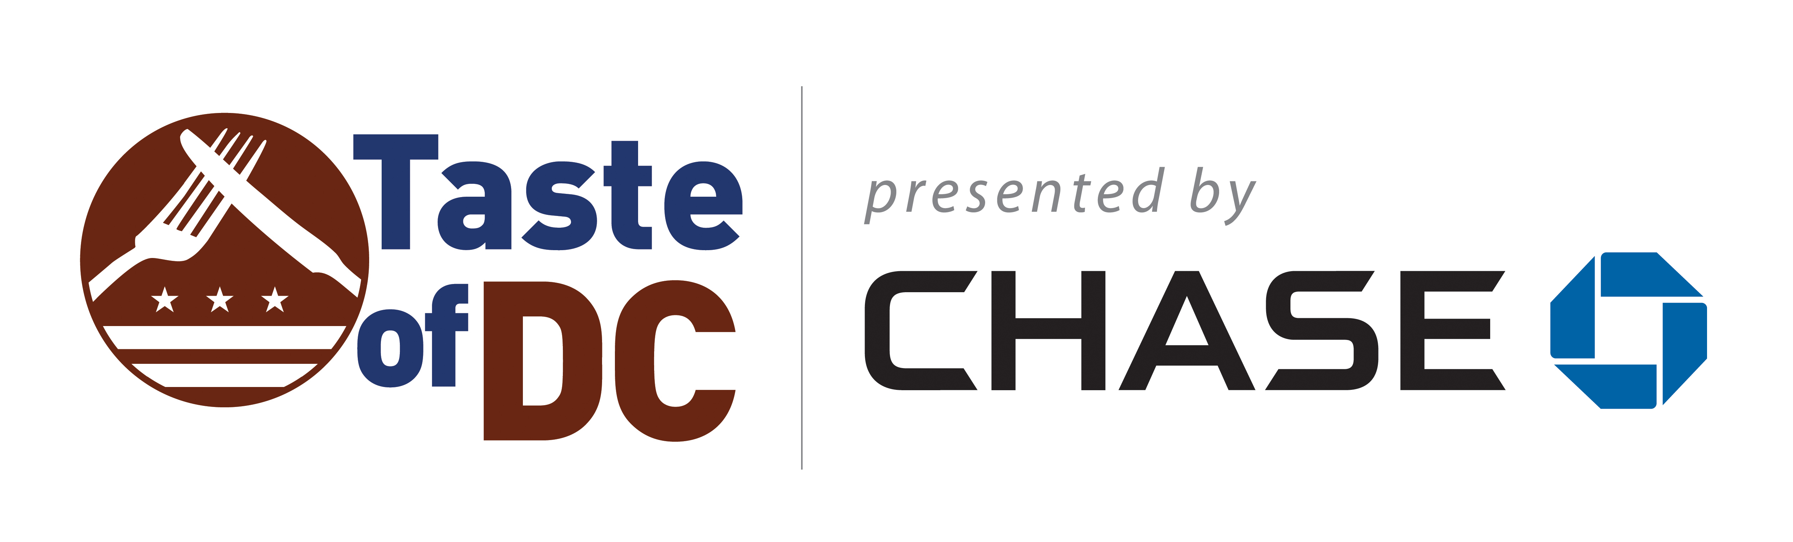

TASTE OF DC WELCOMES CHASE AS THE PREMIER PARTNER FOR TASTE OF DC 2018
BANK CELEBRATES FIRST BRANCHES IN THE GREATER WASHINGTON REGION BY SPONSORING THE REGION’S LARGEST CULINARY FESTIVAL

Washington, D.C. (October 12, 2018), Taste of DC (www.TheTasteofDC.org), DC’s largest culinary festival, today announced its partnership with Chase as the presenting sponsor of Taste of DC 2018.

The bank announced in April 2018 its intention to open 70 new branches in the Greater Washington D.C. area, the first of which recently opened in McPherson Square at 1401 New York Avenue NW. Visit Chase.com/DC to learn more.

“We’re thrilled to welcome Chase to the DMV area and to the Taste of DC family,” Stu Martens, CEO of Pirate Ventures, says. “This partnership combines Chase’s award-winning services and Taste of DC’s top of the line experiences to provide a memorable festival this year.”

In addition to being the presenting sponsor of Taste of DC, the bank will host one of its popular Chase Lounge experiences on-site exclusively for Chase credit and debit cardholders. The Lounge offers cardholders space to relax and enjoy culinary experiences from the best chefs in the region.

Ticket packages are as follows:

TasteBand Basic Package: $14.99
- One RFID TasteBand pre-loaded with one complimentary beverage valid for a beverage in Restaurant Row or the Taste of DC Beer Garden
- Free Bag/Bike check outside of the stadium ($5 value)
- Entry into festival an hour before General Admission attendees
- Ability to add "Taste Tokens" to your TasteBand to purchase food and drink from more than 65+ restaurants in Restaurant Row and at the beverage areas throughout the festival

Foodie Package: $49.99
- Everything in the TasteBand package plus
- $30 TasteTokens pre-loaded with one complimentary beverage
- Exclusive seating at the ToDC Culinary Stage (limited availability, on a first come, first-served basis)
- $10 credit to upcoming Drink the District events

For tickets and more information and Taste of DC tickets, please visit www.thetasteofdc.org or follow on Facebook, Instagram: @TasteofDC, Twitter: @TasteofDC.

Media Contact:
Michael Wilcox
michael@pirateventures.com
###

