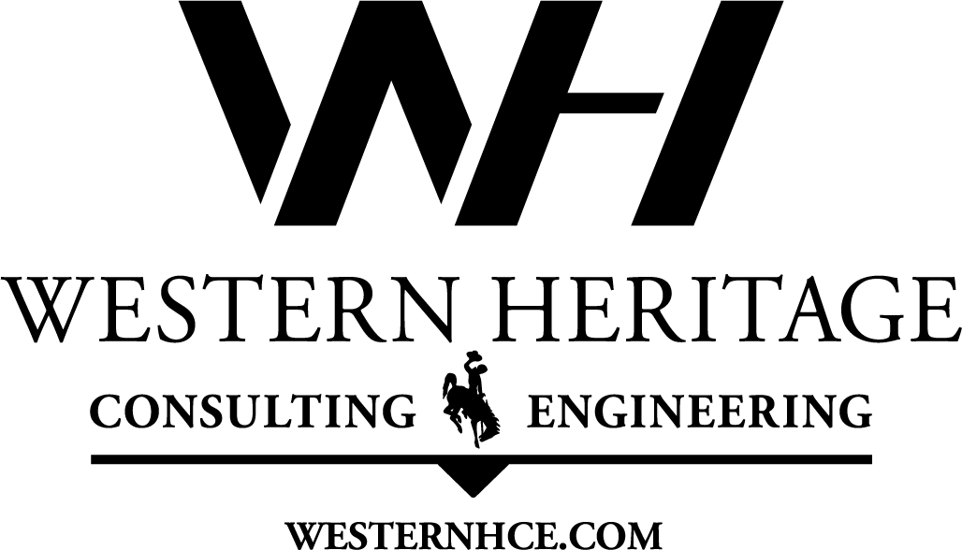
Contact Rikki Altenburg  Telephone 307.215.7430  Email rikki@westernhce.com  Website westernhce.com | FOR IMMEDIATE RELEASE  November 12, 2018

Western Heritage Consulting & Engineering Acquires Paragon Engineering Consultants
Casper, WY, November 12, 2018 – Western Heritage Consulting & Engineering, an engineering and consulting firm specializing in civil, agricultural and natural resource engineering, acquired Paragon Engineering Consultants on November 5, 2018. Paragon, a Civil Engineering firm in Littleton, Colorado, has been providing engineering and land development services on the Colorado Front Range area since 1994.
“With this acquisition, we are continuing down the path of diversifying Western Heritage Consulting & Engineering to meet our client’s needs. Paragon’s 24 years of civil and land development expertise is led by a strong team of surveyors, drafters and engineers, and compliments our desire to be a team that finds solutions. We are so excited to welcome them to the WH family and continue to grow the business,” stated Rikki Altenburg, partner of Western Heritage and Paragon.
Western Heritage Consulting & Engineering utilizes its central location in Casper, Wyoming to serve clientele in the surrounding states and beyond. The merger with Paragon will allow them to continue to preserve the region’s natural resources and to serve Colorado and its Front Range in development, natural resources and civil engineering.
“We are excited to be joining Western Heritage Consulting & Engineering and look forward to expanding our business and the increased opportunities for our employees and service to our clients,” said Paragon Manager Wendell Ayers.
Western Heritage Consulting & Engineering provides sustainable solutions for their clients to address water, environmental and development challenges by providing project management, design-build, construction management, permitting & coordination, wetland delineation & mitigation, wildlife habitat, master planning, easement negotiations, technical grant application, and funding development. Their sister company, WURX, LLC, specializes in design-build and construction projects.
“Bringing these two companies together allows us to utilize the strengths in each office to better serve our clients. We do a substantial amount of work in Wyoming and Colorado, and this will only strengthen our service and response time for projects. Bringing the development expertise of Paragon to assist Wyoming in growth, as well as Western Heritage’s natural resource and water engineering experience to the Front Range, allows us to continue to preserve and responsibly develop land and water,” stated Ryan Altenburg, partner of both firms.
For more information on the merger and Western Heritage Consulting & Engineering, call Rikki Altenburg at (307) 215-7430 ext. 101 or email rikki@westernhce.com.

