19th November, 2018
FOR IMMEDIATE RELEASE
INTRODUCING BIG BLANKET CO: The Biggest, Best Blanket Ever Made
Springfield, MO

BIG BLANKET CO was conceived from a simple idea: that we’ve been duped. The average throw blanket is less than 5 feet tall while the average human is much taller than that. The solution was clear: create a blanket larger than any blanket currently sold.

Over a year in the making, this 10’ x 10’ (you read that right, 10 feet by 10 feet) blanket is more than a giant piece of fabric. It’s made from ultra-premium, baby soft, stretchy material that is moisture wicking and temperature regulating. It’s the best blanket ever made.

BIG BLANKET CO was released on Kickstarter on November 14, 2018 and fully funded within 8 hours. The campaign will run through January 6, 2019.

BIG BLANKET CO’s founding team is made up a passionate team of entrepreneurs, professional athletes, former musicians, and all-around busy people. Understanding time together is sacred, the goal of BIG BLANKET CO is bringing people together.

RETAIL PRICE: $209
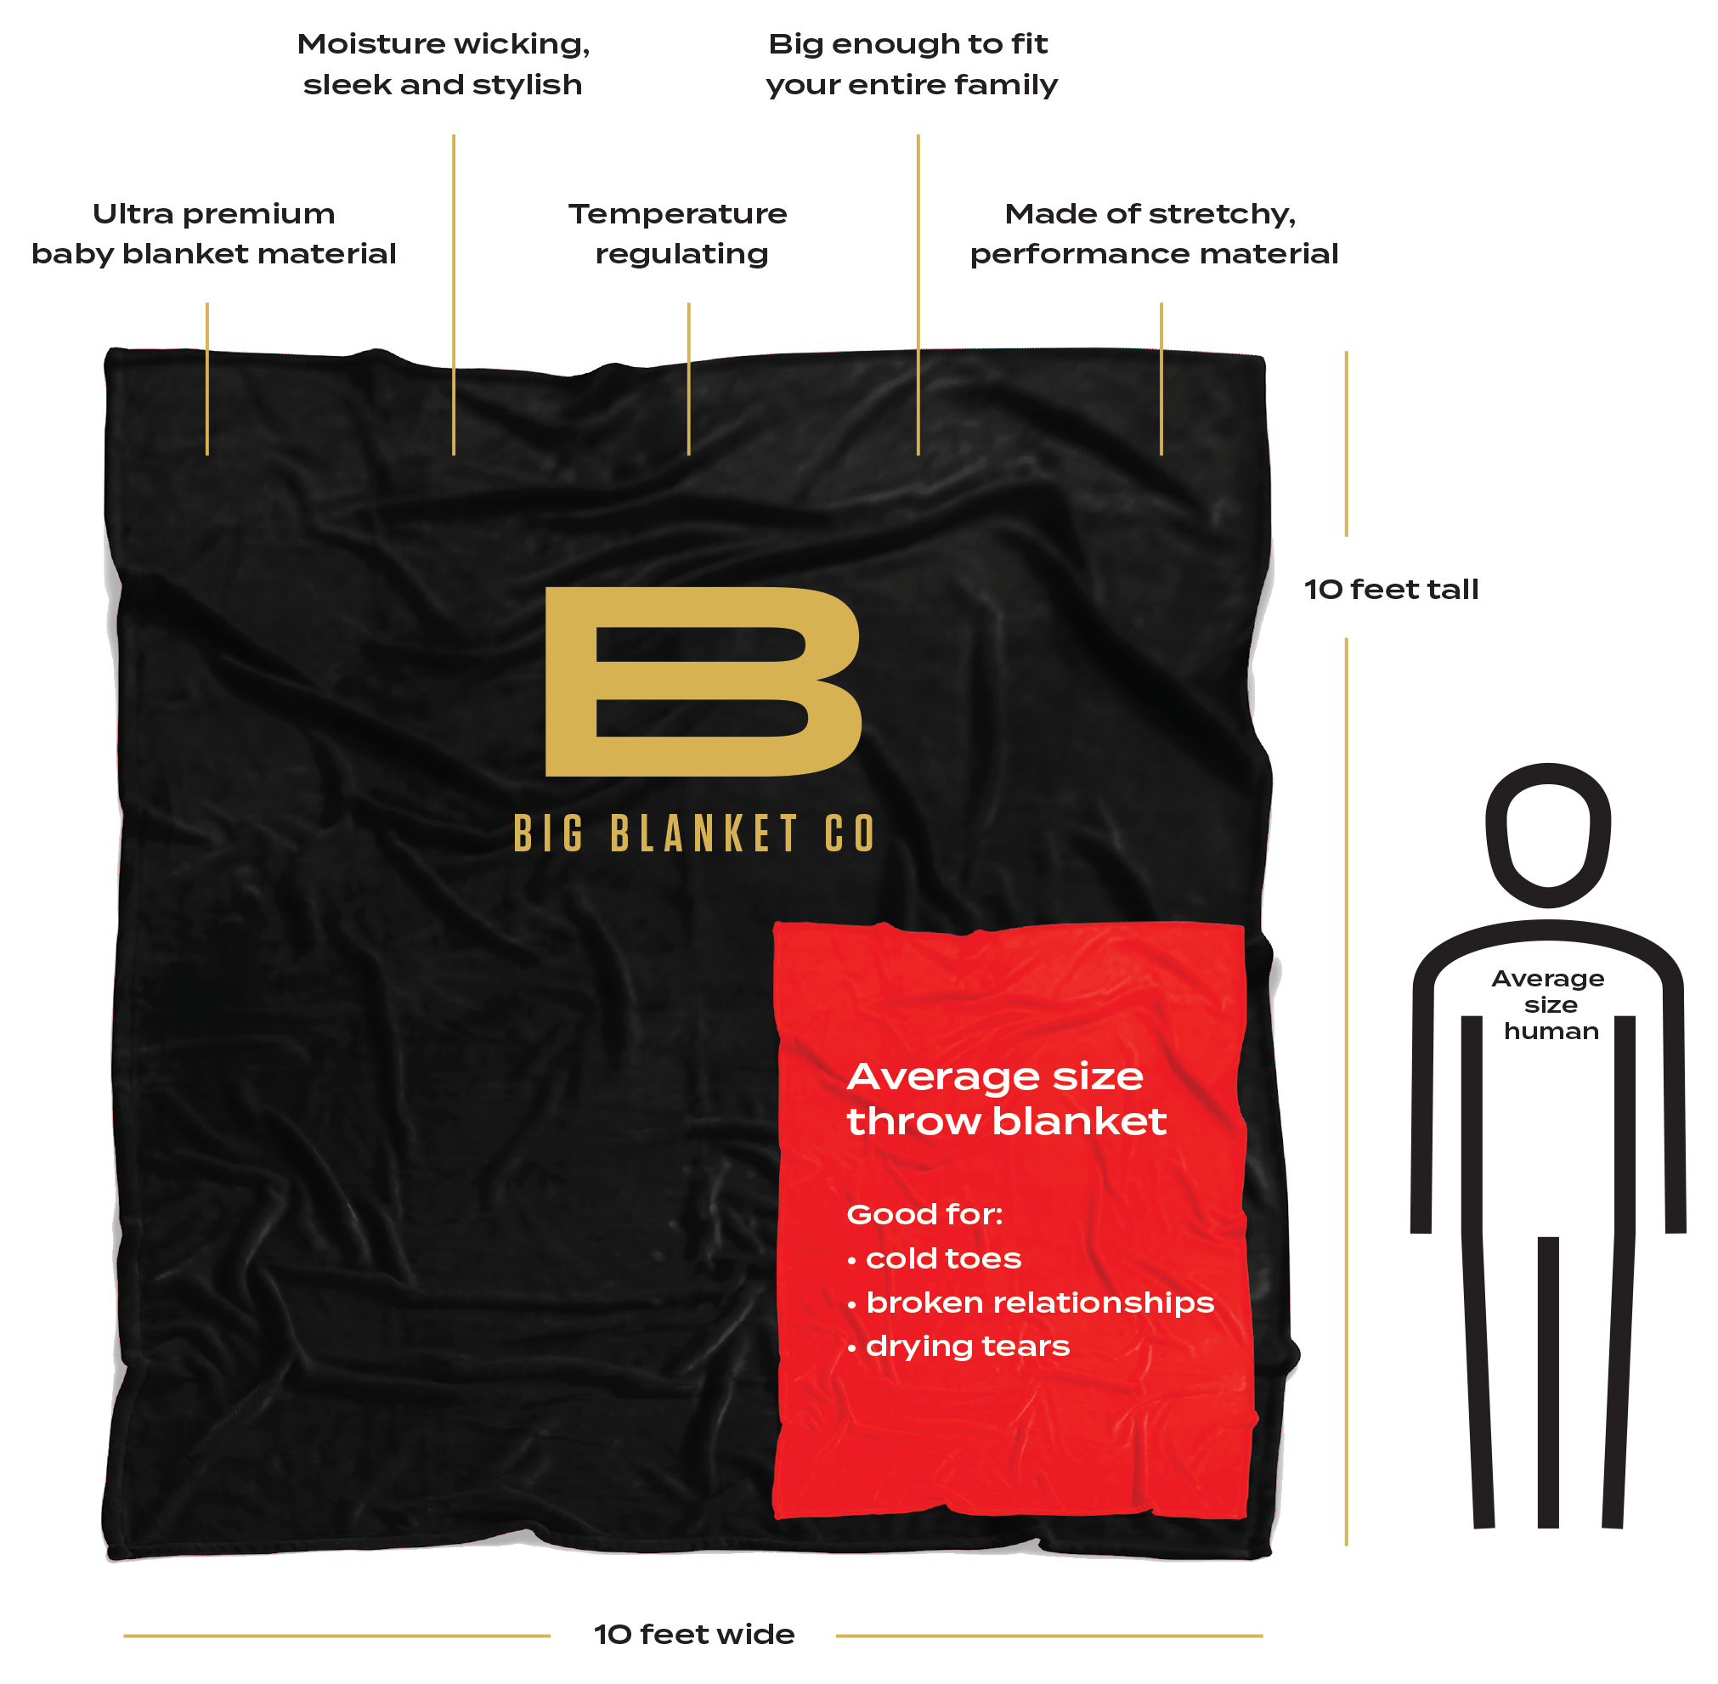
DIMENSIONS: 10’ x 10’

Press Contact:
Bryan Simpson
snuggle@bigblanket.com
417-838-7011

Kickstarter Link:
http://bit.ly/bigblanketco

Website:
www.bigblanket.com

Founding Team:
Bryan Simpson, CEO
Josh Stewart, Chief Creative
Dane Watts, Director of Operations
Anthony Tolliver, Tall Guy

