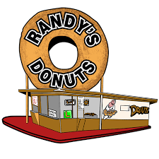
FACT SHEET

ADDRESS 6801 Hollywood Blvd Hollywood, CA 90028
(between TLC box office and Hard Rock Café)

PHONE TBD (please use office # for now 424-371-6500)

WEBSITE www.randysdonuts.com

OPERATING OWNERS Mark Kelegian, Nicolette Kelegian
MARKETING LEAD Thomas Bartsch (323) 868-2404

OPERATIONS LEAD Samara Friedman (310) 351-3330

HOURS OF OPERATION Sunday – Thursday from 8am – 10pm
Friday – Saturday from 8am - Midnight

CREDIT CARDS All major credit cards

PARKING On-site Hollywood & Highland parking lot. Additional parking located all over Hollywood

SOCIAL MEDIA Follow Randy’s Donuts on Instagram @RandysdonutsLA, on Facebook at www.facebook.com/RandysDonutsLA and Twitter @RandysdonutsLA
UNIQUE ELEMENTS The newest Randy’s Donuts shop features an 18-foot-wide, donut-shaped entrance, a Hollywood Star donut exclusive to this location and a wall mural showcasing Randy’s Donuts in Pop Culture over the years
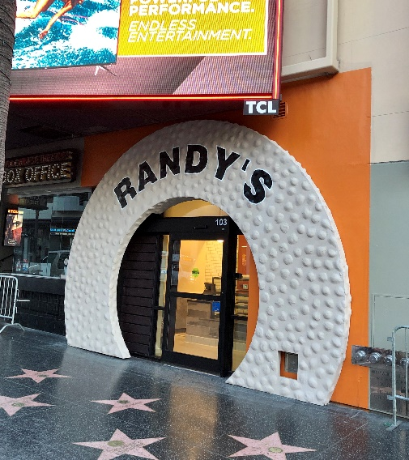

Randy’s Ownership History
Built in 1953 by Robert Wendell, World Famous Randy’s Donuts (formerly known as one of the Big Donut Drive-In stores) is consistently named one of the top donut shops in the country for over 60 years.
In the late 60’s, Mr. Wendell sold the store to Mr. Eskow who renamed it Randy’s Donuts after his son. In the early 1970’s he sold the store to his cousins Larry and Ron Weintraub, who were two hard working brothers who ran the store until 2015, often working 7 days a week.
In 2015, after deciding to retire, Larry and Ron sought out a buyer who would continue the family tradition they had fostered over 45 years, eventually selling to Mark Kelegian and his family. Mr. Kelegian is a California attorney who retired in 2005 after gaining a national reputation as an expert representing victims of sexual assault. Mr. Kelegian was called upon to assist victims throughout the country and was a frequent lecturer and supporter at national and local rape crisis events. Mr. Kelegian is also owns businesses throughout the country. Mr. Kelegian and his three daughters carry on the 60-year tradition and has expanded the company’s charitable and social efforts.
Randy’s Place in Donut History
Randy’s is widely recognized as one of the most iconic locations in Los Angeles attracting visitors from around the world to take pictures of the giant rooftop donut and enjoy the best donuts in the world! Always a line, but always worth the wait!
No doubt you immediately recognize the landmark building from its many appearances in movies such as: Iron Man II, Entourage, Dope, Californication, California Girls, 2012, Earth Girls Are Easy, Mars Attacks!, Volcano, Get Shorty, Crocodile Dundee in Los Angeles. Randy’s Donuts is also well known for its references and appearances on Tonight Show with Jimmy Fallon, Big Bang Theory, The Simpsons, Arrested Development, Victorious, and many others. It is also featured in music videos including Randy Newman’s “I Love L.A.”, Red Hot Chili Peppers’ “Californication”, and Becky G’s “Becky from the Block.”
Of course, to stand the test of time, it is not enough to be an iconic tourist attraction, you must have the best donuts. In addition to being the most reviewed and highest rated donut shop on Yelp, and other social media sites, Randy’s has been named a Top Spot for donuts in the United States for over 50 years; including: Los Angeles Hot List #1 for Best Donuts 2014, 2013, 2012, 2011, and more; #1 on Bon Appetit’s Top 10 Best Places for Donuts; #7 on America’s Best Donuts – The Master List; USA Today’s America’s 12 Best Donut Shops; Travel & Leisure – America’s Best Donuts; Fox News America’s Best Donut Shops; CBS News Latest Best of LA Best Places to Get Donuts in Los Angeles 2015; America’s 10 Best Donut Shops – relish.com; The 9 Best Donuts in Los Angeles (#1 Classic) – thrillist.com; and many more!
Randy’s is an incredible partner for businesses and charitable partners due to its national and international appeal. People from all over the state and world come to Randy’s iconic location either on their way to the airport or as their first stop after they land. On any given day at least 100 people are in the parking lot taking pictures of the big donut. As such, it is no wonder that Randy’s is widely considered the most famous donut in the world. One might say it is the 8th Wonder of the World or at least the most famous spot in Los Angeles (wall mural commissioned by major airline for two locations in Brooklyn, New York this summer features Randy’s Donuts as the symbol of Los Angeles).
While many have visited, many more long for the opportunity to try our donuts. As such, national and global travelers not only enjoy them at the store, but also take dozens to share when they get back home.
Unlike other donut or dessert stores that make a few hundred a day of only a handful of varieties, Randy’s team of bakers produces over 40 different varieties daily that appeal to everyone from kids, parents, business travelers, and those with the most discriminating tastes.
At Randy’s we have been making every donut by hand for over 60 years using many of the same equipment and baking tools for decades! Better yet, because all our donuts are handmade, every donut is unique. No two are exactly alike.
We only use the finest baking ingredients available in the world. The best ingredients coupled with expert bakers and our Randy’s secret mixes, produces a donut that is fluffier, airier, larger, and stays fresh longer.
We never skimp on icing, glaze, sprinkles, or other decorations. We go over the top to put as much chocolate, maple, cream filling, or other toppings as the donuts can possibly hold. You never have to ask, “Where’s the icing?”
We pride ourselves on being a great value for families and businesses with glazed donuts, twists, chocolate raised, cinnamon rolls, apple fritters, or any of our 35 other donuts at under $2.
Randy’s Today
While donuts have always been a “forever” product in the breakfast and dessert categories, donuts have seen a tremendous increase in appeal over the past 24 months with all indications that it will continue to grow. Of course, donuts and coffee go together like hamburgers and fries, or peanut butter and jelly.
Although donuts are generally thought of as a breakfast food, and traditional desserts are limited primarily to after lunch or dinner meals, Randy’s breaks the mold by appealing to tourists and locals throughout the day. For example, our iconic store location, open 24 hours a day, sells approximately 50% of its 8,000 to 10,000 donuts a day between 5am to 1pm and approximately 35% between 1pm to 10pm. The afternoon and evening business is so strong that Randy’s is launching a “Donuts for Dessert” marketing campaign.
Never being one to stand on its laurels, in 2017 we introduced our new Premium Donut line for the customer seeking a more indulgent donut, or fanciful toppings, such as red velvet with vanilla ganache, blueberry cake, butter crumb cake, chocolate raised with fruity pebbles, M&Ms, Oreos and other cookie or candy treats, tiger tails, roasted coconut raised, and many others. Please see the attached menu from our iconic location.
Further, our giant donut holes are about one-quarter to one-third the size of a regular donut (which is already nearly 50% larger than most other shops offer). Stated simply, they are a hit. These smaller donuts are easy to decorate and offer customers the chance to sample a variety of types of fillings, icings, and toppings, without eating 4-6 regular donuts.
Randy’s Tomorrow
Randy’s Donuts is growing across the greater Los Angeles area with additional new locations opening in Downey and Torrance as well as several other locations in Orange County and the Inland Empire. Randy’s Donuts is also expanding across the USA and globally in the next 5 years. The goal is to scale the success of Randy’s Donuts flagship location in Inglewood, CA, which has amassed thousands of raving reviews across Google, Facebook and Yelp and is always included as a top tourist stop for anyone living in or visiting Los Angeles.

In the Media
Please visit our website at www.randysdonuts.com to find links to a sampling of news articles and videos featuring Randy’s Donuts.
Global Reach
Randy’s Donuts is featured in tourism and travel video and promotional materials on behalf of the Los Angeles Tourism board and by countries all over the world, including most recently, New Zealand, Germany, Japan, Korea, and the United Kingdom.
Further, we expect franchise stores to open this year in Manila, and we are currently fielding interests from potential franchisees in China, Korea, Scotland, India, Hong Kong, and Taiwan.
In the Community
Randy’s Donuts receives requests on almost a daily basis to donate dozens of donuts or gift certificates to support local communities including schools at all levels, churches, and other charitable and non-profit groups. Our mission is to fulfill every request and we come pretty close! In particular, Randy’s Donuts goes the extra mile to support all Inglewood City functions. Finally, we join with local professional sports teams in their community efforts.
For nearly 60 years, we have donated donuts every day to multiple homeless programs. We estimate we have donated over 1 million donuts in the past 20 years alone.
We also are a proud supporter of the Salvation Army and its mission to support veterans. We have been honored to receive the highest award for our support from the Salvation Army on National Donut Day in 2016 and 2017.

