“ONE NIGHT IN MEXICO” / “UNA NOCHE EN MEXICO”

PRESS KIT

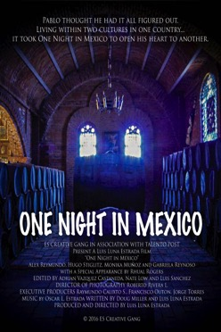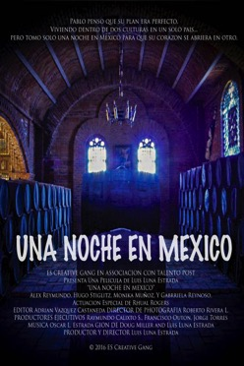

One story, one script, one cast, two languages two movies!

Contact: Luis Luna Estrada – Luis@ESCG.tv - (817) 271-5865

www.OneNightInMexico.com

ES Creative Gang presents:

One Night In Mexico / Una Noche En Mexico

Running time ..................................................... 67 min English
Running time ..................................................... 73 min Spanish

Genre.................................................................. Drama/Comedy

Rating................................................................. Not yet rated

Year..................................................................... 2018

Language............................................................ English and Spanish versions available.

Country of Origin............................................... United States / Mexico

Format................................................................ 1920x1080 Sound 5.1

Sales / Distribution............................................. Luis Luna Estrada, Luis@ESCG.tv , (817) 271-5865

Virtual Press Office........................................... www.ESCreativeGang.com

Links................................................................... Official website: www.OneNightInMexico.com

###

Press, booking, links and general information:
Press Contact: Luis Luna Estrada
Phone: 817 271-5865
Email: Luis@ESCG.tv

Press kit:
http://www.onenightinmexico.com/credits-media-info/

Website/General information:
www.OneNightInMexico.com

IMDB
https://www.imdb.com/title/tt6337290/?ref_=nv_sr_1

Link to film:
https://www.amazon.com/One-Night-Mexico-Alex-Reymundo/dp/B07MG8XL2G

Synopsis
Pablo is a first generation Mexican/American born in the United States, his parents gave him a great education and family life as they assimilated into the American lifestyle.
His parents planned on returning to Mexico to retire but after the death of Pablo’s mother their dream of returning to their beloved country died with her.
Pablo’s father vowed to show Pablo the roots of his heritage and sends his son to Mexico to their family’s Tequila factory in hopes he will understand and appreciate his heritage. Little did he know that “One Night in Mexico” would change his son’s life forever.

Director’s Statement
These films are a long labor of love that has taken 13 years to complete. It’s a story that the whole family can enjoy. The project was also a pilot to reach audiences in two languages and cultures.

We shot the movie simultaneously with the same cast, same script, same locations, and did two versions, English and Spanish. I felt it was important that the story be told “in language” so both audiences could enjoy the story in their native language.

These films are dedicated to the dreamers in the US, with hopes that this will give an insight to the people of the US and Mexico on how rich in culture and emotion first and second generation Latinos feel about both their countries. The Dreamers have the best of both worlds and have a lot to contribute to both cultures.

Luis Luna Estrada – Writer/Producer/Director “One Night In Mexico” / “Una Noche En Mexico”
Cast
Alex Reymundo - Comic/Writer/Actor/Producer and Cool Dude
as Pablo Corralejo

With two 1 hour specials that aired on Showtime & Comedy Central, (Red-Nexican” & ALMA Award winning “Hick-Spanic) Reymundo appeals to all demographics. Alex has spent years touring with Blue Collar’s Bad Boy Ron White & was seen by 6 million viewers on CMT (2011) with Ron White’s Salute to the Troops (w/ Lewis Black & Kathleen Madigan). Reymundo was a highlight of P. Diddy’s “Bad Boy’s of Comedy” and hit the scene as one of “The Original Latin Kings of Comedy” along side Cheech, Paul Rodriguez, George Lopez & Joey Medina.

Alex played as Host & Producer on “The Payaso Comedy Slam” (Showtime & Comedy Central) & The Latin Diva’s of Comedy” (Showtime)

The twenty year standup has widened his skills in 3 films, “Permanent Vacation”, “The Movement” & “El Matador” has done voice over work for many companies as well as Disney’s animated “Cars” project and has 20 years of touring under his belt. Alex has performed on the deck of the USS Roosevelt at sea and soared with legendary Blue Angels. Reymundo was born in Acapulco Mexico, raised in Ft. Worth, Texas and now resides in the Blue Grass state of Kentucky.

Monika Muñoz
as Angelica

Monica Muñoz Arruñada was born in in El Paso, Texas.
She studied acting in "Centro de Eduacion Artistica de Televisa" for 3 years.
She landed her first role in "Amigas y Rivales" (2001). Because of her talent and bilingual abilities she was chosen for the leading role in "One Night in Mexico".

Hugo Stiglitz
as Ernesto Garcia

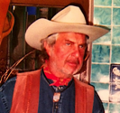

Extraordinarily prolific Mexican actor Hugo Stiglitz appeared in scores of low-budget, crowd-pleasing genre films from his native country, including "Survive!" (1976) and "Tintorera" (1977), which translated into international appeal and opportunities to appear in other foreign productions, including American pictures lensed in Mexico. Tall, rugged and exceedingly stoic - occasionally to the point of seeming ossified - Stiglitz began his career in 1969 and worked steadily throughout the 1970s, scoring hits throughout the world with the aforementioned titles, both gritty, grimy exploitation movies by writer-director Rene Cardona, Jr. These and other films helped to make Stiglitz a dependable box office presence throughout the world, which translated into roles in European and the occasional American film like "Under the Volcano" (1984). In the 1980s, Stiglitz worked almost exclusively in direct-to-video features, often pulling double duty as writer, director or producer. His cachet among Mexican audiences and American cult movie fans alike kept him busy into the 21st century while earning tributes from the likes of Quentin Tarantino, who borrowed the actor's name for Til Schweiger's violent rogue Nazi in "Inglourious Basterds" (2009). Throughout his long career, Hugo Stiglitz remained the rare Mexican screen star who also enjoyed popularity around the world.

Gabriela Reynoso
as Carmen Valdez

Gabriela Reynoso is an actress, known for The Company You Keep (2012), And Starring Pancho Villa as Himself (2003) and The Cinema Hold Up (2011).

BIOGRAPHY:
Luis Luna Estrada – Writer/Producer/Director “One Night In Mexico” / “Una Noche En Mexico”

Luis is a thirty-seven year media and entertainment industry professional with experience in Television, Film, International Broadcasting, Branding, Production, Creative Services, Media Sales, New Business Development, Network Operations, Radio, Advertising, Digital Media and General Management.

Experience includes launching and serving as Head of Creative Services at Turner Broadcasting’s Cartoon Network and TNT for Latin America, management positions at Univision Television Group, Telemundo’s Flagship station in Los Angeles, Friedland Jacobs Latin America, where key client was DirecTV Latin America, Fremantle Latin America, the United States Information Agency, was on staff at Paramount Pictures Corporation where he assisted in the production of over 20 major motion pictures he describes his career at Paramount as “Gun to Gun, “Top Gun” to “The Naked Gun” and everything in between”.

Luis has been the head of studio/network origination facilities, creative agencies and has worked with Los Angeles, Mexico City, and Dallas/Fort Worth based broadcasters, agencies and clients where he has produced media content and developed marketing/branding campaigns

He served on the Texas Workforce Solutions Commission for Tarrant County Board, North Texas Toll Road Authority NTTA’s Business Diversity Advisory Council (BDAC), The Parenting Center Board, served 3 years on the Fort Worth Hispanic Chamber Board and various other committees and Advisory Boards in Texas, now services on the Marketing and Development committee for “Feeding America San Diego”.

Currently he is Senior Producer and On-Air Fundraising Manager for KPBS, the PBS and NPR affiliates in San Diego, California. He continues to develop projects as an independent Producer/Director, through his production company ES Creative Gang a full service production and creative services company.

“One Night in Mexico” and “Una Noche en Mexico” are Luis’ first fully independent feature film projects.

CREDITS

ONE NIGHT IN MEXICO

PRODUCED AND DIRECTED BY
Luis Luna Estrada

Written by Doug Miller and Luis Luna Estrada

CAST
Pablo Corralejo Alex Reymundo
Angelica Valdez Monika Munoz
Ernesto Garcia Hugo Stiglitz
Carmen Valdez Gabriela Reynoso
Juvenal Rhual Rogers

CREW
Director of Photography Roberto Rivera L.
Assistant Director Antonia Preza L.
Camera Assistant Luis Alberto Lemus
Sound Alejandro Velazquez L.
Boom Operator Domitilo Gomez
Key Grip Esteban Perez
Key Utility Aron Gamez Sanchez
Electrician Angel Gonzalez S.
Grip #1 Erick Dhaen
Grip #2 Edgar Garcia
Make Up/Hair Mercedes Uribe V.
Wardrobe Rosario Acosta S.
Craft Services Fabiola Frias C.
Patricia Gonzalez F.
Rosa Isela Barroso H.
Executive Producers Raymundo Calixto Sanchez
Francisco Outon
Jorge Torres

Post Production
Talento Post S.A. de C.V.
Mexico D.F.
ES Creative Gang U.S.A.

Film
Kodak S.A. de C.V.
Film Laboratory
Churubusco Azteca S.A. de C.V.

Casting
Talento Post S.A. de C.V.

Special Thanks
Angela Allison Estrada
Samuel Allison Estrada
Pedro Vicuna Estrada
Eliova Luna Estrada
Oscar Luna Estrada
Delia Luna Estrada
Angela Luna Estrada
Francisco Outon and Family
Jorge Torres and Family
Scott and Maria Montoya
Roger Nygard
Mario Calderon
Greg Richardson
Aurora Hernandez Farias and Family
Francisco Cuevas and Family
Juan Luis Duenas
The Staff and Friends at Talento Post
Don Cesar M. Balestra y Campuzano
Juan Luis Duenas
Carlos King
Denise Manning
Alfonso Lopez Negrete
William Kim and Family
Rene Sanchez
Augustine Martinez
Rolando Santos
Gabriela Charlie, Andrea, Marianna Guerrero
Nate Lowe, Carrie Wright, Jeremy Kemp

THE TEAM & FRIENDS AT TEQUILERA CORRALEJO
Ing. Miguel Roa Castaneda
Srta. Martha Araceli Paz
Sr. Felipe Leal
Sr. Miguel Aguilera
Sr. Jorge Aguilera
And Sr. Salvador Abad

In Memory of
Alejandro Reymundo Mejia
and
Rhual Rogers

We appreciate the support from the Penjamo Guanajuato Police Department
Comandante Daniel Luna
Comandante Raul Campos Alvarado
Teniente Juan Bribisesca Saldana
Teniente Jose Alberto Navarro A.
Teniente Jose Guadalupe Lopez N.

Hotel Santa Rita
Familia Martinez Medina

MUSIC
Inspired by Cornelio Reyna
Written by Edmundo Ortega Garcia
Performed by La Pandilla Nortena
Courtesy of Sony Music Latin America

“Una Noche en Mexico” and “One Night in Mexico”
Written by Oscar L. Estrada
Performed by Oscar L. Estrada
Sung by Angela Luna Estrada

“Esos Altos de Jalisco”
Written by Manuel Esperon
Performed by Mariachi Voces de Corralejo

We greatly appreciate the support and patience of everyone associated with this production.

This motion picture was filmed entirely on location in Mexico.

ONE NIGHT IN MEXICO/UNA NOCHE EN MEXICO
All Rights Reserved 2016
Luis Luna Estrada / ES Creative Gang ©

PRODUCTION PICTURES

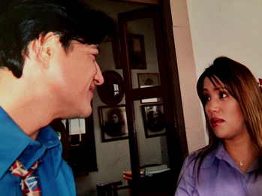
Cast and Director. Alex and Monica playing a scene.

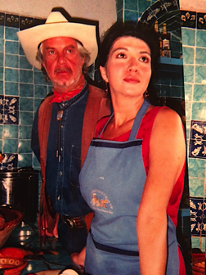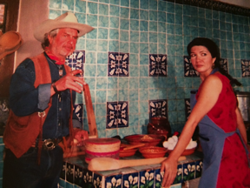
Hugo and Gabriela playing a scene.

BTS - PRODUCTION PICTURES

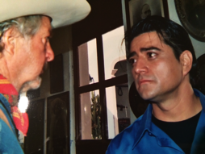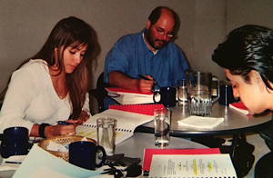
Hugo and Alex Rehearsals
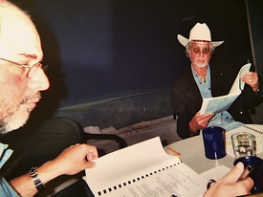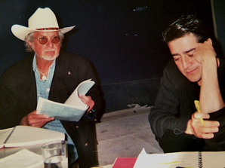

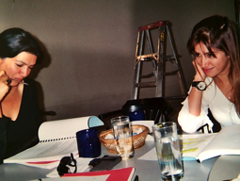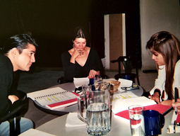

A picture break during production.
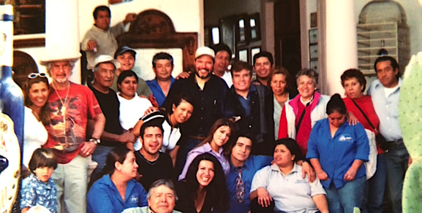
Cast and Crew
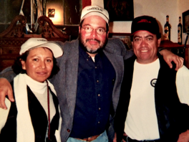 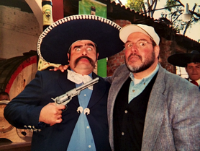Director, AD and DP The late Rhual Rogers having some fun.

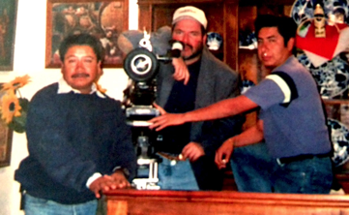
Checking the scene with film crew.

