FOR IMMEDIATE RELEASE

FIRST AFRICAN AMERICAN MUSLIM MOTHER DUO EMBARK ON
CHANGING THE NARRATIVE OF CHILDREN’S BOOKS AND ANIMATION

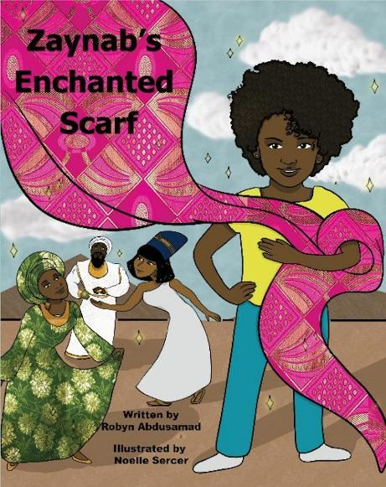
GREENSBORO, NC – Robyn Abdusamad and Dr. Kimberly Harper decided it was time to change the narrative of children’s books and animation when they created their company Omera Productions in 2017. As new mothers they noticed a lack of books and children’s animated stories featuring African-American and/or African-American Muslim children as the main characters. That’s when the Muslim mommy duo decided to create Omera Productions, subsequently publish Robyn’s third children’s book Zaynab’s Enchanted Scarf and begin working on an animated short series to accompany the book. Zaynab’s Enchanted Scarf is about a little girl who receives a special scarf that takes her all over the world learning about African and African-American history. Robyn has also written Wahid and His Special Friend, and You are Beautiful. Zaynab’s Enchanted Scarf and all of Robyn’s book are online at Amazon.com and BarnesandNoble.com.
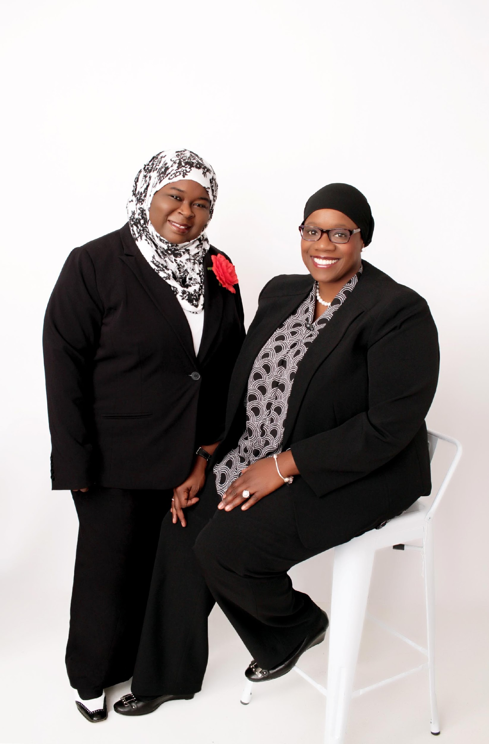
Robyn and Kim are the owners of Omera Productions, LLP, a multimedia company which creates content that changes the narrative of anti-Black and anti-Muslim bias in society. Their goal is to create books and animated children’s stories that present positive and healthy images of African American children and African-American Muslim children to society. Robyn was a featured reader at the National Black Book Festival in Houston, TX. They have been featured in The Muslim Journal (March 16, 2018 issue) and most recently Robyn was a featured guest on Radio Islam (WCEV 1450 am) in Chicago with host Tariq El-Amin. Both Robyn and Dr. Kim were guests on Intellectual Chocolate - a Dr. Boyce Watkins sponsored radio podcast. Dr. Kim as she is called by children at book readings just completed two events (October 22 & 31) at the Greensboro Islamic Academy in Greensboro, NC.
For more information about Omera Productions and what Robyn and Kim are doing visit www.omperaproductions.com or you can find them on social media:
- Facebook: omeraprod
- Instagram: omeraproductions16
- Twitter: @OmeraProduction
- and YouTube channel, OmeraTV
NOTE TO MEDIA: Robyn Abdusamad is available to do book readings of Zaynab’s Enchanted Scarf, Wahid and his Special Friend, and You Are Beautiful. And, Robyn and Dr. Kim are both available for interviews and speaking engagements on several topics related to the need and importance of diversity. For a press review copy of the book, contact info@omeraproductions.com

