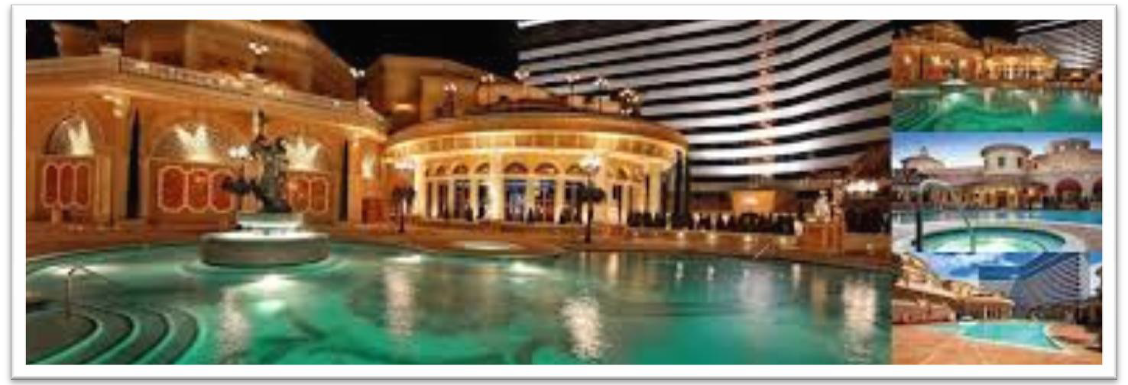

New Starting Time
8 A.M. Friday, March 8, 2019
New Classes Added New Location:
The Peppermill Resort
2707 S. Virginia Street Reno, NV 89502

775-826-2121

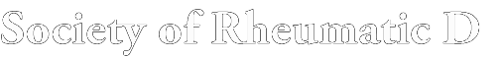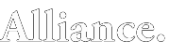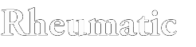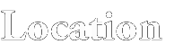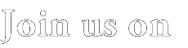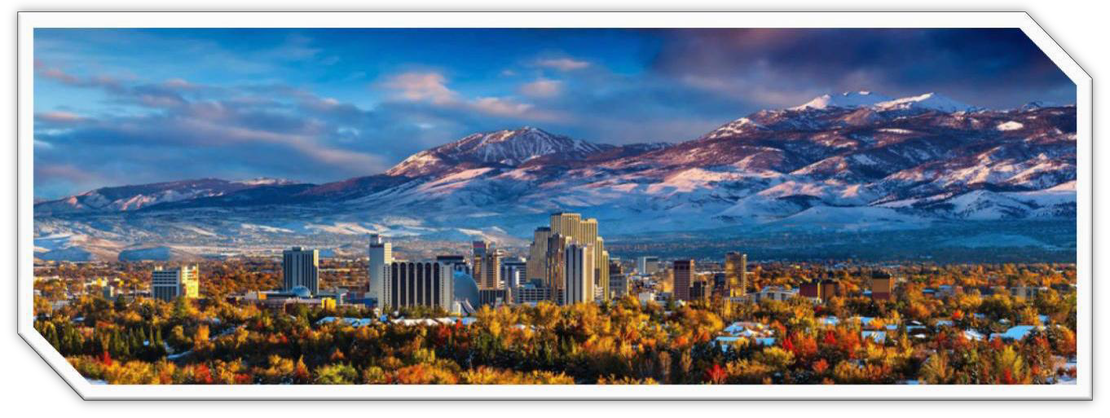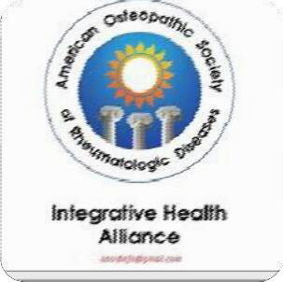

(Auto-immune and Rheumatic Disease Issues with Studies in Conventional, Integrative, and Historical Aspects of Auto-Immune Pathologies).

The Peppermill Resort

2707 S. Virginia Street Reno, NV 89502 775-826-2121
Open to D.O.s, M.D.s, N.P.s, P.A.s, D.C.s, N.D.s, O.M.D.s, C.M.D.s

March 2019; Friday 8thMarch, Saturday 9thMarch, Sunday 10thMarch

Dear Colleagues and Friends,
We cordially invite you to attend the Annual Scientific Meeting of the American Osteopathic Society of Rheumatic Disease and the Integrative Health Alliance at the Peppermill Spa and Casino in Reno, Nevada, March 8-10, 2019. Rated as the top resortin Northern Nevada, the Peppermillis a short ride to fabulous Lake Tahoe.
We look forward to your participation in our upcoming event.
An outstanding program with an impressive schedule of presentations awaits our participants. Registered participants can attend and interact with Dr. A.J. Farschian, the President and Founder of the American Association of Stem Cell Physicians, Dr. Danial Royal presenting alternative medicine and the Native American experience, Doctors Jon and Gretchen Marsh, Dr. Jerel Glassman as well as our resident rheumatologists, Drs. Robert Speer and Richard Renza.
We anticipate 20 hours of didactics covering basic and advanced concepts in Rheumatology, Traumatic Brain Injury care, lipidology, and opioid recovery.
We are pleased to sponsor the American Osteopathic Association’s CORE RE’MS “Pain Management and Opioids: Balancing Risks and Benefits.” This satisfies most state board of medicine’s core requirement in opioid education. Opioid addiction and suicide prevention, necessary for licensure in Nevada and most other states, are other topics for discussion.
A continental breakfast is offered each morning before sessions begin and we anticipate anon-CME lunch on Saturday will feature member sof the AOSRD and plans for the future.
Our reasonably priced registration fee (less than $20 per CME Credit!), and, to stay at the Peppermillat a below-market room price, are just two of the incentives to attend and participate in this toutstanding event.
CONFERENCE INFORMATION
OBJECTIVES

Designed for practicing physicians, students, nurse practitioners, nurses, physical and occupational therapists, and physician assistants interested in autoimmune and rheumatic disease issues, integrative, holistic, and osteopathic medicine, those interested in the latest research in lipidology, and new concepts in the diagnosis of, and treatment of traumatic brain injury.
Lecture material is intended to meet the needs of physicians in clinical practice for up-to-date informationon the latest techniques in general and specialty areas and to provide a means for physicians, researchers and students to gather, share ideas and report the results of their research.

ACCREDITATION

The American Osteopathic Society of Rheumatic Disease is accredited by the Council on Osteopathic Continuing Medical Education (COCME) to provide continuing medical education for physicians. The AOSRD designates this live activity for a maximum of 20.0 AOA category 1 CME credits.
We look forward to seeing you in Sparks. Sincerely yours,
William Clearfield DO John Burgess DO

Friday 8 March 2019
The Line-Up

- A.M-8:50 A.M.-Dental Caries and Autoimmunity, Christopher Hussar, D.O.
9 A.M.-9:50 A.M.- Ibogaine in the Treatment of Opioid Dependence, John Burgess, D.O.
10 A.M.-Noon-.- Pain Management and Opioids: Balancing Risks and Benefits,” AOA CO*RE REMS Noon-1:30 P.M. Lunch
1:30-2:20 P.M.-Psoriatic Arthritis, Robert Speer D.O.

2:30-3:20 P.M.-Head Injury Update, Richard Renza D.O. 3:30-4:20 P.M.-RBC Stem Cells, Dan Royal D.O., C.T.P., J.D.
4:30-5:20 P.M.- Probiotics, Facts and Fiction, Jon Marsh,D.O.
5:30-6:20 P.M.- Colonic Inertia, How to Move a Mountain, Jon Marsh D.O
Refreshments Served.

Saturday, March 9, 2019
8-8:50 A.M.- The Application of NaPro Technology in Common Fertility Disorders, Gretchen Marsh, D.O
9-9:50 A.M.- OMT Mild Traumatic Brain Injury, Jerel Glassman, D.O.
10-10:50 A.M.-Mesenchemal Stem Cells-From Clinicial Trial to Practical Applications, A.J. Farschian M.D., Founder American Association of Stem Cell Physicians
11-11:50 A.M.- The Connectome: Interruptors and Disruptors, Aaron Heide, M.D.
12-1:30 P.M. Meeting of the Members and Board of Directors of the American Osteopathic Society fo Rheumatic Diseases. (Working Lunch)
1:30-2:20 P.M.- Using Indian Sovereign Immunity for the Protection of Medical Alternatives pursuant to U.S.C. Section 25, 1680u, Dan Royal, D.O., C.T.P., J.D.

2:30-3:20 P.M.- What’s New from our Lipidologist; Diagnostics and Therapy, Joseph Lillio, D.O.
3:30-4:20 P.M- Use of Nutrient-Dense Foods to Reduce Inflammation, Body Weight, and Blood Pressure, Stacey Bell, DsC.
4 :30-5:20 P.M.-The Anti-Inflammatory Diet for Arthritis, Robert Speer D.O.
5:30-6:20 P.M.-Neural Therapy for Back Pain, John Burgess, D.O.
7:00 PM -Dinner and Show

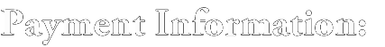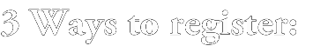Sunday, March 10, 2019

08:00-10 A.M.- The Endocrinology of Traumatic Brain Injury-William Clearfield D.O.

10 A.M.-10:50 A.M. -Cognitive Impairment, Dementia: A Novel Intensive Intervention
Robert Adams, D.O.
11:00 A.M.-11:50 A.M. Suicide Issues-TBA

Adjourn

See You at OMED 19 in Baltimore October 25-28, 2019

Contact:
William Clearfield, DO, doctrbil9@gmail.com John Burgess D.O. jb@jb5.com

9550 S. McCarran Blvd., Suite B, Reno, NV 89523
If you would like to be more active in the AOSRD, give lectures, journal submissions, administration, marketing, research, product development, etc. please let us know.

Online  Use the fast and secure online format: | Fax  Complete form and fax : 888-977-3503 | Mail  Complete form with payment to: AOSRD c/o William Clearfield  D.O. 9550 S. McCarran Blvd. Reno, NV 89523

Fill out form completely. Please print information clearly.
Your Full Name:
Street Address / Suite/Apartment Number (if applicable): City / State / Zip Code:

Telephone:
Email:
EARLY BIRD REGISTRATION
ENDS ON February 22, 2019
Registrations received after that date are automatically charged, and the delegate is expected to pay the late registration fee levels.
CANCELLATION & REFUNDPOLICY
Cancellations must be received in writing by February 18, 2019, to receive a refund. A $50 handling charge will be deducted from all refunds. No refundwill

REGISTER NOW
be provided for cancellations received after February 18,2019.
SPEAKERS AND PRESENTERS

All members participating in the program, as well as fellows, residents, and students, are expected to register.

RESIDENT, STUDENTS, AND FELLOWS

Admittance to meetings and all meal and social functions.
REGISTRATION

Includes General AOSRD Meetings, Membership Meeting and Social Functions, including breakfast daily, and receptions

SPOUSE REGISTRATION

Includes all meals and social functions as listed above

SCIENTIFIC SESSION REGISTRATION  (Check only one) | EARLY BIRD BY JANUARY 22 | LATE REGISTRATION AFTER JANUARY 22 | AMOUNT DUE
Physicians | $275 | $300 | $
o Non-Physicians | $175 | $200 | $
o Active Duty Military | $150 | $175 | $
o Residents, Students, and Fellows | $ 0 | $ 0 | $
o Retired Physicians | $100 | $125 | $
- Daily Registration Fee-SpecifyDay  - Spouse(Name) _ | $100  $85 | $115  $100 | $

TOTAL ENCLOSED$

CHARGE MY:
oVISAoMASTERCAR
DoAMERICANEXPRES S

Name (As it appears on card.Pleaseprint.)

CardNumber

Expiration Date /SecurityCode BillingAddress_
City State Zip
Phone with AreaCode

SIGNATURE (As it appears oncard.)

Make Checks payable to “AOSRD. Mail with completed form and payment in full (in U.S. dollars) to: AOSRD, 9550 S. McCarran Blvd., Suite B, Reno, NV, 89523

The Venue
The Peppermill Resort Spa Casino

2707 S. Virginia Street Reno, NV 89502
775-826-2121

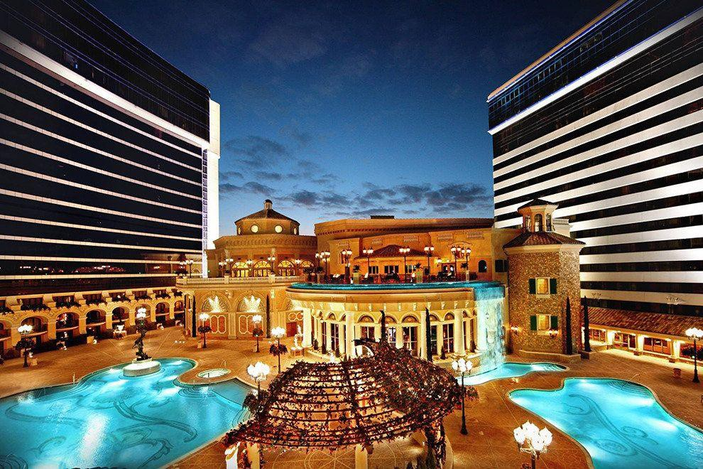

A block of rooms is reserved at a special, below market price. Call the Peppermill directly at 775-826-2121 for reservations. Mention the American Osteopathic Society of Rheumatic Disease to qualify for our special rate.

