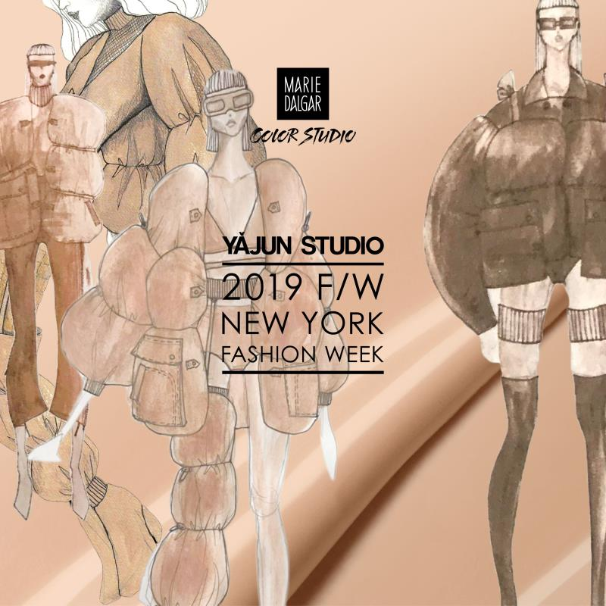
The winter is coming to an end. On February 11, 2019, the independent designer brand YAJUN STUDIO released its Fall/Winter 2019 collection at New York Fashion Week. The theme of this collection of works is "Natural Attitude X Flesh Philosophy", which is another bold attempt of designer Melody Yajun Lin.
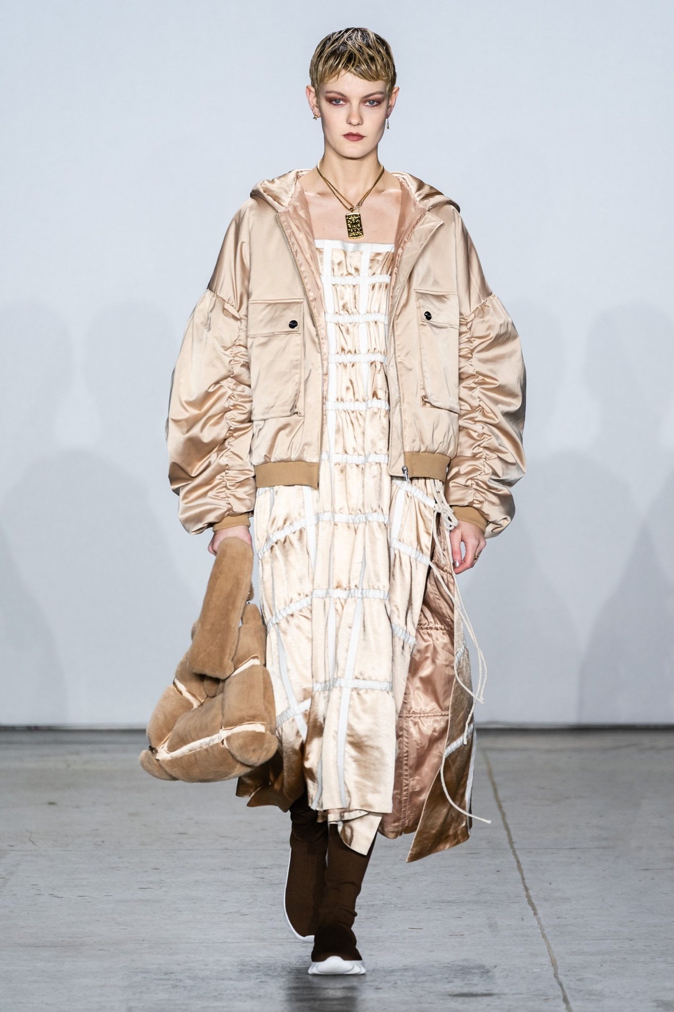
In the design process, the designer chose a large number of artificial leather to replace the natural leather and carried out the brand concept of "Sustainable Fashion" and the Surrealist expression method——bold profile cutting and massive pure color, which not only reflects the concept of environmental protection and sustainable development, but also conformed to the current trend of the times.
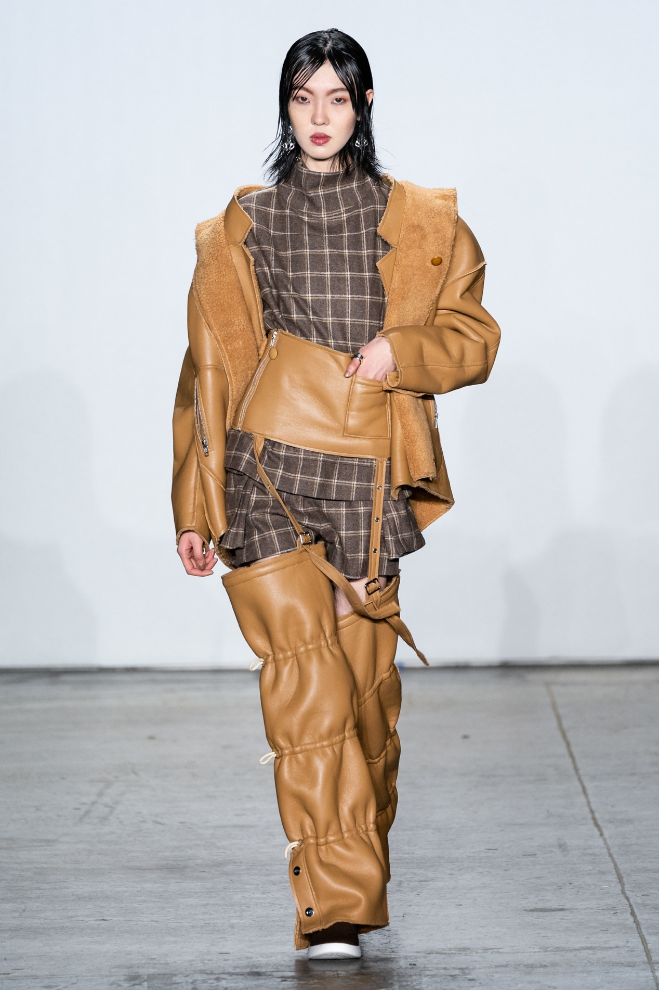
Designer Yajun integrates the inspiration from George Lakoff's book “Philosophy in the Flesh” ——George Lakoff into her works, combines it with her own aesthetic ideas, and the first collaboration with Marie Dalgar Color Studio, which finally launches the YAJUN STUDIO Fall/Winter 2019 collection of "Natural Attitude x Flesh Philosophy".

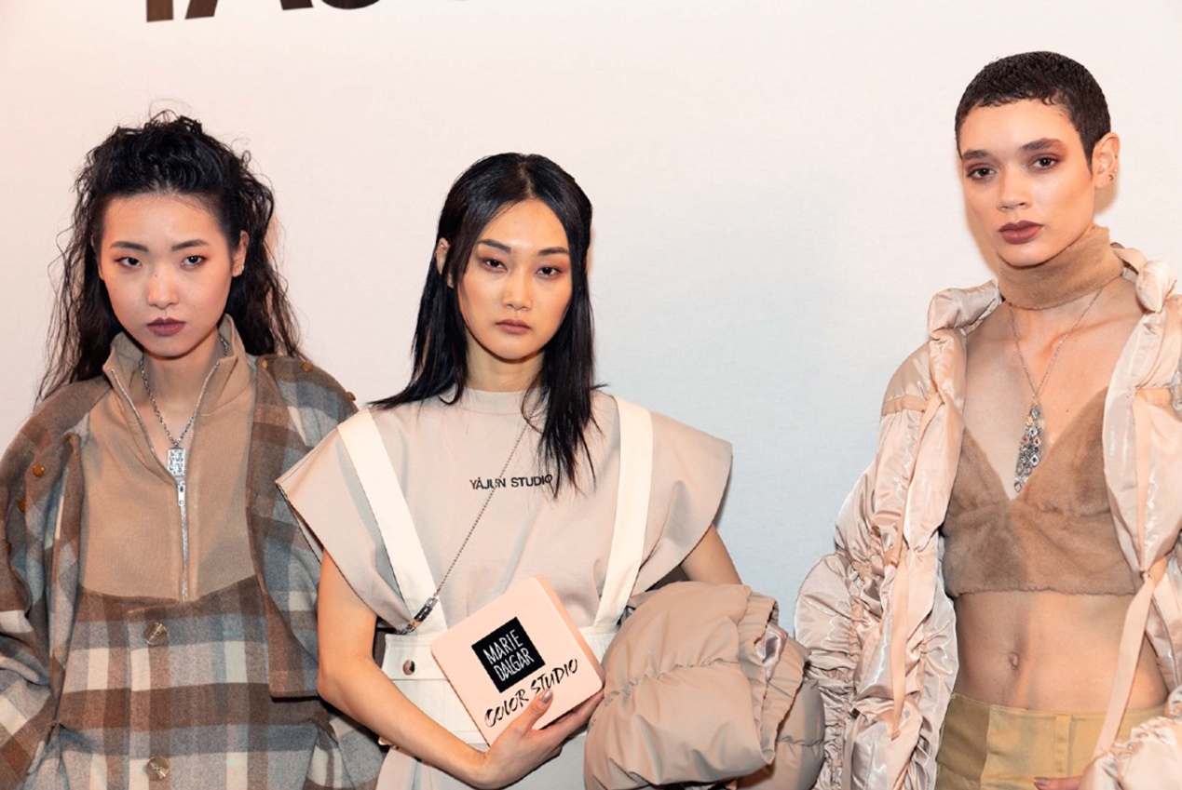
The collection combines the physical, temporal, spatial and unconscious collisions of fabrics, cuts, and colors. Time and flesh represent experience and wear, and the body produces wrinkles and scars over time; space and flesh are containers for the human body as human souls. Different diets and living habits can cause changes in containers; unconsciousness and the flesh shows the separation of mind and body. In this collection of works, this philosophical concept is concreted: large-scale use of solid colors - especially the Marie Dalgar Color Studio makeup liquid foundation, in the form of color blocks to meet different colors, one in rough. The complex beauty of the delicate and delicate pink hair bursts into the mysterious temperament of the wearer's free and elegant. The Oversize and silhouette down jackets in this collection are like quilts that can be worn, which simulates the unconscious sleep state, breaking the bondage of the intrinsic and obsolete fashion elements, and presenting a rigid and soft visual experience.

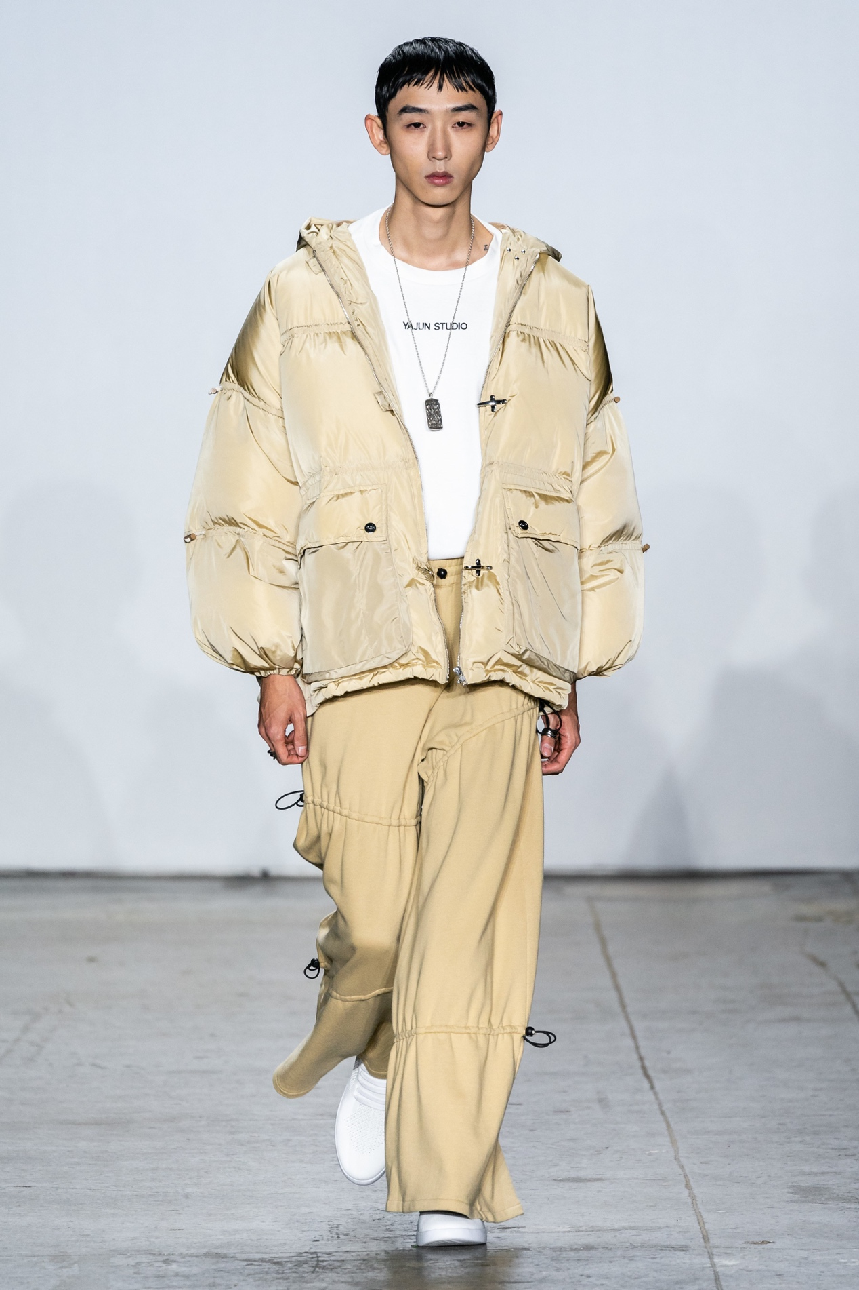

In terms of clothing matching, this work adopts OPINION PRIVÉ BY D.CHEN jewelry products. OPINION PRIVÉ BY D.CHEN is dedicated to exploring the potential of combining art with fashion and the infinite possibilities of design and creation, which undoubtedly coincides with YAJUN STUDIO's creative philosophy. The two are also approaching the creation of merchandise to the creation of art, pursuing their own unique aesthetic concepts. And this aesthetic concept also pays attention to the diversity of design works. The two kinds of aesthetic pursuit match each other, so that when they are matched, there is absolutely no defect, showing a round and satisfactory aesthetic feeling.

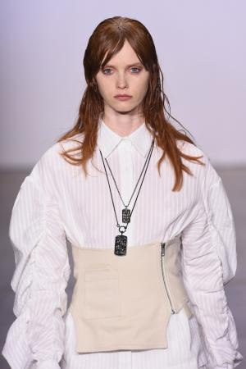
In addition to jewelry, the strong support of the footwear brand DUOZOULU has also laid a solid foundation for the success of this show. DUOZOULU redefines walking through technology, so that everyone can have the ultimate comfortable walking experience and carry the trend culture with innovative technology. In pursuit of comfort while taking into account the trend, the aesthetics of universal significance can be accommodated in it. This kind of aesthetic attitude of Vientiane is exactly the philosophy of life of YAJUN STUDIO.

Designer Lin Yajun Melody graduated from Parsons The New School, the Nation's No. 1 Fashion Design Institute. After winning the competition jointly organized by Vogue, the most famous fashion magazine, and Kering Group, a global luxury leader, she established the design brand YAJUN STUDIO in New York in 2016. Once launched, it has won the favor of many stars and stylists. YAJUN STUDIO regards fashion as a neutral and all-inclusive philosophy of life, aiming to convey the same aesthetic concept to people of different genders, ages, regions and figures through design——"elegance and restraint, gentleman's style". Designers are keen to use surrealist techniques to subvert the limitations of deduces in choosing clothes, so as to highlight personal style and temperament, and to deduce distinctive shapes.

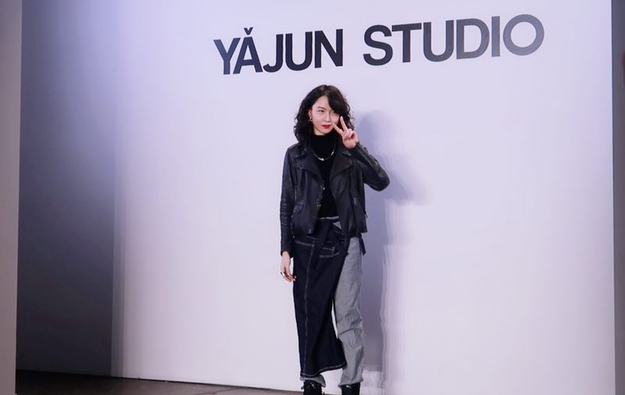
Yajun Lin, a young designer, with her extremely high aesthetic orientation and surrealist technique with the most prominent personality in contemporary art, has created elegant works with Chinese characteristics in cooperation with Marie Dalgar Color Studio. Combining individuality and commonness, Melody Yajun Lin's s creation is not only a ready-made garment, but also a work of art; it's a design, and it's also an understanding of the world.

