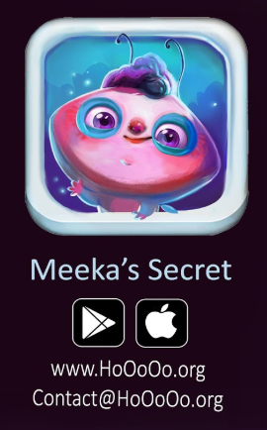**MEDIA CONTACTS:**

[Sahar Shams](https://www.saharshams.com/)

415-416-0132

[contact@hooooo.org](mailto:contact@hooooo.org)

Suzanne Darley

415-381-5451

[sdarley@mac.com](mailto:sdarley@mac.com)

**Meeka’s Secret Game App Teaches Emotional Intelligence and Self-Advocacy Skills to Defend Against Childhood Abuse**

Limited time free downloads during April to honor National Child Abuse Prevention Month

**San Francisco, April 4, 2019** – [Meeka’s Secret](https://www.hooooo.org/), an engaging new audiobook and game app for both iOS and Android is available for free during the month of April to honor [National Child Abuse Prevention Month](https://www.childwelfare.gov/topics/preventing/preventionmonth/). In the age of the [#MeToo](https://metoomvmt.org/) movement, Meeka’s Secret addresses the taboo topic of childhood abuse offering an age appropriate tool to raise public awareness and teach emotional intelligence, self-advocacy and resilience. The app was first launched in Farsi with more than 125,000 downloads in 7 months and is now available in English. Meeka’s Secret can be downloaded for free on the App Store or Google Play during April.

Created by award-winning artist and director, Sahar Shams, in conjunction with psychologist and expressive arts education expert, Dr. Suzanne Darley, Meeka’s Secret combines a beautifully rendered interactive eBook with compelling gameplay to support the well-being of those affected by adverse childhood experiences. It teaches young children how to identify and address physical and sexual abuse to help prevent childhood trauma. It dramatically improves emotional intelligence while modeling how to stand up for oneself and find the right course of action in a traumatic situation.

Meeka’s Secret engages children, parents and mental health professionals in building skills to safeguard against childhood abuse. Through stunning digital artistry and powerful storytelling, the app tells the tale of Meeka, a gender-neutral insect whose wings are its private parts. When an adult insect touches Meeka’s wings, the little one embarks on a journey of that teaches viewers how to speak up and self-advocate.

*“I created Meeka’s Secret to teach children, parents and communities how to cope with childhood trauma and heal,”* said Sahar Shams, Founder of The HoOoOo Foundation and creator of Meeka’s Secret app. *“Meeka’s Secret is a resource for adults to communicate about the difficult topic of sexual abuse in a language that is appropriate, understandable and non-threatening for children. Education is the most effective tool for prevention.”*

*"Our mission at HoOoOo is to improve the heath and well-being* of children by tackling the problems associated with sexual abuse and childhood trauma,” said Dr. Suzanne Darley, PhD Psychology. *“HoOoOo products are unique in the marketplace combining fun and compelling game play with curriculum that builds resilience, self-esteem, mindfulness, empathy, gratitude, respect, trust and optimism. These are essential skills for navigating life and growing happy and healthy adults.”*

Meeka’s Secret is sponsored by [HoOoOo Foundation](http://www.hooooo.org), a nonprofit dedicated to improving the well-being of people affected by childhood trauma. For more information visit: https://www.hooooo.org/

[Download on the App Store](https://itunes.apple.com/us/app/meekas-secret/id1443436586):

<https://itunes.apple.com/us/app/meekas-secret/id1443436586>

[Get it on Google Play](https://play.google.com/store/apps/details?id=com.Hooooo.MeekasSecret&hl=en_US)

<https://play.google.com/store/apps/details?id=com.Hooooo.MeekasSecret&hl=en_US>